**Background and Guidance Notes for LEADER Applications to Denbighshire, Flintshire and Wrexham Local Action Groups**

1. **Background: What is LEADER and what is the Local Action Group (LAG)?**

LEADER is an initiative to support rural development projects initiated at the local level in order to revitalise rural areas and create jobs. It is part of the Welsh Government Rural Communities – Rural Development Programme 2014 – 2020, which is financed by the Welsh Government and European Agricultural Fund for Rural Development (EAFRD).

‘LEADER’ is the term used to describe a special type of local development approach for rural areas. The name LEADER comes from the French acronym ‘Liaison Entre Actions pour le Development de L'Economie Rurale’ (which roughly translates to ‘links between actions for developing the rural economy’). LEADER’s approach involves a rural development methodology based a number of core components including partnership, ‘bottom-up’ development, innovation and cooperation.

The LEADER programme is implemented by Local Action Groups (LAGs). There are three LAGs in North East Wales, each operating on a county basis in the rural areas of Denbighshire, Flintshire and Wrexham. Each LAG is made up of representatives from the public, private, and community/voluntary sectors. Cadwyn Clwyd is the Administrative Body for each LAG, assisting each one to implement its LEADER programme in their respective areas.

The LAG is responsible for making decisions on how the LEADER monies are distributed in each area. Cadwyn Clwyd is responsible for providing technical, administrative support and assisting the implementation of projects in accordance with the direction of the LAG. Each LAG in the three county areas has 18 members, with 6 members coming from the private, community and public sectors respectively. Each LAG also has a number of advisors to the decision-makers. The LAGs meet every quarter to monitor the programme’s delivery, the implementation of the Local Development Strategy (LDS) and to appraise applications for funding.

Each LAG has a Local Development Strategy (LDS) that contains a set of rural development actions and objectives which have been suggested by local communities in the LAG area. Innovation is an important part of the LEADER methodology. By promoting innovation, LAGs aim to encourage local organisations and businesses to test new ways of developing their areas. LEADER has been extremely effective at stimulating all sorts of different socio-economic and environmental innovations throughout rural Europe. Different ways that innovation is expressed by LEADER include:

* Working in new ways: this might involve rural development approaches that apply new ideas, using new techniques, focusing on alternative markets, bringing diverse sectors and stakeholders together via new networking methods, supporting new priority groups, or finding new solutions to social, economic and environmental challenges.
* Developing new products and services: these often result from testing innovative ways of working and can be created through the application of new or novel techniques, partnerships, technology, processes, research and thinking.
* Adapting proven approaches to new circumstances is also recognised as an effective means of creating locally significant innovative rural developments. These types of innovative actions are often facilitated by knowledge transfer between regions or Member States.

The European aspect of LEADER has always been an important characteristic of the methodology. Specific parts of the LAGs’ European Agricultural Fund for Rural Development (EAFRD) budgets are provided for Transnational Cooperation (TNC). TNC means undertaking a joint rural development project with at least one other area in another country. TNC can be, among other things, a way of getting enough people involved in an activity to make it viable, or as a means of encouraging complementary actions, e.g. joint marketing by rural business organisations from different regions of local products or services, like food or tourism initiatives. Mutual learning is a useful result from TNC projects. TNC helps rural people learn from their peers in other countries about new ideas for rural development projects. Such LAG cooperation has created a great many mutual benefits for many different rural areas across the EU.

LEADER is based on seven principles - all of which must come together for it to be successful.  


The key advantages of the LEADER approach are:

* Local people have a better knowledge of local challenges that need to be addressed and the resource and opportunities available.
* They are able to mobilise local resources for the development process in a way that does not happen with traditional "top-down" approaches.
* This gives local people a greater sense of ownership and commitment to the projects, which in turn allows them to make the best of their local assets.
* The approach can help develop trust and positive working relationships amongst the local community and businesses.

1. **LEADER Local Development Strategy (LDS)**

Each county area has a Local Development Strategy (LDS) that provides a framework on how LEADER funds will be used in the area. The Local Development Strategy focuses its interventions around 5 themes which are listed below:

|  |
| --- |
| 1. Adding value to local identity and natural and cultural resources |
| 1. Facilitating pre-commercial development, business partnerships and short supply chains |
| 1. Exploring new ways of providing non-statutory local services |
| 1. Renewable energy at Community level |
| 1. Exploitation of digital technology |

A project must fit with one of the themes listed above.

The Local Development Strategies for Denbighshire, Flintshire and Wrexham can be found on the Cadwyn Clwyd website:

<http://www.cadwynclwyd.co.uk/news/local_development_strategies>

Diagrams summarising each Local Development Strategy - its vision, aims, objectives and priorities – are also available.

1. **Cross cutting themes**

The Local Action Groups have a responsibility to maximise the local LEADER programmes’ contribution towards three cross cutting themes:

Equal Opportunities and the Welsh Language

The LAG must ensure that no disproportionate negative effects occur to the below protected characteristic groups via any LEADER funded actions:

* The Welsh language and Welsh speakers.
* Age (covering all age groups, being particularly aware of children aged under 16, younger people aged 16-24, and older people aged 65 and over).
* Disability (which may include people with sensory impairments, mobility impairments, learning disabilities and mental wellbeing disabilities).
* Gender reassignment (including persons who are at any stage of gender reassignment therapy).
* Marriage and civil partnership (with a focus purely on discrimination on the basis of whether someone is married or in a civil partnership – single people are not covered by this characteristic).
* Pregnancy and maternity (including pregnant women and nursing mothers);
* Race and ethnicity (which may include ethnic or national origins, colour or nationality).
* Religion or belief (which may include all religion, faith or belief groups, including lack of belief).
* Sex / gender (including both women and men).
* Sexual orientation (including heterosexuals, and lesbians, gay men and bisexual (LGB) people).

Tackling Poverty and Social Exclusion

The LAG will make a positive contribution to tackling some of the underlying causes of poverty, deprivation and exclusion in rural communities by investing in actions that help tackle fuel poverty amongst vulnerable older and disabled people:

* Investing in actions that create opportunities for young people not in employment or learning (NEET).
* Investing in actions that maintain and enhance equitable access to basic services to help tackle financial and social exclusion.
* Investing in actions that tackle digital exclusion.

Sustainable Development

The LAG plans to support sustainable development by:

* Investing in actions that support management conservation, sustainable use and enjoyment of the natural landscape and enhancements to the environment.
* Investing in pre-commercial concepts and piloting new businesses that enhance the environment, promote local produce and promote the natural environment as a positive commercial asset.
* Investing in actions which support sustainable and low carbon community transport schemes, the transfer of assets and engagement of volunteers in social enterprises to help deliver physical and natural improvements.
* Investing in actions which support, advise and test/pilot community driven renewable energy technologies, disseminate information and intelligence on renewables at a community level and assist with sustainable re-investment of revenues generated from renewables.
* Investing in actions that encourage the procurement and use of highly efficient Energy Star ICT hardware and which use re-cycled and re-used equipment where appropriate.

Covid-19

The Covid Pandemic has had a significant impact on communities in the LAG area, in health, economic and social aspects.  Revised WG LEADER guidance (dated June 2020) identifies the need to support the most vulnerable citizens and communities.  Immediate priorities on the ground include:

* securing and distributing food and medical supplies to all, including the most rurally/socially isolated
* Identifying local resources including co-ordinating volunteers and supporting short supply chains,
* Networking and collaborating to ensure an informed and appropriate approach to meet local needs

There will also be a need to work with our rural communities as we move forward from the response to the recovery period to help address the socioeconomic and other societal effects of the lockdown, such as the economic impact on certain socioeconomic groups of not being able to work, impacts on businesses of being closed or facing falling customer demand, psychological harms to the public of social distancing and many others. The existing 5 Themes for the LEADER Local Development Strategy are considered relevant in supporting the response to the COVID-19 immediate priorities above and also to future Covid Recovery actions.  Project applicants will be required to clearly demonstrate how their project contributes to the above.

More information on the cross cutting themes can be found in the Local Development Strategies (Section 8.1).

1. **Eligible areas**

The following is a list of eligible rural wards in each County area:

|  |  |  |  |
| --- | --- | --- | --- |
| **Denbighshire** | **Flintshire** | **Wrexham** | |
| ***Rural Ward*** | ***Rural Ward*** | ***Rural Ward*** |
| Bodelwyddan | Brynford | Bronington |
| Corwen | Buckley Mountain | Brymbo |
| Denbigh Central | Caergwrle | Bryn Cefn |
| Denbigh Lower | Caerwys | Chirk North |
| Denbigh Upper/Henllan | Cilcain | Chirk South |
| Efenechtyd | Ffynnongroyw | Coedpoeth |
| Llanarmon-yn-Ial/Llandegla | Flint Oakenholt | Dyffryn Ceiriog/Ceiriog Valley |
| Llanbedr Dyffryn Clwyd/Llangynhafal | Flint Trelawny | Esclusham |
| Llandrillo | Gronant | Gresford East and West |
| Llandyrnog | Gwernaffield | Gwenfro |
| Llanfair Dyffryn Clwyd/Gwyddelwern | Gwernymynydd | Gwersyllt North |
| Llangollen | Halkyn | Holt |
| Llanrhaeadr-yng-Nghinmeirch | Higher Kinnerton | Llangollen Rural |
| Rhuddlan | Hope | Llay |
| Ruthin | Leeswood | Marchwiel |
| St. Asaph East | Llanfynydd | Marford and Hoseley |
| St. Asaph West | Mold Broncoed | Minera |
| Trefnant | Mold East | Overton |
| Tremeirchion | Mold South | Penycae & Ruabon Sth |
|  | Mold West | Ponciau |
| ***Service Centre*** | Mostyn | Rossett |
| *Dyserth* | New Brighton | Ruabon |
|  | Northop |  |
|  | Northop Hall | ***Service Centre*** |
|  | Penyffordd | *Cefn* |
|  | Saltney Mold Junction |  |
|  | Sealand | ***Host Wards*** |
|  | Trelawnyd and Gwaenysgor | *Brynyffynnon* |
|  | Treuddyn | *Grosvenor* |
|  | Whitford | *Maesydre* |
|  |  | *Smithfield* |
|  | ***Service Centre*** |  |
|  | *Holywell Central SC* |  |
|  | *Holywell East SC* |  |
|  | *Holywell West SC* |  |

***Rural Ward:*** *Projects located in Rural Wards are eligible for LEADER support*

***Service Centre:*** *Projects may be located in a Service Centre Ward, but no more than 30% of the benefits of the local LEADER programme can accrue to these wards.*

***Host Ward:*** *A project can be located in a* *Host Ward for practical or operational reasons, but none of the benefits arising from the project can accrue to the ward itself; beneficiaries must come from eligible rural wards.*

**Ineligible Areas**

|  |  |  |  |
| --- | --- | --- | --- |
| **Denbighshire** | **Flintshire** | **Wrexham** | |
| ***Ineligible Ward*** | ***Ineligible Ward*** | ***Ineligible Ward*** |
| Prestatyn Central | Argoed | Acton |
| Prestatyn East | Aston | Borras Park |
| Prestatyn Meliden | Bagillt East | Cartrefle |
| Prestatyn North | Bagillt West | Erddig |
| Prestatyn South West | North East Broughton | Garden Village |
| Rhyl East | South Broughton | Gwersyllt east |
| Rhyl South | Buckley Bistre West | Gwersyllt West |
| Rhyl South East | Bucley Pentrobin | Hermitage |
| Rhyl South West | Connah’s Quay Central | Johnstown |
| Rhyl West | Connah’s Quay Golftyn | Little Acton |
|  | Connah’s Quay South | New Broughton |
|  | Connah’s Quay Wepre | Offa |
|  | Flint Castle | Pant |
|  | Flint Coleshill | Plas Madoc |
|  | Greenfield | Penycae |
|  | Hawarden | Queensway |
|  | Mancot | Rhosesni |
|  | Queensferry | Stansty |
|  | Saltney Stonebridge | Whitegate |
|  | Shotton East | Wynnstay |
|  | Shotton Higher |  |
|  | Shotton West |  |

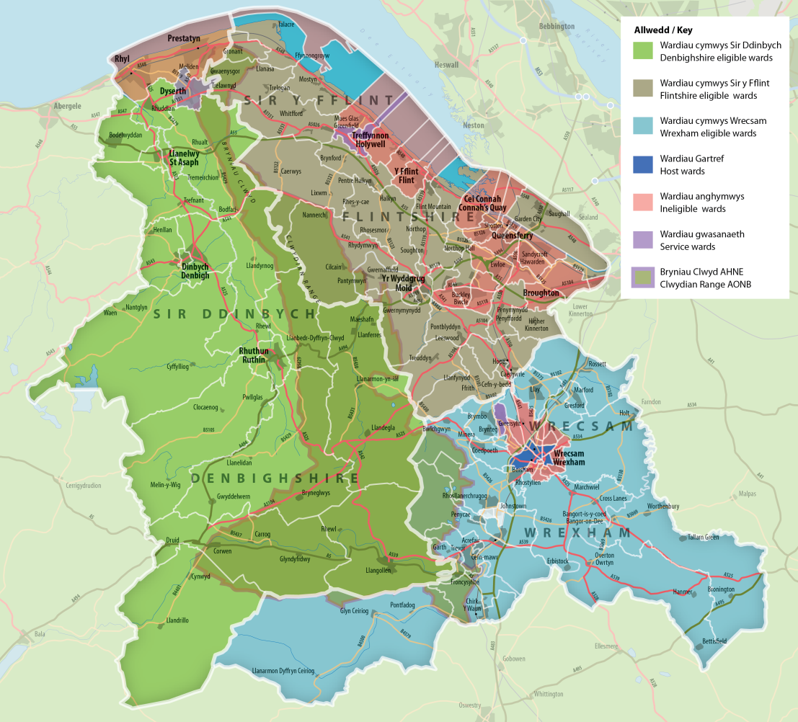

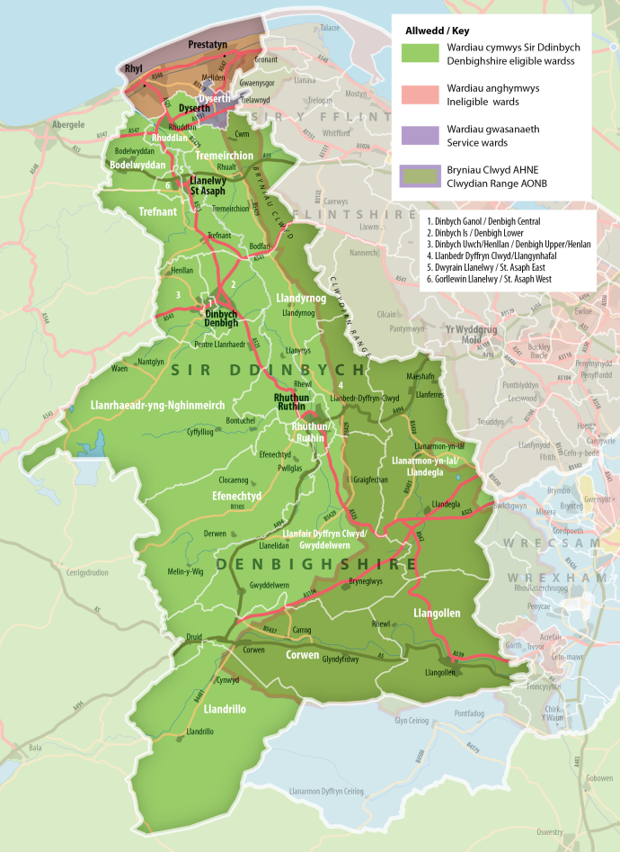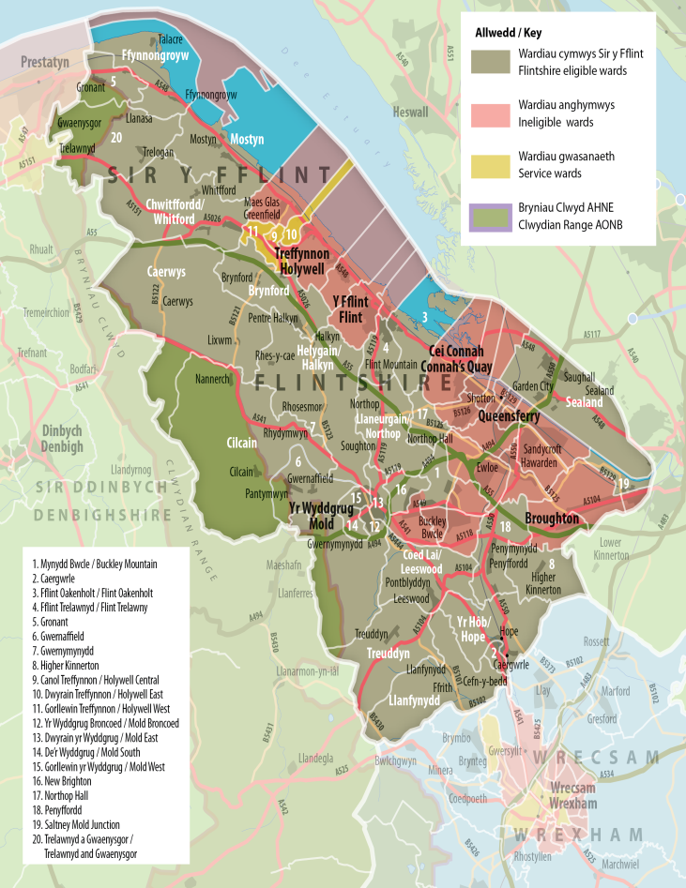

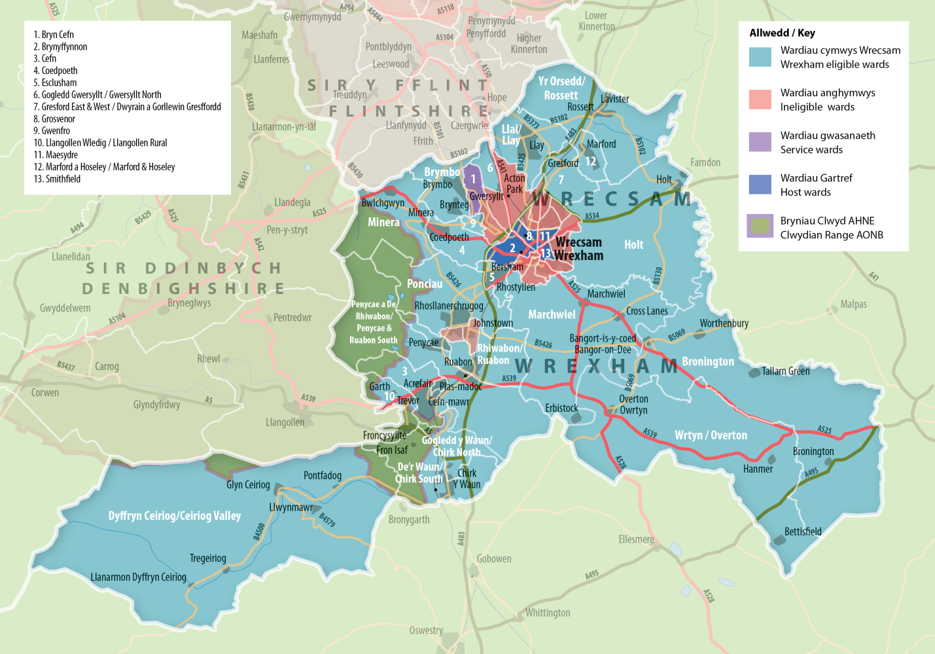

1. **Eligible Project Activities**

Project activities that contribute to the achievement of the objectives of the LDS are eligible. The following are examples of eligible costs:

***Mentoring*** – mainly revenue costs for people who can provide particular kinds of support to organisations and groups to help them develop their own skills and expertise. This is a different approach to training.

***Training*** – mainly revenue costs, though some small items of equipment might fall within the scope of training, for the development and delivery of more formalised courses to groups of people. This may be in formal classroom or lecture room type setting but not necessarily so. The subject matter to be covered and the intended outcome would have been determined by a skills assessment of some kind before the course was delivered.

***Feasibility Studies*** – revenue costs for a combination of staff time and consultancy costs to undertake the background research for a specific problem or issue and the production of a comprehensive written appraisal of the issues, the alternative solutions, the financial costings, a detailed risk analysis and recommendations for the next steps. The conclusion of a feasibility study must not be a recommendation that a further study is necessary. When completed, a feasibility study must show at least the following:

* A detailed description of the issue that any ensuing proposal is expected to address, with particular reference to the actual or potential stakeholders and their requirements. It must also show the applicant's current position in relation to the issue and what they are anticipated to do at the conclusion of the project
* Details of the action to be taken under the proposal, including all items for which grant will be sought
* Why the action is needed in the business, organisation or sector concerned
* An explanation of the benefits of the proposal, particularly in the long-term
* In the case of a proposed new business or organisation, why existing structures cannot be utilised
* A three-year forward cash flow projection for the proposal, showing how it will be implemented and funded
* A three-year forward business plan for the proposal
* A clear recommendation on the likely viability of the project

***Pilot Projects*** – small scale and time limited activities aimed at testing out a concept or to try an innovative technique to see if an idea could be developed into a full scale realisable project. All information gained from pilot project must be freely available so that others outside of the immediate organisation or LAG can see what has been done and how it works. The project can contain revenue or capital expenditure within the capitalisation limits, which is up to £10,000. Total project capital expenditure over £10,000 is not allowed.

1. **Ineligible Activities**

The LEADER measure cannot be used to provide aid or other assistance that would constitute State aid in respect of a business, enterprise, undertaking or ‘economic operator’ receiving such support. This means that LAGs cannot provide any kind of assistance that would reduce the normal day to day operational running costs of the business, enterprise, undertaking or ‘economic operator’ such as: subsidising staff salaries or giving financial support - directly or indirectly- towards rent, rates, energy costs, promotion, publicity, advertising and/or any other running costs or overheads.

The LEADER measure cannot be used to provide capital or revenue grants or other forms of direct or indirect assistance to commercial businesses. This includes but is not restricted to; capital grants towards buildings and equipment; any form of business start-up assistance; business bursaries; aid assistance through the provision of subsidised goods or services (for example, machinery and/or equipment provided on loan) to a business. Direct financial support; loans; financial assistance for new product development; or other methods of indirect financial assistance to a business, such as marketing for publicity or promotional activities that are free or at a reduced rate to a business, are also not eligible.  
  
Any expenditure on ineligible activities such as capital or revenue grants to commercial businesses or other support that would constitute State aid is **not eligible** under the LEADER measure.

The following items or types of expenditure are **not eligible** under the LEADER measure:

* the purchase of trading stock;
* the purchase of land;
* the purchase of buildings;
* the purchase of cars, vans, motorcycles, bicycles and any other form of personal transport (for whatever purpose);
* the purchase of vehicles for external transportation (such as lorries, buses,
* vans, minibuses or any other kind of vehicle used to transport goods or people);
* any physical site work or other expenditure incurred before the project start date without prior written approval from the grantor**;**
* temporary works not **directly** related to the execution of the project;
* maintenance costs for existing buildings, plant or equipment;
* like for like replacement;
* costs connected with a leasing contract such as the lessor’s margin, interest financing costs, overheads and insurance charges;
* costs of arranging loans, VAT and other taxes recoverable by the beneficiary, administrative and staff costs or compensation paid to third parties for expropriation, etc.;
* overheads allocated or apportioned at rates materially in excess of rates for similar costs incurred by other comparable delivery mechanisms;
* notional expenditure;
* payments for activity of a political nature;
* depreciation, amortisation and impairment of assets purchased with the help of a European grant;
* provisions;
* contingent liabilities;
* contingencies;
* dividends to shareholders;
* interest charges (unless under an approved State Aid scheme);
* service charges arising on finance leases, hire purchase and credit arrangements;
* costs resulting from the deferral of payments to creditors;
* costs involved in winding up a commercial company;
* payments for unfunded pensions;
* compensation for loss of office;
* bad debts arising from loans to employees, proprietors, partners directors, guarantors, shareholders or a person connected with any of these;
* payments for gifts and donations;
* personal entertainments (including alcohol);
* statutory fines and penalties;
* criminal fines and damages;
* legal expenses in respect of litigation;
* reclaimable VAT
* Officer costs for third-party organisations

Advice must be sought from Cadwyn Clwyd project officers if there is uncertainty.

1. **Application Process**

Advice must be sought from Cadwyn Clwyd project officers before a Project Proposal Form is completed. The applicant group may be required to hold a Welsh Government Customer Reference Number (CRN) before proceeding.

Completed Project Proposal Forms are technically appraised by Cadwyn Clwyd, before going to the LAG, which decides whether or not to financially support a project. This process takes place every quarter.

Cadwyn Clwyd’s technical appraisal considers the eligibility of the project. Project proposals are given quantitative scores against the following criteria:

1. The project’s fit with the LEADER Local Development Strategy (LDS)
2. The project innovation and implementation of the LEADER method
3. The project’s contribution towards tackling poverty and contributing towards jobs and growth
4. Tackling Covid-19
5. Value for money (project outputs against expenditure)
6. Match Funding
7. Anticipated outcomes

|  |  |
| --- | --- |
| **SCORE** | **CLASSIFICATION** |
| **9-10** | **Excellent** – Proposal strongly and positively satisfies the criterion with a good level of substantiating information provided |
| **7-8** | **Very Good –** Proposal positively satisfies the criterion, but with minor reservations |
| **5-6** | **Good –** Proposal goes some way topositivelysatisfying the scoring criterion, but with some reservations |
| **3-4** | **Weak –** Proposal only weakly satisfies the scoring criterion, with reservations, and little evidence provided |
| **1-2** | **Very Weak –** Proposal provides very weak case against the scoring criterion, there are strong reservations, and very little evidence is provided |
| **0** | **Poor –** Proposal does not satisfactorily address the scoring criterion in any way |

|  |  |
| --- | --- |
| **SCORE** | **MATCH FUNDING** |
| **9-10** | More than the minimum 30% match funding, confirmed |
| **8-9** | More than the minimum 30% match funding, not confirmed |
| **8** | The required 30% match funding as cash, confirmed and ready to go |
| **6-7** | The required 30% match funding as cash, not confirmed (e.g. pending another funding application) |
| **4-8** | More than the minimum 30% match funding but some if it is in-kind |
| **4-6** | The required 30% match funding but some of it is in-kind, source identified |
| **4-5** | The required 30% match funding but some of it is in-kind, source not identified |
| **4-5** | The required 30% match funding but it is in-kind only, source identified |
| **3-4** | The required 30% match funding but it is in-kind only, source not identified |
| **1-2** | Some match funding proposed but not acceptable |
| **0** | No match funding |

A Project Proposal Form requires 42 marks out of 70 to be recommended for approval.

1. **Publication and information about award of funding**

As LEADER is a fund that partly enables rural areas to learn from each other, to transfer good practice and lessons learnt, project applicants must allow their project information to be fully disclosed in the public domain. This means that information about projects must be available for wider dissemination and project applicants must allow their projects to be disseminated and publicised through Welsh, UK and EU LEADER Networks.

In accordance with Commission Regulation (EC) No 1303/2013, the Welsh Government is obliged to publish, at least every six months, details about the beneficiaries receiving Rural Development payments including details of such payments. The details publish will be:

* The first name and surname of the beneficiary or the name of the company, partnership or organisation which is the beneficiary;
* The town or city name and the first 3 characters of the Post Code where the beneficiary resides e.g. Cardiff CF10;
* The amount of funding, including both the contribution from EAFRD and the Welsh Government, received in the financial year.

This information will be published by 30 April each year at <http://cap-payments.defra.gov.uk>

All requests to the Welsh Government for the disclosure of information (including that related to this grant application or award) will be considered in accordance with the Welsh Government’s Code of Practice on Access to Information (‘the Code’) and the Welsh Government’s statutory obligations under the Freedom of Information Act 2000 (FOIA), Environmental Information Regulations 2004 (EIR) and Data Protection Act 1998 (DPA). The Code reflects the Welsh Government’s approach to open government and provides guidance on how the Welsh Government will respond to requests for information from members of the public whether they fall under the FOIA, EIR or DPA.

1. **Finance**

Match Funding

A project must provide a minimum of 30% match-funding. Projects that provide a greater proportion of match-funding will be scored higher. The match-funding cannot be sourced from EU sources. Examples of match funding sources include Local Authority funding, Lottery funding, Natural Resources Wales (NRW) etc. Any match funding provided into LEADER must comply with the same rules as the LEADER grant.

Project applicants may include in-kind contributions; however, they must seek advice from a Cadwyn Clwyd project officer. In-kind contributions must be identified at application stage. The applicant will need to provide timesheets as evidence of their activity allocated as an in-kind contribution to the project. The approved value allocated to volunteer time is as follows:

|  |  |  |  |
| --- | --- | --- | --- |
| Job Title | SOC Code | Hourly Rate (£) | Annual Rate (£) |
| Project Manager | 2424 | 21.86 | 41,851 |
| Project Researcher | 2426 | 16.83 | 31,759 |
| Project Co-ordinator | 3539 | 12.54 | 24,590 |
| Trainer | 3563 | 13.81 | 26,688 |
| Project Administrator | 4159 | 10.00 | 19,461 |
| General Labour | 91 and 92 | 8.50 | 18,193 |

(These rates are subject to change without notice by the Welsh Government, so please check with a Cadwyn Clwyd Project Officer for the latest rates)

Groups will be required to submit separate, signed timesheets for each individual detailing dates, activity and number of hours contributed to the project’s delivery. Cadwyn Clwyd will be able to provide you with a template.

Expenditure

Expenditure may not be incurred before a project proposal is approved financial support by the LAG.

All projects funded through LEADER must demonstrate value for money and open and transparent procurement of goods and services. Projects must adhere to the following requirements for procuring goods and services:

|  |  |  |
| --- | --- | --- |
| **Final Value of Goods/Services**  **(excluding VAT)** | **Requirement** | **Action** |
| £0 - £4,999 | One written quote* | It is recommended to use suppliers that are registered on [www.sell2wales.gov.wales](http://www.sell2wales.gov.wales) |
| £5,000 - £24,999 | At Least Three written quotes* | It is recommended to use suppliers that are registered on [www.sell2wales.gov.wales](http://www.sell2wales.gov.wales) |
| £25,000 - £106,046  (Goods and Services) | Full and open competition* | Requirements may be published through [www.sell2wales.gov.wales](http://www.sell2wales.gov.wales)  Quotes may be sought by direct reference to suppliers |
| £25,000 - £4,104,393 (Works) | Full and open competition* | Requirements may be published through [www.sell2wales.gov.wales](http://www.sell2wales.gov.wales)  Quotes may be sought by direct reference to suppliers |
| £106,047 and above  (Goods and Services) | Full and open competition* | Publish requirement throughout Europe via [www.sell2wales.gov.wales](http://www.sell2wales.gov.wales) |
| £4,104,394 and above (Works) | Full and open competition* | Publish requirement throughout Europe via [www.sell2wales.gov.wales](http://www.sell2wales.gov.wales) |

*Documented evidence will be kept on file

On like-for-like quotations the cheapest quotation is taken as the chosen supplier. There are, however, some instances when it would not necessarily be appropriate to take the cheapest quotation.  These tend to be services where the finished product can vary greatly depending on the supplier, and a written specification cannot pin this down.  For example, commissioning an expert to write copy for a booklet, or engaging with an artist to create artwork.  In these instances a scoring process can be built into the procurement process, with details of how the supplier is selected clearly outlined in the specification document provided to the providers.  If the project wishes to undertake a scored procurement they should contact their Cadwyn Clwyd Project Officer, who will work with them to prepare a specification document.

A typical scoring breakdown would be as follows:

|  |
| --- |
| * **Value for money** (50 marks)                                                     50% * **Approach, Experience and Knowledge** 50% * Response to the brief (25 marks)   Evidence that the consultant fully understands the brief and a clear explanation of how the contract will be delivered with proposed timescales   * Experience of the Consultants (25 marks)   Relevant skills of the consultant and experience of working on similar projects |

Expenditure

Expenditure may not be incurred before a project proposal is approved financial support by the LAG.

LEADER funding can be awarded in two ways:

(a) Cadwyn Direct Project Expenditure, or

(b) Grants

1. ***Cadwyn Direct Project Expenditure***

Under this process, the cash match funding for the project is paid to Cadwyn Clwyd and then Cadwyn Clwyd commissions goods and services for the project directly.  The applicant is not required to have the cash flow to support all the project expenditure upfront.

Quotations are gathered for project expenditure by Cadwyn Clwyd and the project team. Quotes provided for project expenditure by parties other than Cadwyn Clwyd are subject to assessment by Cadwyn Clwyd to ensure value for money.  More quotes may be requested by Cadwyn Clwyd to ensure value for money.  Cadwyn Clwyd will take the lowest price on like-for-like quotes and issue a Purchase Order to that supplier.  Where necessary, a scored procurement can be prepared.

Cadwyn Clwyd will pay all suppliers directly for goods and services.  Cadwyn Clwyd is responsible for issuing all Purchase Orders to suppliers relating to the project.  Any request for payment for goods or services made by anyone other than Cadwyn Clwyd will not be paid by Cadwyn Clwyd.  Expenditure may not be incurred by third party organisations and claimed from Cadwyn Clwyd.  Cadwyn Clwyd contracts directly with service providers and will pay suppliers directly up to the total cash project value approved by Cadwyn Clwyd.  Cadwyn Clwyd is not able to pay for any work undertaken for which there is no Purchase Order, we cannot pay for any work that took place before a Purchase Order was issued, and we cannot pay an invoice for more than the figure stated in the Purchase Order corresponding to that work.

1. ***Grants***

Under this process, the applicant will pay all suppliers directly and then reclaim the agreed amounts (as set-out in the approved application form) from Cadwyn Clwyd using a provided Grant Claim Form. The claim form will be provided to successful grant applicants once the project has been approved. The applicant will need to be aware of the following requirements when claiming funding from Cadwyn Clwyd:

**VAT (Value Added Tax):** It is only irrecoverable VAT that can be claimed via EU funds. If the applicant organisation is able to recover VAT from HMRC, then they would not be able to include this in their claim to Cadwyn Clwyd and all costs claimed must be net of VAT. However, if the applicant organisation cannot recover VAT, they will be able to reclaim this from Cadwyn Clwyd, but they will need to provide a formal statement explaining why their organisation cannot recover VAT.

**CRNs:** Every organisation claiming will need to clearly state on the Claim Form their CRN (Customer Reference Number) from the Welsh Government. Cadwyn Clwyd will be able to assist organisations that do not already have a CRN.

Where possible invoices should be 100% costs to the project in question, rather than invoices which are split across several departments or projects in the organisation.

Please note we will pay the approved intervention rate on each and every claim (as set out in the approval letter).

Original invoices and bank statements will need to be retained in the applicant organisation until at least 31st December 2028, or until Cadwyn Clwyd advises that they can be disposed of. This is to ensure that the original invoices are available to be viewed by auditors where required and to comply with EU document retention requirements.

**Evidence requirements when submitting a claim:**

1. **Copy of Paid Invoice(s):** showing 100% of the costs claimed for. Copies of backing invoices must be made out to the organisation claiming or receipts where appropriate. Photocopies must be certified by a relevant officer in the organisation. Cadwyn Clwyd finance officer will need to view the original documents/invoices. Invoices will be checked to verify if they are in line with the project application.
2. **Bank Statements:** to prove that the organisation reclaiming costs from Cadwyn Clwyd have defrayed the costs. Photocopies must be certified by a relevant officer in the organisation. The name of the organisation and account number and sort code must be clearly visible. On-line statements are acceptable but if this does not show name of organisation please also submit one copy of a bank statement so we can evidence the name of the account etc. Original bank statement should be available to be viewed by the Cadwyn Clwyd finance officer.
3. **Apportionment Methodology:** Copy of apportionment procedures e.g. floor space, number of people etc. for invoices which are split and not 100% funded through the project.
4. **Financial Policies:** e.g. invoice authorisation procedures for organisation re-claiming costs from Cadwyn Clwyd. The organisation claiming must use the Welsh Government’s (WG) Procurement Policy to seek quotes. The only exception to this is where the organisations own procurement policy is more stringent and this will need to be verified by Cadwyn Clwyd.
5. **Procurement Evidence**: Evidence to support/prove that the procurement procedures have been followed correctly by the organisation reclaiming the costs.
6. **Evidence of work done:** e.g. copy of a written report, evidence of events, press releases, PR undertaken etc.
7. **Written Progress Report:** you will need to complete a Progress Report. A template will be provided to successful applicants upon approval. This should be submitted to Cadwyn Clwyd on specific project intervals as detailed in your Approval Letter.
8. **Evidence of compliance:** with EU regulations:
9. Acknowledgement of EU funds in press release
10. Correct use of logos on documents viewed by public, timesheets etc. Wales Rural Development Programme 2014-2020 Information & Publicity Guidelines will be provided to you on approval.
11. Eligibility of expenditure – needs to be in-line with project application and please refer to WG LEADER Guidance regarding in-eligible costs.
12. **Outputs Evidence:** you will need to provide Outputs Evidence. Template forms will be provided to you on approval and should be submitted to Cadwyn Clwyd on specific project intervals as detailed in your Approval Letter.
13. **Staffing Costs**
    * Travel cannot be claimed above the HMRC rate of 45p per mile.
    * Timesheets will need to be provided showing hours worked for project out of total contracted hours. A Timesheet Template, will be provided on approval.
    * Calculation for hourly rate
    * Supporting evidence of hourly rate will need to be provided. (i.e Copy of Employment Contract, annual salary amount, employer contributions (NI) and any pension contributions etc)
    * Subsistence – please provide certified copy of receipts, and evidence to prove that spend is in line with your organisations subsistence limits if applicable. Cadwyn Clwyd’s subsistence rates are as follows: Breakfast £6.57, Lunch £8.59, Dinner £18.18. Please note that the purchase of alcohol with European Funds is prohibited.

Claim Forms should be sent along with supporting documentation & reports as detailed above to Cadwyn Clwyd, Llys Owain, Stryd y Bont, Corwen, LL21 0AH. Please note the Claim Form needs to be signed by both the ‘project officer’ or equivalent and a Senior Officer who has the authority to submit the claim on behalf of the organisation.

1. **Publicity**

Projects must comply with European Commission and Welsh Government publicity requirements. All projects should publicise the support received when communicating the project to beneficiaries and / or the general public.

Printed and Digital Materials for Public Consumption

Before the final items are produced Cadwyn Clwyd must see an electronic proof for each of the items being produced and sign it off. This can be done by sending an email with an electronic proof to your Cadwyn Clwyd Project Officer. All of the items must be fully bilingual (Welsh & English) and the funders’ logos must be featured.  Please note that when Cadwyn Clwyd checks proofs we are only checking they satisfy Cadwyn Clwyd Welsh Language and Publicity guidelines; it is the responsibility of the applicant to check copy for accuracy and ensure all permissions are in place (copyright etc.).

Welsh Language

All printed and digital materials for public consumption must be fully bilingual (Welsh-English), with the Welsh appearing before the English.

Logos

There are 2 funding logos and they have to be present on all items financially supported by the project:

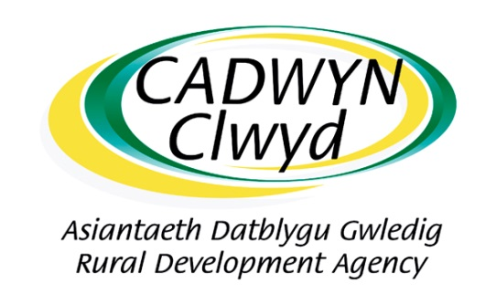 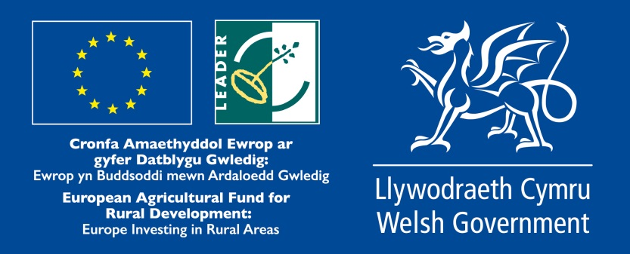

These are the Cadwyn Clwyd logo and the European Agricultural Fund for Rural Development- LEADER-Welsh Government (EAFRD/LEADER/WG) logo.

The EAFRD/LEADER/WG logo comprises five elements as follows:

1. Emblem of the European Union in accordance with the graphics standards set out in Annex III of Commission Implementation Regulation (EU) No 808/2014.
2. A reference to the support from the European Agricultural Fund for Rural Development (EAFRD).
3. The LEADER logo
4. The statement “Europe investing in Rural Areas”; and
5. The Welsh Government logo.

The logos should be placed together in a line, with EAFRD/LEADER/WG logo on the furthest right of the line. If there are additional logos, they should not appear to the right of the EAFRD/LEADER/WG logo in the line of logos. If there are multiple lines of logos, the additional logos should not appear to the right or above the EAFRD/LEADER/WG logo. All logos should be given equal importance; they should be equal in height, equally spaced and of equitable resolution. No logo can be bigger than the EAFRD/LEADER/WG logo. The logos should be in colour and reproduced on a white background. If there is no alternative to a coloured background, a white border should be placed around the logo; a background of varied colours should be avoided. The logos must be reproduced in a size that allows the smallest text to be read without difficulty.

The logos can be attained in an electronic format from your Cadwyn Clwyd Project Officer.

Press Releases

It is a requirement that Cadwyn Clwyd be informed of public relations initiatives relating to projects supported by Cadwyn Clwyd, and that we must sign off any prepared press releases before circulation. In particular, we ask for an acknowledgment to be included, worded something like the below:

***English***

*This project has received funding through the Welsh Government Rural Communities - Rural Development Programme 2014-2020, which is funded by the European Agricultural Fund for Rural Development and the Welsh Government.*

***Welsh***

*Cyllidwyd y prosiect hwn drwy Cymunedau Gwledig Llywodraeth Cymru - Rhaglen Datblygu Gwledig Cymru 2014-2020, a ariennir gan Lywodraeth Cymru a’r Gronfa Amaethyddol Ewrop ar gyfer Datblygu Gwledig.*

It is recommended that engagements with the press are carefully manage by producing a press release (a short written document with your message and detailing all the important facts, normally around one page of A4) before contacting them.  Articles written by reporters from scratch, even with multiple interviews, are often prone to mistakes.  If you prepare a press release you have the opportunity to write down a prepared message and circulate it to all committee members and partners for their comment.  Then you would contact the press, provide them with the press release, and arrange interviews and picture opportunities.  Even at launch events it is common for the invited press to also be provided with a prepared press release.

Any press release, communication text or materials that contain logos should have Welsh Government approval prior to being disseminated. Please ensure that documents are sent to the relevant Project Officer within Cadwyn Clwyd so that he/she can attain Welsh Government approval of publicity material. Projects should factor in sufficient time for this process, which can take up to a week.

Your website

Project sponsors’ websites should clearly acknowledge the EU funding awarded by displaying the logo (and LEADER logo where relevant), as a minimum requirement, on the home page and also a link to the European Commission’s website relating to the European Agricultural Fund for Rural Development (EAFRD) –

<http://eur-lex.europa.eu/browse/summaries.html>. If there are other logos on the page then each logo should be given equal prominence.

Social Media

We expect your website and social media home pages to acknowledge the EAFRD and Welsh Government funding in the form of logos and wording. Inclusion of logos and wording in each post is not expected.

1. **Monitoring and Evaluation**

The Welsh Government requires a monitoring and evaluation (M&E) process be in place for all projects. Cadwyn Clwyd will commission an independent consultancy to undertake the monitoring and evaluation for all LEADER projects that have followed the Cadwyn Direct Project Expenditure method of financial support. In order to fund and match this expenditure, ‘Monitoring and Evaluation’ will need to be present in the cost section of all project applications. The monitoring and evaluation cost should be 1% of the total project cost. For example, if the total project cost were £10,000, the cost for M&E as part of this figure would be £100.

For LEADER funding awarded as a Grant, the applicant will need to specify how they will undertake the monitoring and evaluation of the project. Applicants can include costs for undertaking monitoring and evaluation of their project in the finance table of the application form. Applicants will be required to provide evidence that monitoring and evaluation of their project been undertaken when submitting claims.

1. **Performance Indicators and Evidence of Project Activity**

The applicant is required to assist Cadwyn Clwyd Project Officers in recording evidence of project activity and ensure all audit evidence pertaining to project Performance Indicators is collected. The Performance Indicators to be achieved should be identified at application stage. Project Officers will provide guidance on the Performance Indicators and audit evidence requirements.

|  |  |
| --- | --- |
| **No.** | **Performance indicator** |
| LD-CL.001 | **Number of Feasibility Studies completed** |
| LD-CL.002 | **Number of Networks established** |
| LD-CL.004 | **Number of Pilot activities undertaken (new approaches/new products/new processes/new services)** |
| LD-CL.005 | **Number of Community Hubs** |
| LD-CL.006 | **Number of Information dissemination actions/promotional and/or marketing activities undertaken** |
| LD-CL.007 | **Number of Stakeholders engaged** |
| LD-CL.008 | **Number of Participants supported** |



1. **Cadwyn Clwyd Privacy Statement**

Cadwyn Clwyd treats data privacy very seriously and complies with all aspects of the UK's data protection legislative framework, which includes the European General Data Protection Regulation (GDPR) and the UK's own legislation.  You can view our privacy policy here <http://cadwynclwyd.co.uk/wp-content/uploads/Cadwyn-Clwyd-Privacy-Policy.pdf> which explains how we safeguard your personal rights.