LOOP HEAD LEARNING JOURNEY: STAY, EAT, DO
Tuesday 1st May – Thursday 3rd May 2018

Learning Journey Report

BACKGROUND TO VISIT

As part of the feasibility study for the Stay, Eat and Do project the consultants identified Loop Head as being a destination that has already implemented itineraries for visitors and undertaken work to get businesses to work together. Their offer is similar to what our project is aiming to achieve.

The visiting group that had members from the Clwydian Range Tourism Group’s board most of whom run tourism related businesses along with one board member who is a photographer and film maker. We also had representation from the Clwydian Range Food Trail and a tourism development officer from each of our local authorities – DCC, FCC and Wrexham.

The purpose of the visit was to meet Tourism Businesses in the Loop Head Peninsular to aid the progress and success of the Stay Eat & Do project.

The Learning Journey also offered a great networking opportunity for the CRTG Board members, food trail members and local authority tourism departments to assist in understanding each other’s work and how all parties can work together to overcome challenges that tourism brings to the businesses & local area.

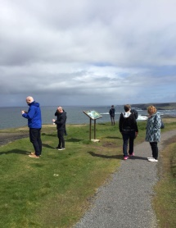
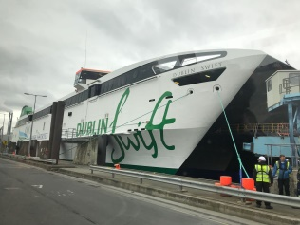
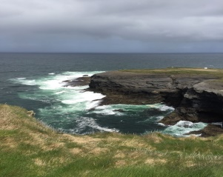

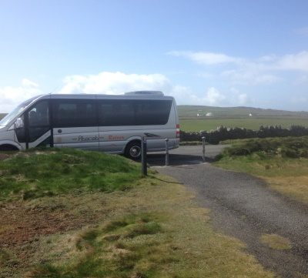

Programme of the Visit

Day | Arr Time | Depart Time | Event | Contact
Tues 1st May | 17.30 |  | Arrive Kilkee | John Hickie
 | 19.30 |  | Dinner at Bayview | Margaret Haugh  Mags Cotter
Weds 2nd May | 08.00 |  | Cliff Walk | Self-Guided
 | 09.30 | 10.30 | DolphinWatch  www.dolphinwatch.ie | Sue McGee
 | 10.45 | 11.45 | Purecamping  www.purecamping.ie | Trea Heapes
 | 12.00 | 13.10 | Lunch Diamond Rocks Café www.diamondrockscafe.com | Margaret Haugh
 | 13.30 | 14.15 | Thalassotheraphy Centre | Eileen Mulcahy
 | 14.45 | 15.50 | Loop Head Lighthouse www.loophead.ie | Kathy Lordan
 | 16.00 | 17.15 | Kilbaha Gallery www.kilbahagallery.com | Ailish Connolly  Liz Greehy
 | 18.00 |  | Return Kilkee
 | 20.00 |  | Dinner Long Doc www.thelongdock.com | Tony Lynch, Cillian Murphy, Ian
Thur 3rd May | 9.00 |  | Depart

Loophead Tourism Association

Have 40 paid up members (an estimated 90% of businesses in the area). At peak had 44.

Formed in 2010. Group is made up of mainly activity providers.

Began developing itineraries in 2012 following funding for Animator.

Charge 240 Euros per year (paid before Dec, 260 Euros after)

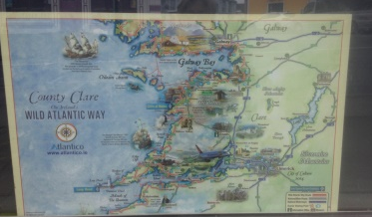
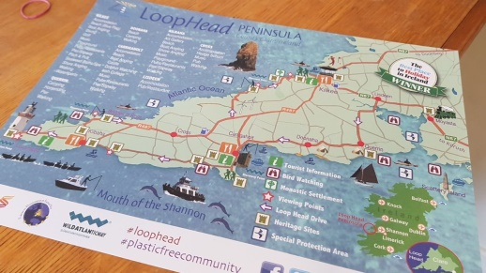
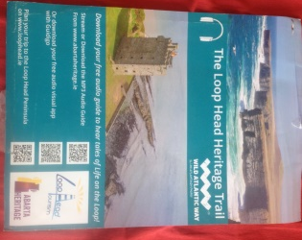
No real issues re membership payment/renewal

Members perceive good benefits, including:

- Website
- Map held by all businesses

- Tear off pads of maps
- Great design – consistent with other Loop Head promotional materials
- 2 Version of Map:

- Used locally with map on one side and business details on
reverse
- Used further afield e.g. car hire at airport: map on one side, info about area on the reverse

Someone is paid to distribute the maps.

- WhatsApp groups for communication & referral
- Attendance at Berlin Tourism Fair
- Group acts as strong voice with Local Authorities and other partners on tourism matters
- Management committee made up of 3 reps from each of 4 geographic areas
- Twice yearly network meetings
- There are sub groups for:

  - Heritage
  - Food
  - Conservation
  - Transport

- Won EDEN European Destination of Excellence – this was game changer for group. LA and Irish tourism took note and wanted to work with them.
- Familiarisation visits to each other’s businesses
- Have ‘WhatsApp’ Group for Board, sub groups, full memberships, and accommodation providers. Use extensively for member communication:

  - Advising of accommodation availability
  - Finding accommodation for visitors if full
  - Passing on referrals
  - Advising of Dolphin watch trip times
  - Advising of events in the area e.g. gigs/visiting fayre
As a group are anti coach tours – ‘tea & pee’. Recognised as low spending and placing short term, heavy demands on businesses. Have agreement with local authority about not accepting coach tours on narrow picturesque coach road and remote light house. Looking at introducing electric buses on the peninsular.

The Wild Atlantic Way has had a big impact on tourism to Loop Head. Work with communities to help people not involved with tourism to understand the local community benefits e.g. keeping pubs, shops etc. open for local community benefit. Local ‘clean up’ initiatives that both community & tourism businesses are involved with.

Report of the visits

Dolphin Watch, Carrigaholt

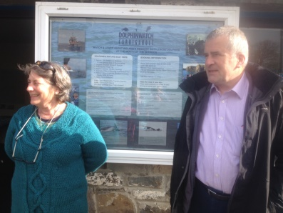

They perceive the map, website and the group’s social media use to be of paramount importance.

The group’s marketing materials, (maps, posters) have a consistent look including colours and distinctive font. A3 full colour posters produced by the group include:

- Loop Head Festivals
- Loop the Loop Craft Trail
- Guided Walks on Loop Head

Tear off maps and posters were prominently displayed.
The business was in agreement about not having coach tours because of low spend and impact on small villages.

A temporary sign for the Wild Atlantic Way that is put out every morning by the owner to promote route.

Cross promotion in the group is very strong and is found to be beneficial. Dolphin Watch emails the group with daily schedule as it is so weather dependent.
There is a plan to have hop-on, hop-off electric buses around the Loop to spread people around and reduce traffic.

Recent initiative is plastic-free community and all businesses are embracing this.
- Shops doing free refills of water (branded sticker on shop/café windows)
- Discount if using your own coffee mug
- Aiming to have all take-away packaging compostable

Diamond Rocks Café

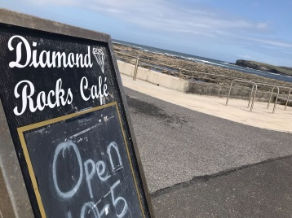
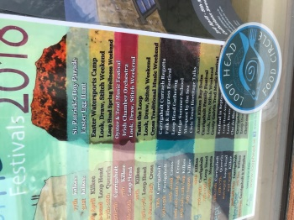

Converted 10 years ago. Cliff top location with natural bathing pools. High quality food.

During the week customers are 80% tourists and at weekends more locals and people from nearby cities e.g. Limerick. Local activities and events posters prominently displayed.

Loop Head Food Circle badge also displayed.

Pure Camping

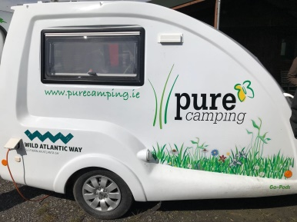
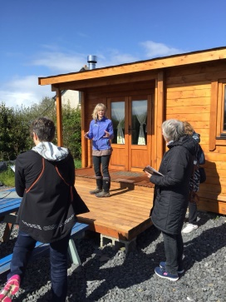

Like most of the other businesses we visited it seemed to be more important to Trea to provide a good experience to the visitor rather than making lots and lots of money. They just want to live in the area they love and be part of the community they grew up in.

Pure Camping is run from a 24 acre farm, 10 acres of which is woodland. There are hill forts, an orchard and a labyrinth on the site. It is run by a husband and wife team – Kevin and Trea who in a former life were engineer and IT professionals.

They started a yoga camp wanting to give people attending an experience connecting with the earth. They have received Leader funding -50% to help with development costs.
They now run Dawn camp outs, Women and girls weekends and Yoga weekends. They celebrate all the Celtic festivals.

There are four wooden cabins (no kitchens – too much work cleaning) holding up to 6 people and 4 permanent tents that hold up to 4 people each.

Old farm buildings have been tastefully and ecologically converted into a yoga centre, shower block (with solar hot water units) and communal kitchen with eating area. There is a pizza oven – Daily in the high season Trea makes the dough for the pizza bases, the guests provide their own toppings and Kevin does the cooking.

Rain water is collected to service the toilets and showers. Their land is managed with biodiversity in mind and do not use any chemicals to control weeds.

Guests are encouraged to interact and feed the animals – donkeys and hens. Trea also runs yoga classes for local people.

Kevin and Trea aim to give their guests a relaxing experience with little impact on the environment.

Thalassotheraphy Centre
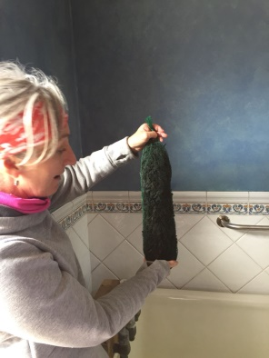
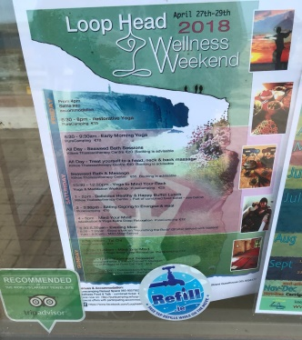

This is a business that has 2 offers – the seaweed therapies and accommodation on a B&B basis.

A warm welcome as with everywhere we went.

Emphasis on collective working since joining the group.

History of coming to the sea for relaxation and re-cooperation

Researched other spa offers prior to setting up their business to ensure that their offer was unique.

Being sustainable is very important throughout the peninsular and the centre does this by;

The seaweed is harvested in the bay – Aug/Sep are the best months for this

It can be dried and rehydrated for use at a later time

The seawater is also pumped from the bay

After treatment the seaweed is then used for fertiliser in the garden

As well as the baths the centre offer other treatments that use dried seaweed. This is sourced from Thalgo which is a brand leader and therefore ensures a good standard for visitors. Staff all receive training to aid this.

The centre has a very flexible approach to running the business. Guests can just use B&B facilities/just have treatments or make up a stay & treatment package.

Recently held a wellness weekend – advertising posters use the Loop Head branding and have a consistent theme with other posters promoting other events. They had run this previously in September when attendance was higher. Thought put into when events are timed depending on who your market is. In this instance, in September children were back at school and settled in, thus allowing ‘mums’ to escape & relax. Note poster with water refill badge.

Strong emphasis on ensuring visitors are aware of what else is on offer in the area thus encouraging longer stays.

The group have a very short season so are looking at ways of extending this. Their ideas include Dark skies and storm watching

The business welcomes local residents as well as tourists.

They employ staff, but this is seasonal with more work offered in the summer months.

When guests receive a confirmation of their bookings they receive details of all Loop Head has to offer

Loop Head Light House
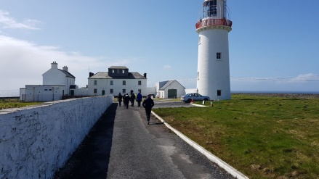

Loop Head Lighthouse was the only place we visited which is not a business. It is a working lighthouse operated by the Commissioners of Irish Lights for the protection of mariners around the coast. There has also been involvement from the local council which led to car parking being provided and the lighthouse being opened to the public some seven years ago. Guided tours of the lighthouse are offered for 5 euros per person which tell the history of the lighthouse and allow visitors to climb up to the light and the outside balcony with views south to the Blasket Islands and north to Connemara. From the area around the lighthouse it is often possible to see whales, dolphins and basking sharks.

The lighthouse’s position at the end of the peninsula makes it both an iconic image of the area and an obvious destination point in following the circular drive around the peninsula which is shown on the map. Its image is also the logo for Loop Head tourism and features on marketing material and posters of events in the area.

The site also includes a house operated by the Irish Landmark Trust as a getaway holiday destination and further buildings which include an interactive display about the history of the lighthouse housed in the Light keeper’s Cottage. While there appears to be the potential for some further development such as a small shop or a cafe there are some difficulties with water supply which make this not straightforward. In addition it was a positive choice when the lighthouse was opened to avoid providing further facilities. The Kilbaha Gallery with its cafe is on the route to and from the lighthouse and it was intended that businesses such as these should benefit from the footfall associated with visits to the lighthouse.

The importance of the lighthouse to the image and branding of Loop Head is huge because it is instantly recognisable, although it is the businesses and their ethos of networking, sharing and sustainability which have transformed the potential of the area and the quality of the visitor experience.

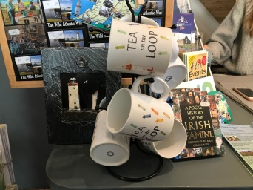
Kilbaha Gallery
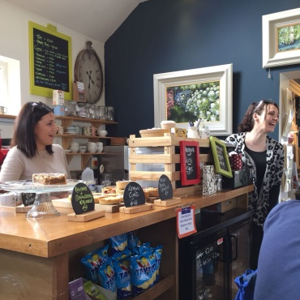
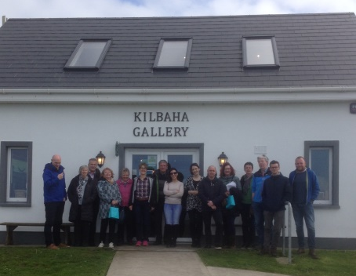

First impressions were excellent. This tiny, neat gallery turned out to be long and spacious and beautifully lit. At first glance the products in the shop were botanical, hand-made, organic, natural, palm oil-free with minimal plastic and packaging.

We were led through to the small café with high ceilings, a wood burner and lots of quality artwork.
Aishling and Elizabeth spoke enthusiastically and animatedly about their family business and the importance of the Loop Head Tourism Group to the success. Benefits they talked about were;

- Buying strength. 55 companies on Loop Head have signed up to the plastic-free community scheme. When they realised how much more expensive the compostable coffee cups were they all got together to be able to buy bigger quantities at better price.
- Network of people who understand and know. They use the network regularly to ask for advice and support because other small business owners understand and can often help. Anything from the mundane to the more complex they have found solutions through the group. They also all feel a responsibility to the land, they have and will fight against development on the cliffs.
- Sets a standard. Both a quality standard and a responsible standard. Those that join do so because they share the same ethos. This confidence in each other’s offer makes it easy for them to recommend each other, encouraging longer or repeat stays and more local spend.
- They see themselves and every visitor as an ambassador for the area so if any rare bad experiences happen they rally around to ensure it’s dealt with and that those people have an amazing time.
- They all pride themselves on their local knowledge and local produce.
- Lobbying/ one voice. When a coach company wanted to start bringing big coaches in they were in a position to negotiate with the council to say no. The coaches stop at the gateway towns and if people want to venture into the peninsula they find another way. Why? The infrastructure is not set up for coaches and their spend is minimal and they don’t want to compromise people’s experiences with overcrowding or add to erosion issues. They have a bid in for electric buses.

They had a lovely and refreshing attitude to sustainable tourism saying, “it’s not just the eye-rolling, green, eco thing - it means we can live here, breathe the air – sustain our families and communities and the next generation”. They also prefer the types of visitors that share their ethos. They love walkers and cyclists, those that love the landscape and the ‘crack’. (They have a basket of useful toiletries in the toilets targeted at those favourite visitors which includes chaffing cream!).

They talked about their individual passions that can filter through to their business. Between them they have researched history of local buildings, taken some oral histories from ageing local people, lead the tidy town’s initiative and beach cleans and work towards creating an authentic and local experience for every visitor.

They spoke very highly of Trea’s animator role at the beginning of the Loop Head tourism revolution. They talked of her being a leader and an inspiration. They added that the familiarisation trips were wonderful as they say you must ‘experience it to sell it.’

Of the Management Group they suggest;

- All areas need an equal representation
- Focus groups for specialisms essential; food circle, tidy towns, beach cleans, arts, history, etc.
- Always rifts and politics but must retain the overall positivity.
- Be open to feedback
- Be prepared for creative ‘Bundling’; jam making weekend, wellbeing weekend, etc.
- Identify each other’s strengths. Pick those that are best at certain things and share that skill or knowledge.
- Have a sharing mentality, no competition.
- Support the arts. Promote and support local artists and photographers, they are allies and have great gifts and should feel like members without the charge! They are the ‘jewel in the crown’

Concluding Comments

There was huge consistency in the comments and messages coming from all the business owners we visited. We were struck by how close their connections were (possibly helped by the family connections!) and how much they shared a vision of what they were trying to do. We have in lots of ways more to offer as a destination, or certainly as much, but we don’t yet have that shared sense of ourselves as a destination to the same degree.

We were very struck by the importance of the animator role which Trea had played and I think it would transform what we do to have someone focused on inspiring and bringing the thing together for whom it is a paid role. They all recognised that they all had businesses to run and the developmental work needed professional paid input. From them this input has been a real game changer.

Membership is a lot more but there appears to be a collective recognition of the value and a wider range of members who are willing to be involved.

ACTION IDEAS

Throughout the visit, ideas, thoughts and suggestions were collected. This list was then used as the basis for the follow up workshop. All ideas were considered and were categorised into the 4 groups below. At this stage no prioritisation has taken place but those identified for the Stay, Eat Do project will be prioritised and incorporated into the project brief

Quick Hits

- WhatsApp Group/s
- Annual membership map/s (in partnership with AONB)
- Castle March, Hillfort March

CRTG medium to long term development

- More arty, natural, unique materials for membership plaques
- Set up CRTG Instagram, populate with images of local produce, trips and User Generated content by creating a hashtag e.g. #clwydianrange #eatstaydo
- Create a catchy slogan (e.g. prepare to be blown away) for group (AONB toolkit)
- Branding logo to be reviewed. Have a common member badge/signage that members could use as per Loop Head.
- Can we apply for awards?? Winning the EDEN award was a catalyst for Loop Head.
Use map to define boundary

Stay, Eat Do Implementation

- Stay, Eat Do Blog
- Themed events programmes eg Well Being, Music,
- Things to do in the Clwydian Range posters in pubs and cafes

- Stock take of all accommodation, activities and food houses in area, to identify what we have and more importantly what we haven’t got. . Richard Jones indicated that he believed that such a stocktake had taken place for Flintshire in readiness for launching Destination Management. Ask Richard and the other local authority reps to investigate this so that the information can be brought together as a starting point for such a stock take.

- Create activity packages alongside accommodation : Stay, Eat Do project
- Familiarisation visits – if you’ve been yourself it’s much easier to engage with a visitor
- Offas Dyke and Wales Coast Path...drivers or USPs which should be used like the Wild Atlantic Way to draw visitors.
- A days March between castles...idea from Ian which may help to draw walkers with challenge style routes.
- 'Stay' 'Eat' 'Do' focused social media?
- Clwydian Range blog - Stay Eat Do posts once a week? Have we got resources to for this?
- Berlin...international tourism expo got good results.
- Food and CRTG integration...need to work together more. Focus on dishes and products with social media accounts.
- New members and new board members needed.
- The right type of tourism....slow, sustainable Visit for 1/2 days. No coach parties.

Potential Partner Action

- Tin Mug with carabiner like Loop Head Mug – great design and big on social media – mug unusual/exotic places.
- Clean ups – e.g. litter on Moel Famau at New Year (LAs, AONB, Keep Wales Tidy)
- Plastic free – Assoc has negotiated all business deal with supplier of compostable cups which individual businesses can then make own purchases at discounted prices (CRFD, GGC, AONB)
- Look to encourage all business’s to offer ‘free fill’ of tap water – sticker to advertise
- Communication to businesses to ensure everyone is informed and delivering the same standard/level of information to visitors – visitor then gets Impression of a ‘joined up’ network of places that they are welcome & everyone wants them to get the best experience from their visit
- Review structure/reporting lines of all of local tourism groups
- ‘Giddy go’ audio app no marketing required good app.
- Solar charging stations at key points on the Range.

