LLANDRILLO oLD SCHOOL

Feasibility Study

Final Report

March 2019

Version control
Version | Date | Author | Checker | Approver | Comment
001 | 20.03.19 | Alec Shand | Alison Powell | Alison Powell | Draft Final Report
002 | 29.03.19 | Alec Shand | Alison Powell | Alison Powell | Final Report

This report dated 20 March 2019 has been prepared for Cadwyn Clwyd (the “Client”) in accordance with the terms and conditions of appointment dated 19 November 2018(the “Appointment”) between the Client and (“Arcadis”) for the purposes specified in the Appointment. For avoidance of doubt, no other person(s) may use or rely upon this report or its contents, and Arcadis accepts no responsibility for any such use or reliance thereon by any other third party.

Contents

1 Introduction 1
1.1 Aims of the Study 1
1.2 Llandrillo Old School 1
1.3 Community Involvement to Date 4
1.4 Report Structure 4
2 Policy Context 5
2.2 National Legislation, Policy and Programmes 5
2.3 Local Policy and Strategies 6
3 Characteristics of the Local Area 9
3.1 Introduction 9
3.2 Population 9
3.3 Local Economy and Employment 9
3.4 Tourism 12
3.5 Welsh Index of Multiple Deprivation 13
3.6 Local Services and Facilities 14
4 Consultation 16
5 Potential Uses and Opportunities for the Old School 17
5.1 Introduction 17
5.2 Community Café 17
5.3 Multi-functional Space 19
5.4 Workshop Space / Men’s Sheds 20
5.5 Employment Uses 20
5.6 Sale of Local Produce / Crafts 21
5.7 Bunkhouse Accommodation 21
5.8 Child Daycare / Nursery Provision 22
5.9 Soft Play 23
5.10 Tourist Information Centre 23
5.11 Sports Changing Facility 23
5.12 External Areas 24
5.13 Evaluation of Potential Uses 25
6 Development of Options 28
6.1 Introduction 28
6.2 Option 1 – Café and Community Sports Uses 28
6.3 Option 2 – Bunkhouse and Outdoor Activity 28
6.4 Other Options 29
6.5 Public Consultation on Options 32
6.6 Preferred Option 33
7 Outline Business Plan 34
7.1 Introduction 34
7.2 Capital Costs 34
7.3 Revenue Costs and Income 35
7.4 Funding Opportunities 38
7.5 Support Organisations and Opportunities 40
8 Management Arrangements 41
8.1 Introduction 41
8.2 Community Asset Transfer (CAT) 41
8.3 Management 41
8.4 Case Studies 42
9 Next Steps 45
Appendix A 46
Public Consultation Event Summary – March 2018 47
Appendix B 48
List of Consultees 49

- Introduction
  - Aims of the Study
    - Arcadis Consulting (UK) Ltd was commissioned by Cadwyn Clwyd, Grwp Cynefin and the Llandrillo Old School Regeneration Steering Group (the Steering Group) to prepare a feasibility study for the former Llandrillo School. The school was closed by Denbighshire County Council (DCC) in 2014 following a review of primary school provision across the wider Dee Valley. This was a devastating blow to the small community of Llandrillo, as the school had not only provided an education facility for generations of local children but also provided a valuable community resource and opportunities for social interaction.
    - Following the closure of the school, meetings with DCC’s Asset Management team have indicated that the local authority would be willing to pass the school building and grounds to Llandrillo Community Council via the Community Asset Transfer (CAT) process, subject to receipt of a viable and sustainable business plan for the re-use of the site. The Llandrillo Old School Regeneration Steering Group was established in order to progress feasibility work and take the project forward.
    - The purpose of the study as stated in the brief is to “to complete a feasibility study that provides a viable and sustainable business plan for the existing Llandrillo Old School site for wider community- based activities”. Stated objectives include to:
- investigate and assess the various options for the potential utilisation of the old school site in terms of the viability, sustainability and economic / social impact on the community;
- assess the ‘pros and cons’ of each option including projected financial costs in terms of capital investment and revenue costs;
- make independent recommendations for the future use of the old school site and provide a business case / plan that would satisfy the requirements of potential grant application(s) to national funding bodies;
- identify and review other similar projects to inform future decisions; and
- assess other options and possibilities for use of the old school building to deliver the aims of the project.
  - Llandrillo Old School
    - Llandrillo is a small village found in the Edeirnion area of Denbighshire almost equidistant between the settlements of Corwen and Bala. The village has a population of around 580 people, and a small range of local services and facilities including St Trillo’s Parish Church, Y Ganolfan, an independent shop and post office, bowling club and sports field, a public toilet block operated and maintained by the independent community group Llandrillo Public Conveniences Access Group, a local pub and two local restaurants (one of which, Tyddyn Llan, has a Michelin star).
    - Llandrillo Old School itself is found in the centre of the village on the eastern side of the village green known as ‘Y Wern’ (see Figure 1 overleaf). The school itself is immediately adjacent to several of the facilities mentioned above, notably the public toilets, community sports field, bowls green, children’s playground and car parking area. Vehicular access to the school is via the B4401, with pedestrian access provided from the high Street via the footbridge (constructed in 1993) over the River Ceidiog offering a safer route to access the school. The car park is a popular location for people to commence their walk in the surrounding Berwyn mountain range or to stop and have a picnic by the river.

Llandrillo Old School was built around 1850. The main wing of the school is constructed of stone walls with rendered elevations under a pitched slate roof, whilst the extension of 1970 is of cavity brick walks with rendered elevations under a flat felted roof. The school itself, adjoining playground and grassed areas is set within approximately 0.2ha.

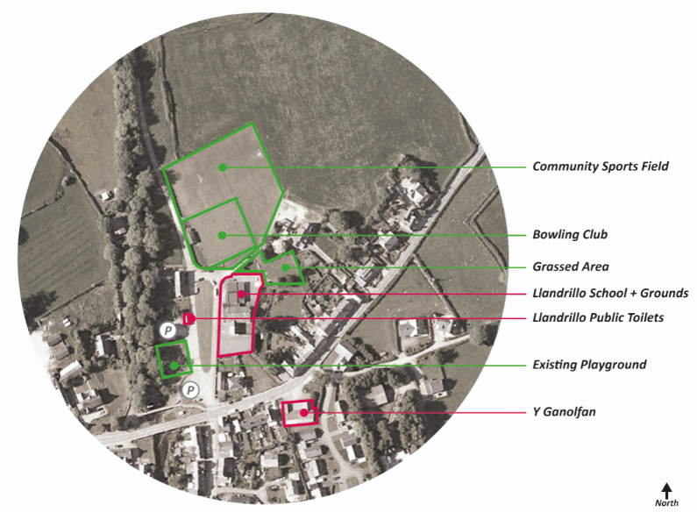
Figure 1 – Context Plan
    - A floorplan of the school building is provided in Figure 2. The main accommodation comprises of the following areas (all measurements are approximate):
- Main Reception Area / Hallway – ground floor entrance leading to covered balcony and steps;
- Main Hall – 13.02m x 9.18m with folding room dividers; two hot and cold stainless-steel sink units; 10 radiators; part block paving; serving hatch to the kitchen;
- Former Headmaster’s Room – 4.28m x 2.97m with one radiator and wash hand basin;
- Two Store Rooms – both with fitted shelving
- Staff Toilet – with WC and wash hand basin, store cupboard;
- Kitchen – 5.22m x 4.82m with three stainless steel sink units and base cupboards; partly tiled walls; mounted hot water tank; quarry tiled floor; two larder cupboards; independent WC with wash hand basin and door out to rear;
- Classroom One – 6.34m x 5.75m with three radiators, fitted shelving and store room;
- Classroom Two – 6.35m x 5.78m with three radiators, fitted shelving and store room;
- Male and female toilets; and
- Outside – boiler house housing the oil-fired boiler and storage tank. Grassed and paved playground areas are on three sides of the school building.

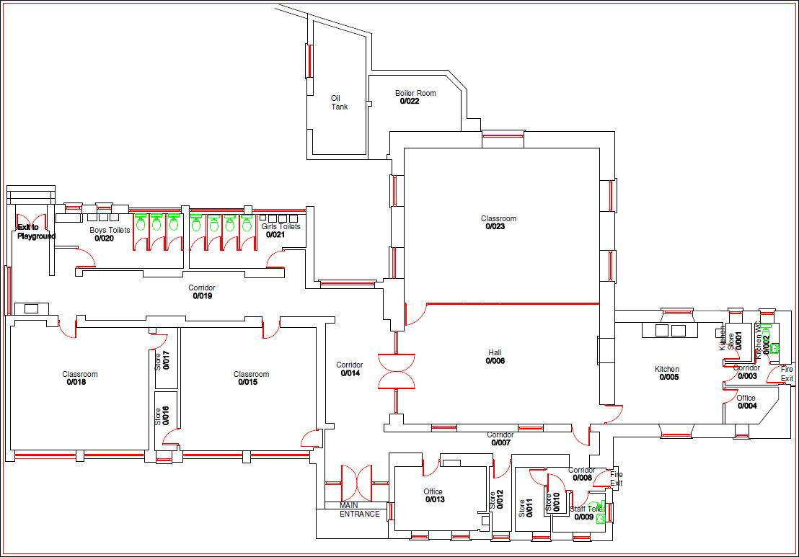
Figure 2 - Building Layout Plan
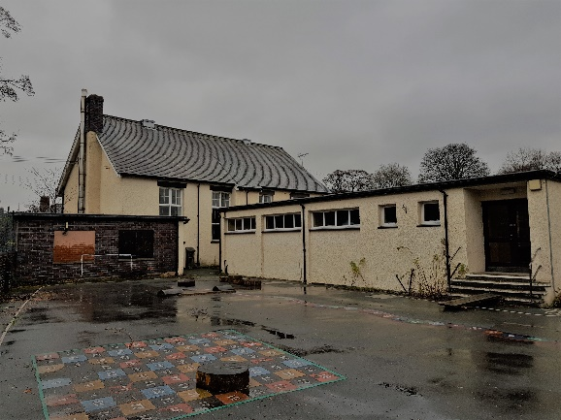
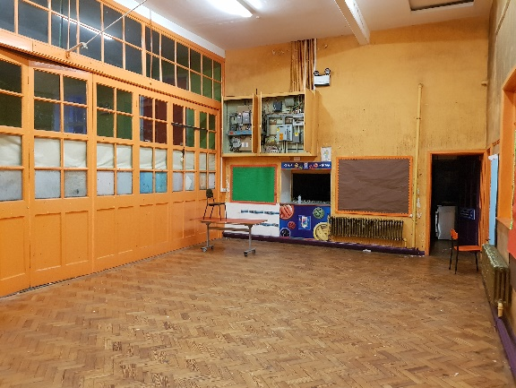
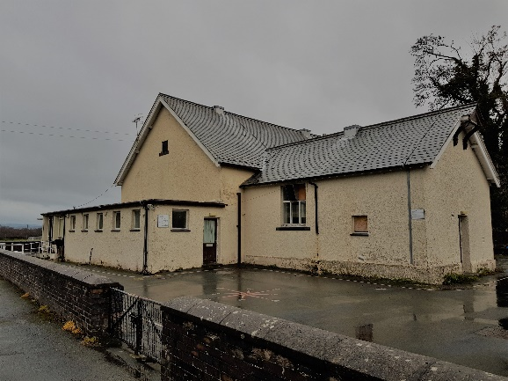
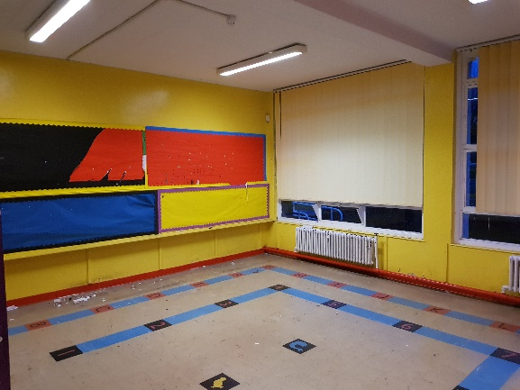
Images - Main Hall, Classroom and external elevations

  - Community Involvement to Date
    - The Steering Group has worked hard to ensure that the wider Llandrillo community has been aware of intentions to reuse the school for community benefit, with various activities taking place during 2018 to help identify potential uses. Public meetings, community events and newsletters have brought members of the community together to help identify the strengths and drawbacks of life in Llandrillo, what services or facilities are missing and what the priorities for the future of the village should be. A summary of some of these early consultations, including what local residents felt are the positives and negatives of living in Llandrillo, can be found at Appendix A. The community involvement has clearly demonstrated the desire locally to see the school building and site being retained for community use, with local residents offering personal services and support to help contribute to the success of the project. Presentations have been given to the community by owners and managers of similar facilities elsewhere to help with inspiration and realise what can be achieved.
    - The community consultation identified a wide range of potential uses for the school, which have formed the starting point for this Feasibility Study. Further consultation has been undertaken during the course of the study with representatives of local groups and societies along with key stakeholders (such as DCC) in order to develop ideas further. A public meeting for local residents was held in March 2019 at which details of options for utilising the building were presented for comment. Details of organisations and stakeholders consulted can be found at Appendix B.
  - Report Structure
    - This Draft Report sets out the findings of the Feasibility Study and is structured as follows:

Section 2 outlines national and local legislation, policy and strategies of relevance to potential future development of the former school in Llandrillo.

Section 3 provides context to the project in terms of local demographic and economic characteristics, drivers of the local economy and an understanding of local services and facilities.

Section 4 identifies the ‘long-list’ of potential uses and opportunities for the former Llandrillo school and wider site, including the strengths and weaknesses associated with individual uses, summarised in an evaluation matrix.

Section 5 presents potential options for the former school building and site, summarises the feedback on options that were received from public consultation and presents confirms the Preferred Option.

Section 6 sets out a three-year business plan for the Preferred Option, including capital costings, revenue costs and potential income and funding opportunities.

Section 7 describes possible management arrangements for the project, including the use of case studies to identify lessons learnt and good practice from examples of Community Asset Transfer (CAT) and community-run projects elsewhere in Wales.

Section 8 suggests a series of next steps for the project.

- Policy Context
    - This chapter sets out the national and local policy context for the project, taking into account relevant economic and planning policy documents and strategies.
  - National Legislation, Policy and Programmes
    - Of relevance at the Wales-wide level are the Wellbeing of Future Generations (Wales) Act (2015) (WFG Act), Planning Policy Wales (PPW), the emerging National Development Framework (NDF) and strategies relating to the national economy.

Well-being of Future Generations (Wales) Act (2015)
    - The WFG Act (2015) aims to improve the social, economic, environmental and cultural well-being of Wales, with a vision of Wales in 2050 being ‘the best place to live, learn, work and do business’. The seven well-being goals are illustrated in Figure 3 below. Public bodies must work to improve the economic, social, environmental and cultural well-being of Wales and make sure that when they make decisions, they think how it will affect people living in Wales in the future.

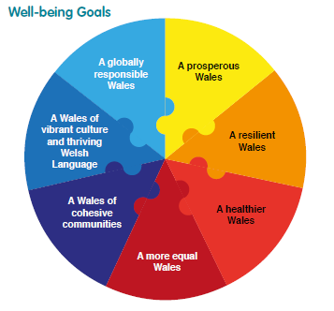
Figure 3 WFG Act Wellbeing Goals (Source: Welsh Government May 2015)

Planning Policy Wales (2018)
    - PPW sets out the land use planning policies of the Welsh Government. The primary objective of PPW is to ensure that the planning system contributes towards the delivery of sustainable development and helps improve the social, economic, environmental and cultural well-being of Wales.
    - Of relevance to Llandrillo is the section relating to Active and Social Places which states these are places that ‘promote our social, economic, environmental and cultural well-being by providing well-connected cohesive communities. Places which are active and social contribute to the seven goals of the Well-being of the Future Generations Act’ as outlined above. PPW makes emphasis on the promotion of accessible development which comprises appropriate combinations of housing, employment, retailing, community, cultural and recreation opportunities in order to foster community cohesion.

Technical Advice Note 15: Development and Flood Risk
    - The former school building is located in an area of flood risk. Technical Advice Note (TAN) 15 ‘Development and Flood Risk’ (Welsh Government July 2004) provides guidance on development and associated flood risk and sets out a precautionary framework to guide planning decisions. The TAN 15 is accompanied by Development Advice Maps (DAMs) which provide up-to-date information on flood risk in Wales to assist with determination of planning applications. The DAMs were updated in January 2015; updated information includes changes to the flood zones including where designations have been extended or contracted based on new modelling information.
    - The former school and grounds are located within areas of C2 flood risk. Zone C2 is used to describe areas of the floodplain without significant flood defence infrastructure and to indicate that only less vulnerable development should be considered subject to application of a justification test. Highly vulnerable development includes all residential premises (including hotels and caravan parks) and public buildings such as school and leisure centres.
    - A review of TAN 15 was undertaken in 2017 by JBA Consulting on behalf of Welsh Government. The review identified how, although guidance presented in TAN 15 is generally well respected, issues were identified in terms of flood zones not always being based on robust evidence. Recommendations included that TAN 15 should move to a fully risk based approach and the precautionary framework should be discontinued, coupled with further review of the DAMs.

Emerging National Development Framework
    - The NDF will be a 20-year national plan for Wales covering the period 2020 – 2040, replacing the Wales Spatial Plan (2008). Consultation on the NDF took place in 2018 and the framework is due to be published in September 2020. The vision of the NDF is to ‘…help deliver sustainable places across Wales by 2040, by supporting positive placemaking and ensuring that our spatial choices direct development to the right places, make the best use of resources, create and sustain accessible, healthy communities, protect our environment and support prosperity for all’.

Prosperity for All: The National Strategy – Taking Wales Forward (2017)
    - The aims of Prosperity for All relate to quality of life and living in strong, safe communities. The strategy aims to deliver quality health and care services, promote good health and well-being and build healthier communities and better environments.

Prosperity for All: Economic Action Plan (2017)
    - The Economic Action Plan aims to create an inclusive economy with well-being at its heart. One of the main goals of the plan is to develop each region of Wales focusing on the distinctive opportunities and challenges presented. The Action Plan describes how support will be delivered according to thematic and foundation sectors, the latter including tourism, retail and food.

Partnership for Growth: Welsh Government Strategy for Tourism 2013 – 2020 (2013)
    - The Partnership for Growth strategy drives the tourism industry across Wales. The strategy has a target of 10% growth in tourism earnings in Wales during the plan period under the goal of growing tourism in a sustainable way. The strategy is built round five pillars, including promoting the brand, product development, people development, profitable performance and place building.
  - Local Policy and Strategies
    - At the local level, relevant documents and strategies include Denbighshire’s Local Development Plan (LDP), the Corwen and Edeyrnion Town and Area Plan as well as local economic and tourism strategies.

Denbighshire Local Development Plan (2013)
    - The LDP was adopted in June 2013 and provides the local planning policy framework for Denbighshire for the period 2006 – 2021. The overarching aim of the LDP is ‘that Denbighshire, through sustainable development, will have a vibrant urban coast, with thriving market towns and rural areas. The housing and employment needs of the County will be met, the high-quality environment protected and an enhanced high quality of life maintained for all communities with full recognition that we have a strong Welsh language and culture that should be maintained and protected throughout the County’.
    - Policies and objectives which are of relevance to the Llandrillo Old School project include:
- Policy BSC 11 – existing recreation, public open space, allotments and amenity greenspace will be protected and where possible enhanced. Development that would result in the loss of public or private land with recreational and / or amenity value will only be permitted where alternative outdoor provision of equivalent or greater community benefit is provided;
- Policy BSC 12 – proposals for the provision of community facilities will be supported providing that they are located within existing development boundaries, or outside of development boundaries, but within settlement clusters and that the proposal will provide an essential facility to support the community;
- Policy PSE4 – all conversions of rural buildings will be expected to make a positive contribution to the landscape. Proposals for the conversion of rural buildings outside development boundaries for employment use will be supported;
- Policy PSE5 – supports tourism and commercial development to sustain the rural economy, subject to proposals meeting detailed criteria including making a significant contribution to sustainable development. This policy has been developed in order to sustain rural employment throughout the County; and
- Policy PSE 14 – supports development proposals that expand or reinforce the tourism offer of the County in the outdoor sectors provided that any development is appropriate to its setting and within the capacity of the local environment and infrastructure.

Corwen & Edeyrnion Town & Area Plan (Denbighshire County Council 2013)
    - DCC invited town and community councils, businesses, community and voluntary sectors of its main towns and smaller outlying communities to come together and develop town plans. The plan for the Corwen and Edeyrnion area was adopted in 2013 and sets out a vision for the area which includes to:
- offer an enviable quality of life which is attractive to residents of all ages
- have the range of community facilities and transport services required to address the town’s relative isolation from larger centres of population
- be the main centre for manufacturing in the south of the country
- offer a brilliant experience for visitors to the area.
    - Key objectives to achieve the vision are of particular relevance to the successful future use of the former school and include:
- improvement in educational attainment
- more and better facilities for community use
- easier access to facilities for the disposal of household waste
- the benefits to the wider area of from the extension of the Llangollen Railway are maximised
- visitors will have a brilliant experience
- supporting communities in finding community enterprise uses for redundant buildings
- encouraging the setting up of new clubs
- developing training and practical support for the community to help them start up or become sustainable cottage industries in sectors such as tourism or outdoor activities
- identifying potential useful sources of funding to help communities develop sustainable initiatives.

Economic and Community Ambition Strategy 2013 - 2023
    - Economic development is one of the seven core corporate priorities of Denbighshire County Council. The Economic and Community Ambition Strategy states that ‘our expectation that local economic growth can lead to improved outcomes for our residents is based on an economic model that links business success with increased opportunities for work, leading to higher levels of income and increased spending power that in turn help to sustain vibrant towns and communities.’ The strategy includes six themes, of which the following are relevant to the Llandrillo Old School project:
- Theme 3 Opportunities for Growth – seeks to build on Denbighshire’s strengths in its tourism and agricultural sectors and encourage them to continue to make strong contributions to Denbighshire’s economy. The theme also encourages and supports growth in the social enterprise sector to deliver alternative and complementary opportunities for services and jobs.
- Theme 4 High Quality Workforce – relates to the need to ensure local residents are well skilled and equipped to benefit from jobs and opportunities that arise and that employment rates across Denbighshire are improved, with a particular focus on youth unemployment.
- Theme 5 Vibrant Towns and Communities – highlights that vibrant and healthy towns and communities are likely to be more attractive places to live with pleasant environments and access to a range of services and facilities therefore delivering a higher quality of life for the people who live there. The theme seeks to address problems of outward migration, particularly of young people, by creating more attractive places to live, thus retaining younger generations.

Denbighshire Destination Management Plan 2017-20
    - The vision for the Destination Management Plan is to ‘develop a thriving visitor economy in Denbighshire which celebrates the unique strengths of the county, supports jobs, generates business opportunities and improves the range and qualities of amenities available for visitors and residents whilst safeguarding the local environment’. An expected outcome of the Destination Management Plan is that tourism businesses in Denbighshire maximise their potential and that visitors have a consistent and high-quality experience.

Sustainable Tourism Strategy and Action Plan 2015-2020
    - Although Llandrillo is not within the Clwydian Range and Dee Valley Area of Outstanding Natural Beauty (AONB), the proximity of the AONB and the focus on encouraging and managing visitors to the area make the Sustainable Tourism Strategy of relevance and interest. The plan covers a five-year period up to 2020 and seeks to pursue forms of tourism that are appropriate to the AONB and which ‘take full account of its current and future economic, social and environmental impacts, addressing the needs of visitors, the industry, the environment and host communities’. The strategy aims to raise awareness of the AONB and all that it has to offer to visitors, as well as encouraging more and longer stays year-round; to develop and enhance the year-round visitor experiences; and to improve, manage and monitor visitor flows and environments for tourism, together with spreading benefits and addressing local impacts.

- Characteristics of the Local Area
  - Introduction
    - This chapter presents an overview of the key characteristics of the local population in terms of age profile and employment, a summary of the main drivers of the local economy and an understanding of the local services and facilities within the Llandrillo area.
  - Population
    - The DCC ward of Llandrillo covers a largely rural area with a population of 1,183 (Mid-Year Population Statistics 2017, Nomis) and is one of the most sparsely populated areas of Denbighshire and indeed Wales. The population density of Llandrillo is 0.1 persons per hectare, compared to 1.1 persons per hectare for Denbighshire and 1.5 for Wales. The village itself has a population of around 580 people.
    - On a wider scale, analysis has shown that within a 10-minute drive-time of Llandrillo there is a population of approximately 3,600; this extends to 9,500 people within a 20-minute drive-time of the village and 16,500 people within a 30-minute drive-time.
    - Figure 4 shows the age structure of Llandrillo ward, confirming that Llandrillo has an older population profile when compared to Denbighshire and Wales as a whole. Analysis of mid-year population estimate data for 2017 reveals that Llandrillo ward has a total of 76 children aged five years and under, 6% of the total population. Analysis of people living in the area aged 65 and over, shows there are 318, 27% of the total population.

Figure 4 Age Profile for Llandrillo ward, Denbighshire and Wales (Source: Census 2011)
  - Local Economy and Employment
    - Economic activity levels for Llandrillo, Denbighshire and Wales (as set out in the 2011 Census) are shown in Table 1. The data shows that Llandrillo has a higher proportion of residents who are economically active when compared to Denbighshire and Wales as a whole and subsequently has a lower proportion of residents who are economically inactive.
    - However, when looking at economically inactive residents in keeping with the fact that Llandrillo has a relatively older population, there are significantly higher proportions of residents who are retired living in Llandrillo when compared to both Denbighshire and Wales as a whole.

Table 1: Economic Activity
 | Llandrillo Ward | Denbighshire | Wales
Economically Active | 72% | 66% | 66%
Employees | 70% | 77% | 79%
Self-employed | 27% | 16% | 14%
Unemployed | 3% | 7% | 7%
Economically Inactive | 28% | 34% | 34%
Retired | 72% | 56% | 50%
Student | 12% | 15% | 19%
Looking after home or family | 7% | 10% | 12%
Long-term sick or disabled | 9% | 18% | 19%

Source: Census data 2011
    - Table 2 shows that a lower proportion of residents living in Llandrillo work in both higher and lower managerial professions when compared to Denbighshire and Wales as a whole. The data also shows that a significantly higher proportion of residents living in Llandrillo are small employers and own account workers ((people in self-employed positions in which people are engaged in any (non-professional) trade, personal service, or semi-routine, routine or other occupation but have no employees other than family workers)).

Table 2: Socio-economic classification
 | Llandrillo Ward | Denbighshire | Wales
Higher managerial, administrative and professional occupations | 8% | 7% | 8%
Lower managerial, administrative and professional occupations | 20% | 21% | 20%
Intermediate occupations | 9% | 11% | 12%
Small employers and own account workers | 20% | 12% | 9%
Lower supervisory and technical occupations | 8% | 8% | 8%
Semi-routine occupations | 17% | 17% | 16%
Routine occupations | 11% | 12% | 13%
Never worked and long-term unemployed | 3% | 5% | 5%
Not classified | 4% | 7% | 9%

Source: Census data 2011
    - Table 3 shows the employment by industry. The table shows that agriculture, forestry & fishing, manufacturing, construction and wholesale & retail trade; repair of motor vehicles & motorcycles are the largest employers in Llandrillo ward, accounting for 46% of employment. The proportion of residents who are employed in these industry sectors is significantly higher than for Denbighshire and Wales as a whole, 33% and 37% respectively. Manufacturing is the largest employer in Llandrillo, accounting for 18%, again significantly higher than Denbighshire and Wales as whole, 9% and 11% respectively.
    - Looking at professional, scientific & technical activities, administrative & support service activities and public administration & defence, compulsory social security, a significantly lower proportion of residents living in Llandrillo work in these industry sectors, when compared to Denbighshire and Wales as a whole, 9%, 15% and 16% respectively.

Table 3: Employment by Industry
 | Llandrillo Ward | Denbighshire | Wales
Agriculture, forestry and fishing | 9% | 2% | 2%
Mining and quarrying | 0% | 0% | 0%
Manufacturing | 18% | 9% | 11%
Electricity, gas, steam and air conditioning supply | 1% | 1% | 1%
Water supply, sewerage, waste management and remediation activities | 1% | 1% | 1%
Construction | 9% | 8% | 8%
Wholesale and retail trade; repair of motor vehicles and motor cycles | 10% | 14% | 16%
Transport and storage | 5% | 4% | 4%
Accommodation and food service activities | 8% | 7% | 6%
Information and communication | 1% | 2% | 2%
Financial and insurance activities | 1% | 2% | 3%
Real estate activities | 1% | 1% | 1%
Professional, scientific and technical activities | 2% | 4% | 4%
Administrative and support service activities | 3% | 4% | 4%
Public administration and defence; compulsory social security | 4% | 7% | 8%
Education | 9% | 10% | 10%

Source: Census data 2011

  - Tourism
    - Visitor data for 2016 has been produced for both Denbighshire and rural Denbighshire area using the STEAM model. Analysis of STEAM data demonstrates the important role that tourism has to play in rural Denbighshire and the potential visitor market within which Llandrillo is located:
- The economic impact of tourism to rural Denbighshire in 2016 was some £208.4mn, divided between sectors as follows: accommodation (14.4%), food and drink (16%), recreation (5%), shopping (19.9%), transport (7.8%) and indirect expenditure (36.9%).
- In terms of employment, tourism was responsible for 2,918 FTE (Full Time Equivalent) jobs. Again, looking at specific sectors, this was divided as follows: accommodation (24.8%), food and drink (24.5%), recreation (6.4%), shopping (21.3%), transport (4.1%) and indirect employment (19%).
- In 2016, the number of staying visitors was 619,000 (a 6% increase on 2015), with the number of day visitors reaching 2.19mn.
- Visitor spend per day can equate to £18 for day visitors and £30 for staying visitors.
- Within rural Denbighshire, there are 2,377 hotel bed-spaces and 10,713 non-services bed-spaces.
    - The wider North Wales region is growing as a destination for activity, adventure and relaxation holidays. Llandrillo is located within twenty miles of a range of significant visitor attractions, as demonstrated in Table 4.

Table 4: Principal Visitor Attractions within a Twenty Mile Radius of Llandrillo
Attraction | Visitor Numbers (2017) | Commentary
Snowdonia National Park | 654,000 | Visits to the Snowdon Summit Visitor Centre.  Snowdon is the second most visited attraction in Wales.
Llangollen Railway | 100,000 | The only standard gauge heritage railway in North Wales. Run by volunteers and operates on part of the former Ruabon – Barmouth Great Western Railway (GWR) route that closed in 1965. Railway recently extended to Corwen.
Pontcysyllte Aqueduct and Canal World Heritage Site | 333,000 | Visitors to the aqueduct itself. The WHS stretches 11 miles to the Horseshoe Falls at Llantysilio, west of Llangollen.
Clwydian Range and Dee Valley AONB | - | The AONB extends from the Prestatyn Hills towards the Berwyn Mountains, has a variety of attractions and facilities and attracts thousands of visitors ever year.
National White-Water Centre | - | Located eleven miles from Llandrillo in Bala, the centre offers a range of rafting activities.
Coed Llandegla | - | Well known across the UK as a location for mountain biking, with trails designed to suit all abilities and fitness levels.

    - Local towns such as Llangollen (fifteen miles from Llandrillo) provide a visitor attraction in their own right.
    - Closer to Llandrillo, there are a number of more local visitor attractions and activities. These include:
- Llandrillo is very popular with walkers, with a number of local and long-distance routes (such as the Tegid Way) offering walks of various distance and difficulty. A number of these routes are publicised on walking / rambling websites and as a result, Llandrillo sees organised groups of walkers (for example local rambling groups) regularly in the village (thank you letters to the Llandrillo Public Convenience Access Group from local rambling groups and other visitors are displayed in the exemplary maintained public toilets in the village).
- Moel Ty Uchaf is a stone circle found to the north-east of Llandrillo (around an hour’s walk away). The circle is a collection of 41 stones with a cist in the centre and an outlying stone to the north-east.
- Tyddyn Llan is a restaurant with rooms with a Michelin star restaurant, situated just five minutes walking distance along the B4401 to the west of Llandrillo. This high-end establishment has a high rating in the Good Food Guide, Good Hotel Guide and TripAdvisor and is well known across north and Mid-Wales.
- Cilan Holiday Park is found towards the north west of Llandrillo and is home to 32 caravans which are all privately owned, with owners renting out their caravans on a short-term basis.
- Hendwr Caravan Park is found 1.5 miles to the north east of Llandrillo. Located on a working family sheep and beef farm, the caravan park is home to approximately 80 caravans and accommodates touring caravans and motorhomes as well.
- Coed Pale Wood is found 3 miles to the west of Llandrillo. Set in 43 acres of private woodland, the caravan park is home to approximately 80 caravans.
- The Rivercatcher Luxury Holiday Cottages are located just to the west of Llandrillo and offer five luxury cottages and four log cabins. Taken together, the accommodation can cater for up to 38 guests. Each of the individual cottages / log cabins consistently receive 5/5 ratings on TripAdvisor. For the month of August 2019, the occupancy rating for the cottages and cabins are currently 71% and 51%.
- On the 23rd January 1974, residents of Llandrillo reported mysterious activity in the sky which for some was attributed to a UFO crashing in the Berwyn Mountains and subsequently the incident was ‘covered up’ by the British Government. A number of UFO hunters visit Llandrillo each year, in order to explore the Berwyn Mountains and the history of the incident (although declassified Ministry of Defence documents suggest the incident was caused by the combined effects of an earthquake and a meteor).
- The B4391 which is found to the south of Llandrillo is a popular road for car enthusiasts and has featured on shows such as Top Gear. The road is known for its beautiful views, rural nature and the good quality of the road surface making it a draw for driving enthusiasts from across the United Kingdom.
  - Welsh Index of Multiple Deprivation
    - The Welsh Index of Multiple Deprivation (WIMD) is designed to identify the small areas of Wales that are the most and least deprived. WIMD is made up of separate domains of deprivation: income; employment; health; education; housing; access to services; environment and community safety. WIMD is used to give an overall deprivation for each of the 1,909 lower super output areas (LSOA) in Wales and to give ranks for the separate domains for each LSOA with the most deprived area ranked as one and the least deprived area ranked as 1,909.
    - Each of the eight domains are based on a range of different indicators. The domain indexes are weighted and combined into an overall index of multiple deprivation. The weighting is the adjustment of the contribution of the domain indexes makes to the overall index when they are combined. Income and employment are classed as the most important indicator and are given the biggest weighting in the overall index. The LSOA for Llandrillo is W01000205 and deprivation data which has been collected is shown in Table 5 below. Ranking is given for the position of the ward within Denbighshire (there are 58 LSOAs in Denbighshire) and within Wales as a whole (there are 1,909 LSOAs within Wales).
    - Table 5 shows that although overall, Llandrillo has a relatively good score in terms of levels of deprivation compared to other parts of Denbighshire and Wales, ranking for individual deprivation domains tell a slightly different story. Llandrillo is ranked one out of 58 for Denbighshire (i.e. the ward is the most deprived within Denbighshire for this particular aspect) and seventh out of 1,909 for the whole of Wales in terms of access to services (obviously reflecting the very rural nature of the ward). Llandrillo is also ranked relatively high in terms of the physical environment (five out of 58 for Denbighshire and 250 out of 1,909 for the whole of Wales).

Table 5: Llandrillo Ward Ranking (Welsh Index of Multiple Deprivation data)
WIMD Domains | Rank Within Denbighshire | Rank Within Wales
WIMD 2014 | 25 | 869
Income | 39 | 1246
Employment | 47 | 1546
Health | 50 | 1485
Education | 33 | 1095
Access to Services | 1 | 7
Community Safety | 50 | 1638
Physical Environment | 5 | 250
Housing | 32 | 780

Source: Welsh Index of Multiple Deprivation, 2014 (revised August 2015)

Note: LSOAs in Denbighshire are ranked between 1 and 58 (where one is the most deprived and 58 the least deprived) and between 1 and 1,909 for Wales as a whole (again where one is the most deprived and 1,909 the least deprived)
  - Local Services and Facilities
    - Despite its rural nature and small population, Llandrillo is home to a number of community facilities and amenities which are well used and widely supported by the local population. A summary of the main services and facilities is provided below.

Y Ganolfan
    - Built in 1905 and extended in 1982 and 2002, Y Ganolfan is centrally located within the village. The building hosts a number of community activities and events including for local groups such as the Women’s Institute, gardening club, youth club and indoor short-mat bowls club. The building is independently owned and operated by trustees with a management committee. Facilities within the building include a central hall with stage area, used for frequent evening entertainment events plus the newly invigorated and very popular annual pantomime. The hall is also used for various community events over the Christmas period and the summer months for a variety of village activities; making it a key community facility for the village.

General Store and Post Office
    - The general store and post office counter has been run and expanded by the current owners since 2004. The store is well supported by the local community and has been a successful business operation, particularly busy through the summer months as a result of the large caravan park community located nearby. The shop is currently on the market for sale as a going concern.

Church of St Trillo
    - The Church of St Trillo is a Victorian Gothic-revival, Grade II listed church found in the centre of the village fronting the High Street opposite the Dudley Arms. The church is used by the local community for various church services and hosts a coffee morning every Saturday (except during the winter months), which is popular with visitors of the surrounding visitor accommodation found within Llandrillo and throughout the wider area.

Llandrillo Bowls Club

- Llandrillo bowling green is found immediately adjacent to the former school building and is used between the months of April and September (with Y Ganolfan used for indoor bowls between October and April). The club has approximately 50 members and currently uses a small building found adjacent to the bowling green as a clubhouse. The bowling green was constructed during the autumn and spring 2000-2001 and hosted a visit by HRH Prince of Wales to celebrates its opening in May 2002.

Community Sports Field

    - The community sports field is found immediately to the north of the bowling green and former school. The sports field is owned by Llandrillo Community Council and managed by Llandrillo Sports & Leisure Club. The field is used during the summer months for up to 10/12 local children’s football teams, hosting matches weekly and over the weekend. In addition to being used for football matches, the field is also used for other sports such as rounders and badminton, for adult football matches during the summer, and for the annual Llandrillo Carnival which attracts over 300 visitors. Llandrillo Sports & Leisure Club has recently secured funding from DCC to level the playing field and hope to increase usage.

Local Pubs and Restaurants
    - In addition to the Tyddyn Llan restaurant with rooms referred to earlier, Llandrillo can also boast a good quality pub and restaurant, in the form of the Dudley Arms and the Berwyn Restaurant. In addition to food and drink, the Dudley Arms also provides two double en-suite bedrooms above the pub and a 2-bedroom self-catering cottage to let. The pub is very popular and well supported by locals and visitors alike, with 44% of ratings on TripAdvisor ‘Excellent’. Similarly, the Berwyn Restaurant has constantly been rated in the top two places to eat in North Wales by TripAdvisor, despite having little promotion or publicity. 97% of reviews ratings on TripAdvisor are excellent.
    - The fact that Llandrillo despite its ruralness and small population can sustain a number of well-supported and widely praised facilities, speaks volumes for the draw the area has for local people and tourists alike.

- Consultation
    - In order to develop a good understanding of Llandrillo, some of the challenges that the village faces and opportunities presented, wide-ranging community consultations were undertaken at the beginning of this commission. A list of community representatives and stakeholders consulted during the course of the study can be found at Appendix B.
    - The following provides a summary of the key points which were taken from the community consultations:
- Consultees highlighted the sadness felt throughout the village when the school was closed and how people miss the sound of children playing during break times reverberating throughout the village.
- The closure was felt to have had a negative impact on social cohesion and the older generations feel a detachment from the younger generations, as there are no longer opportunities to socialise during school drop-off and pick up.
- Llandrillo is very popular with walkers who are attracted to the rural nature of the area and the fact that it ticks all the five boxes to satisfy their needs – free car park – public toilets – open environment – shop – pub for refreshments at the end of the day.
- Consultees highlighted how in the past decade, there had been a number of new attractions to the area, which had changed the demographic of visitors, attracting younger people looking for different thrills. New attractions include Zip World at Penrhyn Quarry and Fforest Coaster.
- A number of stakeholders raised concerns that any proposed use in the school could have an adverse effect on Y Ganolfan. People were concerned that the village would not be able support both. Equally, other consultees were adamant that the village could support both and that there would be no negative impact on Y Ganolfan.
- Members of Llandrillo Community Council were concerned over the capacity of the Community to manage both Y Ganolfan and the school successfully.
- The most popular suggestion for the school was to use it as a café.
- A few consultees highlighted surprise at the number of pre-school children present at the village Christmas lights turn-on and were frustrated that the school was closed but pleased to see that a number of young families were being attracted to living in the village.
- Members of Llandrillo Sports & Leisure Club highlighted how they would like to be able to host more games for a variety of sports but were limited by a lack of changing facilities. It was therefore suggested that the school could be used to provide changing facilities.
- However, overall there was wide ranging support for the school to be brought back into use as a building which can be used by the community.
- Potential Uses and Opportunities for the Old School
  - Introduction
    - This chapter identifies a ‘long-list’ of potential uses and opportunities for Llandrillo Old School and the wider site, including the strengths and weaknesses associated with individual uses. A summary of how uses have been assessed and prioritised is provided in an evaluation matrix at the end of this chapter (Table 6). Potential uses have been identified through:
- Outputs from suggestions boxes and public meetings held by the Steering Group in 2018;
- Consultation with local stakeholders during the course of the study; and
- Local market analysis and consideration of comparable projects
    - For each potential use we have considered existing facilities within the local and wider areas, the level of demand for uses in the local market, links with local strategies and objectives where relevant and any observations relating to constraints and opportunities that may be associated with a particular usage. The uses that have been considered are as follows (not in any priority order):

- Community café
- Changing Rooms
- Multifunctional Space
- Play Area
- Storage Shed for Carnival
- Community Growing Space
- Workshop Space
- Local Produce Sale
- Cookery Courses
- Tourist Information Centre
- Daycare / Nursery
- Softplay
- Bunkhouse
- Employment uses

    - Uses which have been excluded from the list of potential opportunities are those considered to be inappropriate because of the location of the school in relation to floodrisk areas or those which would directly duplicate uses offered by Y Ganolfan. In relation to the former category, excluded uses relate to residential and visitor accommodation uses in the grounds of the former school buildings (such as log cabins / glamping pods). Uses that would duplicate with activities at Y Ganolfan include youth groups, community meeting space and amateur dramatics uses (although it is noted in this chapter that there may be opportunities for events at the former school when Y Ganolfan is fully booked or unable to accommodate an activity).
  - Community Café
    - From consultations and from looking at comparable community buildings and locations, a potential use to include within the former school building is a café. A community café would provide a facility for both local residents and for the wider visitor market. Local residents have highlighted that, particularly since the closure of the school, the opportunities for social integration have declined. Consultations have also highlighted the lack of familiarity between the different generations of residents of Llandrillo, a ‘generational divide’, which is accentuated by a lack of everyday meeting places such as a café.
    - Llandrillo is already a welcome location for walkers by virtue of the well-maintained public toilets in the village; adding a café to the offer for walkers and cyclists would provide an additional attraction and reason to stop. The review of visitor numbers highlighted that the Tegid Way and other local circular walks including Public Rights of Way (PRoWs) in the area are well-used routes, particularly by groups of organised rambling societies (which can easily include fifteen to twenty people in any one group arriving on a coach or individual vehicles).
    - As would be expected, the nearest centres to Llandrillo (Bala and Corwen) are home to a variety of cafes and food establishments. However, the offer that could be provided at Llandrillo is more unique and could potentially provide a facility attracting from both the local and wider visitor catchment areas. Examples of cafes in similarly rural or non-town centre locations that have been very successful in the wider area include:
- Sugar Plum Tea Room (outskirts of Ruthin) – a very ordinary former agricultural building has been transformed into a tea room and vintage furniture shop. The Tea Room has a very good reputation and bookings are advised for cream teas, for example. People travel from a wide catchment area to visit the café.
- Caffi Yr Eliffant (located in the Canolfan y Ffron) – taking its name from the ‘elephant’ mountain, the café specialises in breakfasts, simple day fare, cakes, teas and coffees. Canolfan y Ffron is in a rural location and provides a stop for walkers on the North Wales Pilgrims Way, Snowdonia Slate Trail and for cyclists doing a climb to the village.
- Caban Cyf, Brynrefail – social enterprise run café in the village of Brynrefail, established with EU funding.
- The Hut, Moel Famau – artisan coffee and food from a shepherd’s hut in the car park on Moel Famau, within the Clwydian Range and Dee Valley AONB.
- Coed Llandegla – as part of the mountain biking centre, the independent café here is extremely successful, making a strong focus on local produce and using loyalty cards to bring back repeat visitors.
- Cilcain Community Café – opened in June 2018 and now open every morning and open in the afternoons between Wednesday and Saturday.

    - What the above cafes have in common is that they each have a very distinctive identity – whether this comes from location, nearby activities or ethos (i.e. emphasis on local produce). The links that cafes have made with local producers clearly contributes to success. Opening hours vary – some open only Friday to Sunday outside of school holiday periods, others have Tuesday and Wednesday as closed days, others are open all week.
    - The advantages of a café use in the former Llandrillo school include the other attractions that can be linked to it in order to make a more appealing offer for a wide variety of potential users. Examples include:
- good quality Wi-Fi for guests, thereby encouraging customers to stay for longer and also to use the café as a venue for homeworking (particularly relevant in a rural location such as Llandrillo)
- comfortable seating areas
- outdoor play areas that are obviously linked to and visible from the café
- being ‘dog friendly’ and ‘walker friendly’, in order to attract people en route.

- Links with the Llangollen and Dee Valley Good Grub Club will be important to explore – a co-operative of independent businesses from the retail, hospitality and food sectors in and around the Dee Valley; They have at their heart the aim to increase the availability of food raised, grown or made in the region and to improve the quality of the visitor experience to the local area. The Good Grub Club publicises walks and routes where people can stop for particular food and drink experiences –Llandrillo could form part of this.
- Llandrillo already has some food and drink reputation through the presence of the Michelin starred chef, Bryan Webb, at the Tyddyn Llan restaurant, and the presence also of the Dudley Arms and the Berwyn Restaurant. A café in Llandrillo would provide the final piece in the jigsaw to complement this food offer and could use a ‘local to Denbighshire’ strapline for as much of its produce as possible (for example locally sourced coffee as well as other basics). For a café to be successful in Llandrillo, it will need to be established as a destination in itself – marketing and promotion will be vitally important (for example to target walkers and cyclists) and at a Denbighshire-wide scale to consider walking and cycling trails linked with places to eat and drink (similar to that produced by the Forest of Bowland for example).
- A related use for the café and a way of generating additional income could be to hold cookery courses and / or use the space for pop-up bistro and lunch / supper club uses. Examples of pop-up workshops and themed evenings within the wider area include:
- Satsuma run a ‘vegan pop-up’ evening in the Buttered Crust in Llangollen.
- Marina's Italian Cookery do a pop up Italian night and cookery workshops at the Chapel Tea Rooms near Pontcysyllte Aqueduct and at the Bridge Inn.
- There is the possibility of forming partnerships with existing food outlets such as Tyddyn Llan, the Dudley Arms and The Berwyn restaurant.
- Strengths and weaknesses of a community café at the former school can be summarised as follows:
- Potential demand has been identified within the local population and wider visitor market
- Local economic benefits in terms of employment creation, training, spend in the local community, encouraging return trips
- Benefits to the local community in terms of providing an asset to improve social cohesion in the village and promote intergenerational activities
- The use would be compatible with a range of other uses identified for the former school
- Likely to be compatible with local authority priorities and planning policy for rural businesses and opportunities for the rural economy
- Strong level of support from the local community
- Income generating potential for the wider project (extent may depend on how the café is set up – run by volunteers or by a local business)
- Timescale for implementation could be short-term, subject to setting up appropriate management arrangements

  - Multi-functional Space
    - Multi-functional space could be incorporated into the building to use for a variety of activities and income generating opportunities. At a basic level, the space could be utilised on an ad-hoc basis for community events (for example when Y Ganolfan is fully booked or is unable to accommodate the event or when there is an event taking place on the adjacent playing fields, for example the carnival or sporting events).
    - The principal use of the multi-functional area could be for workshop / training / course space for a variety of opportunities. One-off courses and workshops could be culinary, craft or artisan produce based (for example photography, willow weaving / basketry, Christmas-based craft workshops such as pickles, truffle making or Christmas wreath making, artisan breadmaking). There is a network of artisan producers and craftspeople who could potentially be drawn upon to run specific courses and means of publicising events through national websites.
    - The multi-functional space can be used in part for local produce sale, for expansion of ‘pop-up’ café activities and potentially as safeguarded space for a shop should the existing village stores close.
    - Strengths and weaknesses of introducing multi-functional space at the former school can be summarised as follows:
- As the name suggests, the space can be used for a variety of events and income generating opportunities, thereby having economic and potential community benefit (for example by providing space for the occasions when Y Ganolfan is at capacity).
- The use would be likely to be compatible with other proposed uses.
- There would be little in the way of capital outlay for the space, yet returns (for example from courses / workshops) could be generous.
- The space enables an opportunity to safeguard an area for a future community shop if necessary.
  - Workshop Space / Men’s Sheds
    - Consultations have highlighted there may be demand for workshop space, tailored at light, craft type uses and providing flexible space for local artists to make, display and sell their work. Standalone arts and crafts workshops can be difficult to sustain financially, due to relatively low rental costs and difficulty in having spaces that can be shared between individuals due to differing space / lighting / equipment requirements. The example of Ruthin Craft Centre is a case in point – although located in a more urban location, the centre has experienced difficulties maintaining occupancy levels over time. However, there are locations and individual circumstances where a space may be just right for a local artist; consultations identified several artists in the locality of Llandrillo who may be interested in either workshop or exhibition space of this nature and this is worthy of further exploration.
    - A related and popular suggestion for the former school has been as a ‘Men’s Shed’ or ‘She Shed’. These are community spaces for people to ‘connect, converse and create’, hosting a range of activities and in doing so reducing loneliness and isolation that can be experienced particularly in rural areas and in retired populations. The ‘Shed movement’ are typically self-governed, self-supported and sustainable groups with a small committee a constitution and income streams. How each individual shed looks and the activities that take place in them depend entirely on the skills and interests of the group.
    - The Denbigh Men’s Shed is the closest to Llandrillo and a good example of how such a project operates. The Denbigh Shed was set up in 2014 with the aim of providing a supportive meeting place for men of all ages as a way of reducing social isolation. The organisation was originally set up as an independent company and has now also achieved charitable status. Activities offered include woodworking and other craft based activities. Products made can be sold, thus providing a small income stream and covering running costs.
    - Strengths and weaknesses of introducing workshop space / shed type use at the former school can be summarised as follows:
- There has been some community interest in setting up a Men’s Shed in Llandrillo, particularly following a presentation from the organisation in 2018. A flexible workshop space provides the opportunity to do this in the short-term.
- There may be potential economic value from a crafts/ arts workshop or Men’s Shed in terms of sale of goods locally.
- A Men’s Shed style use would be beneficial to and supported by the local community in terms of addressing social isolation for particular groups.
- Likely to be in accordance with local authority priorities regarding social isolation and the rural economy.
- Minimal capital investment required to fitout the space for a workshop or shed space.
  - Employment Uses
    - A final category of potential uses relates to employment – use of the former school for rental space by individual businesses or as a ‘hub’ for small business / flexible working. Consideration of this opportunity highlights a number of obvious things – the very rural location, the lack of an obvious critical mass of employment opportunities in the immediate surroundings, a fairly quiet market in relation to turnover of business opportunities. However, there is also opportunity presented by the location – certain types of business do choose to relocate to attractive rural areas and with homeworking and flexible working practices, small enterprises often seek out hubs where they can share meeting space / ancillary facilities and so on. Further market testing could be undertaken to explore opportunities for employment uses, however it is more likely that take-up of space at the former school would be on a very ad-hoc level (a good example is the use of the former Glyndyfrdwy School further towards Llangollen, where R3 Safety and Rescue Ltd now occupy the building).
    - Strengths and weaknesses of employment uses at the school can be summarised as follows:
- The former school may be appropriate for a sole operator / specific local business but demand is generally low.
- Although there would be economic benefits in terms of employment and local spend, there would be little community benefit from reuse of the building.
- Community support likely to be dependent on the type of user / business taking the site.

  - Sale of Local Produce / Crafts
    - The previous chapter noted that there is an existing village shop in Llandrillo which caters for day to day goods and which is a valuable community facility; the shop is also currently on the market for sale as a going concern. At this stage it is not proposed to incorporate a shop use within the former school, although if over time, the village shop was to close or be sold and converted back into residential use, there is space within the former school to accommodate it. However, aside from day to day produce, as an income-generating opportunity, the former school should incorporate a sales area that could be attractive to potential visitors. This does not necessarily need to be food related, although links with other more specialist food retailers could be beneficial and present an opportunity.
    - Examples could include:
- links with the Rhug Estate (located six miles to the north east of Llandrillo) and the organic farm shop. There has been a significant expansion of the UK organic market, which is now worth more than £2.2 billion, growing 6% in 2017. The organic market now has had six years of steady growth, with organic accounting for 1.5% of the total UK food and drink market.
- links with artisan food producers and suppliers through the Llangollen and Dee Valley Good Grub Club
- the Sugar Plum Tea Room example, described earlier, is part of a family run interiors business Homewood Bound Collections, which offers new and vintage furniture and homeware.
- Strengths and weaknesses of introducing a use focused around selling local produce at the former school can be summarised as follows:
- Sale of local produce would be of benefit to the local economy through spend and also through promotion of local brands and goods.
- Likely to be supported by the local community.
- Would contribute to financial sustainability of the building.
- Likely to be compatible with a range of uses.
- Capital outlay for goods at an early stage would be required.

  - Bunkhouse Accommodation
    - Recent years have shown increasing demand for bunkhouse accommodation throughout the UK, with an increasing number of people seeking to undertake outdoor activities and visit places on relatively low budgets. In order to keep costs down, bunkhouses typically offer a basic service with a high level of self-service.
    - There is a growing range of providers in the wider area, a number of which are community run establishments. Bala is home to two bunkhouses – Bala Backpackers and Bala Bunkhouse – with capacities of 50 people and 26 people respectively. Overnight fees are in the region of £18-£21 per person per night. Consultation with operators has highlighted that demand is steady throughout the year, with weekends being consistently busy and very high rates of occupancy throughout the summer months. Cynwyd (5km to the north east of Llandrillo) is home to Y Hen Felin Cynwyd Activity and Mountain Centre. The centre has been designed to accommodate a party of 30 and can be used over weekends, days and weeks.
    - With the wealth of outdoor activities found within the wider area, there would appear to be scope for additional bunkhouse accommodation to be provided. Examples include the Get Wet Adventure Company situated one mile outside Llandrillo, which provides a wide range of outdoor activities, including white water rafting, paintballing, raft building, gorge walking and karting. The centre is popular for stag and hen parties, courses, corporate events and for expeditions. Bunkhouse accommodation is also suited to the walkers and cyclists making the most of the area’s landscape.
    - Constraints in relation to developing bunkhouse accommodation relate to location of the former school within the C2 flood zone, which restricts development types: bunkhouse accommodation would be classified as ‘highly vulnerable’. Hydrological modelling and a detailed flood consequences assessment would be required to determine whether bunkhouse accommodation was permissible at this location.
    - Strengths and weaknesses of bunkhouse accommodation at the school can be summarised as follows:
- Local enquiries have determined that there is a good level of demand for bunkhouse accommodation in the local and wider area, with high demand during summer months in particular.
- Benefits in terms of employment opportunities and associated spend in the community.
- Community support less obvious for this use – although the income generating opportunities of it are identified and welcomed, there is more concern about it not being a facility for villagers.
- Potential constraints identified around the issue of flood risk – detailed hydrological modelling and consultation with Natural Resources Wales regarding modelling information they hold would be required before this option was taken further.
- Use likely to take up the majority of the building and therefore opportunities for community-related uses would be more limited.
- Use likely to be financially sustainable in this location.

  - Child Daycare / Nursery Provision
    - Consultations identified that locally, there was a desire to see child nursery or daycare provision in the village in some form. The closure of the school has highlighted the lack of facilities for young people in particular. Analysis of population data for the Llandrillo ward shows there to be some 65 under-4s. Consideration has therefore been given as to whether the former school building could lend itself to a formal nursery, or whether some form of daycare could be operated from the building.
    - Market analysis has shown that there are currently nursery providers found in both Bala and Corwen. Consultations with providers in these locations has identified there to be significant spare capacity for both day-time and evening provision at these locations; indeed, there have been recent redundancies at particular locations thought to be linked to lack of demand at present. Running costs for a formal nursery are also high, with strict legislative and safety requirements to be met. It is considered unlikely that a private operator would consider Llandrillo to be an appropriate location to establish a new nursery. It is equally unlikely that a nursery could be set up and run on a fee-earning basis by local volunteers within the school – the space requirements would jeopardise the use of the building and site for other uses which may in turn restrict income generation. The location of the site within the C2 flood zone is also likely to mitigate against this use, with education classified as a ‘highly vulnerable’ land use.
    - Informal baby and toddler groups may be more suited to location at Y Ganolfan than the former school building.
    - Strengths and weaknesses of nursery provision / daycare at the school can be summarised as follows:
- Whilst there is potential demand for such a facility in the Llandrillo area based on the number of children of pre-school age, there is surplus capacity in the wider Corwen area.
- Would bring employment to the community.
- Location is unlikely to attract an established nursery provider; unlikely to be suitable for running by the community group. Children’s groups such as mother and toddler are better suited to location at Y Ganolfan.
- Potential concerns regarding location due to floodrisk (would need to be subject to detailed hydrological modelling and flood consequences assessment).
- Unlikely to be compatible with a range of other uses due to safety and other concerns. Likely to take up the majority of the building and thereby reduce potential benefit to the wider community.
- Significant capital outlay and ongoing running costs.

  - Soft Play
    - The high ceilings of the main hall in the school, mean it could be suited to provide a soft play / indoor play centre. Such a use would be complementary to a café. There is also scope for soft play provision on a much smaller scale for younger children, for example through the provision of a ‘soft play corner’. Whilst there are similar offerings in Bala and Llangollen, there is not a similar use in Corwen.
    - Strengths and weaknesses of a softplay centre at the school can be summarised as follows:
- A quality facility, allied to quality food provision can be an attractive provision for a local and visitor market. It would present an all-weather attraction for the area and could be tied in to quality outdoor facilities too, including natural play and other types of innovative play areas.
- Employment opportunities and associated spend in the local economy.
- Likely to require private funding / operated by a local business or franchise.
- The scale of the building may make it less competitive when compared with other soft play areas.
- Compatible with community café use in particular.

  - Tourist Information Centre
    - Given the popularity of the area for visitors and the number of attractions found in the immediate vicinity and further afield, the former school could be used as a tourist information centre. Discussions with DCC have indicated that the local authority could provide an information stand and visitor attraction leaflets at this location, to help encourage further exploration and spend within the region.
    - Strengths and weaknesses of a tourist information area can be summarised as follows:
- No capital outlay, yet provision of a service for local visitors which may bring people through the door.
- Of wider potential economic benefit through promotion of Denbighshire and wider North Wales region.
- Compatible with a wide range of alternative uses.

  - Sports Changing Facility
    - From meeting with members of Llandrillo Sports & Leisure Club, it is clear that the lack of changing facilities in the village is proving prohibitive to potential expansion of the sports club (who have between ten and twelve children’s football teams amongst other sports). The club would like to attract more teams from further afield to play competitive matches and have secured funding for improvements to the playing field itself. The addition of changing facilities would complement this initial investment. In addition, an increase in use of this nature will bring additional footfall to the building and could potentially benefit other uses, for example the proposed café.
    - Strengths and weaknesses of introducing a changing room facility at the former school can be summarised as follows:
- Consultation with local community and Llandrillo Sports & Leisure Club has identified a need to changing facilities for the community sports field
- Potential benefits to the local community through increasing the usage level of the sports fields
- Use is likely to be compatible with other proposed uses for the former school and have support from members of the local community

  - External Areas

Play Area
    - One issue which has been highlighted from a number of consultations undertaken, is the lack of provision for younger children in the village. The school could provide such an offer, using natural play and equipment, which would not only provide an attraction for children locally, but could potentially attract families from surrounding areas and be a valuable attractor for people on holiday / visiting the area. Such a use would complement a café, particularly during the summer months and holiday periods.

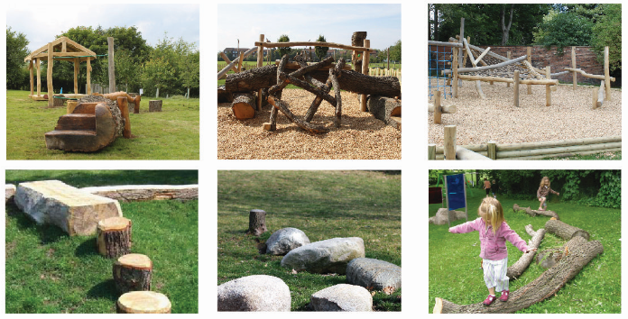

Storage Shed for Carnival
    - From consultations with representatives of Llandrillo Carnival, it has been suggested that the school could be used for storage purposes. The Carnival takes place annually and a number of items which are used are stored in garages and sheds of members of the local community. Although this is not necessarily an income generating use, the former school is felt to be of sufficient size that storage for the Carnival could be incorporated into proposals – in the short-term within the building itself and in the longer time in a purpose built shed in the grounds.

Community Growing Space
    - The former school is surrounded by open space – the playground and in addition the area of green space are areas potentially included within the Community Asset Transfer proposals and, due to the constraints presented by the flood zone are not suitable for building on, making a valuable opportunity for incorporating uses such as community growing space.
    - Several consultees highlighted whether there may be opportunities for allotments in this area, and this could be a use provided on a portion of the site. Research has identified that the closest formal allotment sites to Llandrillo are found in Llangollen and are currently full. Indeed, the five allotment sites across Denbighshire are all currently full, showing there is clearly demand for this type of use.
    - The wider area, and rear of the former school building could be used for more general community growing space – for example a community orchard and garden. Such a use of the space could bring a multitude of benefits to the local community (integration, health and wellbeing as well as benefits associated with creating local produce to potentially be used in the café). The community garden could be used by local groups for people who want to learn about growing vegetables and flowers, which will act as a further way of bringing the community together.
  - Evaluation of Potential Uses
    - The long-list of potential uses and opportunities have been subject to an evaluation process. Criteria used for evaluation are as follows:
- Whether the use meets an identified need (for example if a gap has been identified in the market or community)
- Whether the use benefits the local economy
- Whether the use benefits the local community, including impact on local residential amenity
- If the use is in accordance with planning policy and local authority priorities
- Whether the use would be compatible with other uses within the former school / immediate area
- Compatibility with uses offered by Y Ganolfan
- The level of support for the use from the local community
- The likelihood that the use could attract / obtain funding
- The extent of capital funding required
- The likelihood that the use could contribute to the financial sustainability of the building

    - To identify how the use performs against each of these criteria, we have used the following method to provide a ‘score’.

The use performs very strongly (for example has very strong community support, is directly in accordance with Denbighshire County Council priorities, or has no financial implications for the local authority) (+2 points)
- The use performs reasonably well (+1 point)

X The use does not perform well (-1point)

XX The use performs very weakly (for example has a very low level of community support, is contrary to Denbighshire County Council priorities, has high financial implications for the local authority) (-2 points)

N/A Where no impact is anticipated, or the criteria is not relevant

Table 6 Evaluation Matrix
 | Meets an Identified Need | Benefits the local economy | Benefits the local community | In accordance with planning policy and local authority priorities | Impact on residential amenity | Compatibility with other potential uses on site | Compatibility with Y Ganolfan | Level of community support | Likelihood of obtaining funding | Capital funding outlay | Timescale for implementation | Financial sustainability | TOTAL SCORE
Community Café | √ √ | √ √ | √ √ | √ √ | √ √ | √ √ | √ √ | √ √ | ×× | × | √ | √ | 15
Multi-functional Space | √ √ | √ √ | √ √ | √ | √ √ | √ √ | × | √ √ | ×× | √ √ | √ √ | √ √ | 16
Workshop / Shed Space | √ √ | √ | √ √ | N/A | √ √ | √ √ | √ √ | √ √ | √ | √ √ | √ | √ | 18
Employment Uses | × | √ √ | √ | √ | √ | ×× | √ √ | × | ×× | √ | √ | √ √ | 5
Local Produce Sale | √ | √ √ | √ √ | N/A | √ √ | √ √ | √ √ | √ √ | ×× | √ | √ | √ | 14
Bunkhouse Accommodation | √ √ | √ √ | √ | ×× | √ | √ | √ √ | ×× | × | √ | √ √ | √ √ | 9
Daycare / Nursery | √ | √ √ | √ √ | × | × | ×× | √ √ | √ | ×× | ×× | × | √ | 0
Soft Play | √ √ | √ | √ √ | √ | √ √ | × | √ √ | × | ×× | ×× | √ | √ | 6
Tourist Information Centre | √ √ | √ | × | N/A | √ √ | √ √ | √ | √ | N/A | √ √ | √ √ | ×× | 10
Sports Changing Facility | √ √ | √ | √ √ | √ | √ √ | √ √ | √ | √ √ | √ | √ | √ √ | √ | 18
External Area Uses | √ √ | √ | √ √ | √ | √ √ | √ √ | √ √ | √ √ | √ | √ | √ | √ | 18

    - Using this evaluation matrix it is possible to place the various uses into three categories. Those uses categorised as high scoring (scores 13 - 18) include:
- Community Café
- Sports Changing Facility
- Workshop / Men’s and She Sheds
- Multi-functional Space
- Local Produce Sale
- External Area Uses
    - Middle scoring uses (scores of 7 – 12) worthy of further consideration are:
- Bunkhouse accommodation
- Tourist information
    - Uses that should be discounted (scores of 0 – 6) are identified as:
- Nursery / daycare provision
- Soft play
- Employment uses
    - This evaluation process has been used to consolidate the potential options for the former school as set out in the following chapter.

- Development of Options
  - Introduction
    - From the analysis and review undertaken in relation to the long-list of potential uses for the former school, two options have been prepared for the building and site, illustrated on pages 30 and 31. Option 1 is primarily community-focused, with uses including a community café, multi-functional and workshop space, sports changing facility and improvements to external areas (community growing space and play areas). Option 2 focuses on the use of the building as bunkhouse accommodation, supplemented by a community café.
  - Option 1 – Café and Community Sports Uses
    - Option 1 focuses on the creation of a community hub for the village with specific uses based around the following:

Community café and multi-functional space – the core of the building would comprise a community café linked to an area of multi-functional space. This could include in the short-term comfortable seating areas for café users as well as space that could be used for a variety of workshops and events as described in the previous section. The link to an outdoor play area (natural play or similar facility) would make the café an attractive proposition for young families and local visitors to the area. The café provides income generating opportunities focused around cookery courses and possible training opportunities. The space also to be used in the short-term for local produce sale (there have been several ideas during consultation as to themes for produce sale that could be introduced, not just artisan food). In the long-term the space is safeguarded should the village shop close and alternative premises be needed.

Workshop space – a flexible space designed for use either as a Men’s Shed or alternatively for use by local art / crafts people as demand requires. There is opportunity to overlap with the multi-functional space described above, for example incorporating woodworking courses or similar.

Changing rooms – upgraded showering and changing room facility for the users of the community sports field to attract a greater level of use by local teams and complement the improvement works being undertaken to the playing field. Location of the changing rooms at the rear of the building enables easy access to the playing fields and separation of this use from the publicly used front area as necessary (i.e. the whole building would not necessarily need to be open for use of the changing rooms area). However, encouraging greater sports use of the building would mean that the café facility could be utilised for post-match refreshments, thereby combining the uses.

Community growing space – the external area of the former school and grounds provides opportunities for either formalised (i.e. allotments) or informal community growing space / orchard areas. A combination of both could be provided as necessary.

Storage Shed for Carnival – in the short-term, part of the interior of the building could be used as a storage area for the Carnival, although it is noted that this is not a good use of space from an income perspective. As uses become established in the building, it is proposed for the storage element to be located to a dedicated shed in the grounds of the former school.
  - Option 2 – Bunkhouse and Outdoor Activity
    - Option 2 is focused around a tourism use, drawing on the potential for bunkhouse accommodation in the local and wider area. Due to the nature of the use and constraints associated with the site, the option is dependent on detailed hydrological modelling being undertaken to confirm acceptability or otherwise. An initial review of floodrisk maps has identified that further investigation with updated modelling would be necessary. The option incorporates:

Bunkhouse – sleeping up to 14 people, bunkhouse accommodation could be incorporated into the building in two / three shared rooms. Ancillary accommodation necessary for a bunkhouse relates to eating / seating areas, storage and boot room.

Café – a community café use could also be incorporated into this option, although it would by necessity be smaller than proposed in Option 1 and would be shared with users of the bunkhouse.
  - Other Options
    - For the sake of completeness, although it is acknowledged that at this stage the local community do not want to pursue this until other opportunities have been thoroughly investigated, a third option is noted here, namely the demolition of the former school building and clearance of the site. The opportunities and issues presented by this option are that:
- The local community would only be responsible for a site rather than a community building, which would obviously have a much-reduced financial liability (likely to relate to maintenance only).
- The grounds around the building which form part of the potential community asset transfer are significant in terms of size and would provide an opportunity for the local community to still explore various outdoor uses described in Chapter 4 (play areas, community growing space / allotments, managed green space such as wildflower meadow / community orchard). Potential opportunities for associated café or changing room uses within the green space could be incorporated by more innovative means – the example of the shepherd’s hut café at Moel Famau car park is a good one for an innovative café premises, or a ‘container’ style changing room unit could be a low-cost way of incorporating improved sports use on the site.
- The heart of the village in terms of green space would remain protected for community use / in community ownership without long-term concerns for building management.
- The removal of the school building would be a blow to the community in terms of loss of community fabric; hence this option is regarded as an option of ‘last resort’ (for example if funding applications are unsuccessful and where the appetite to protect the site for community uses remains).

Option 1 – Café and Community Uses
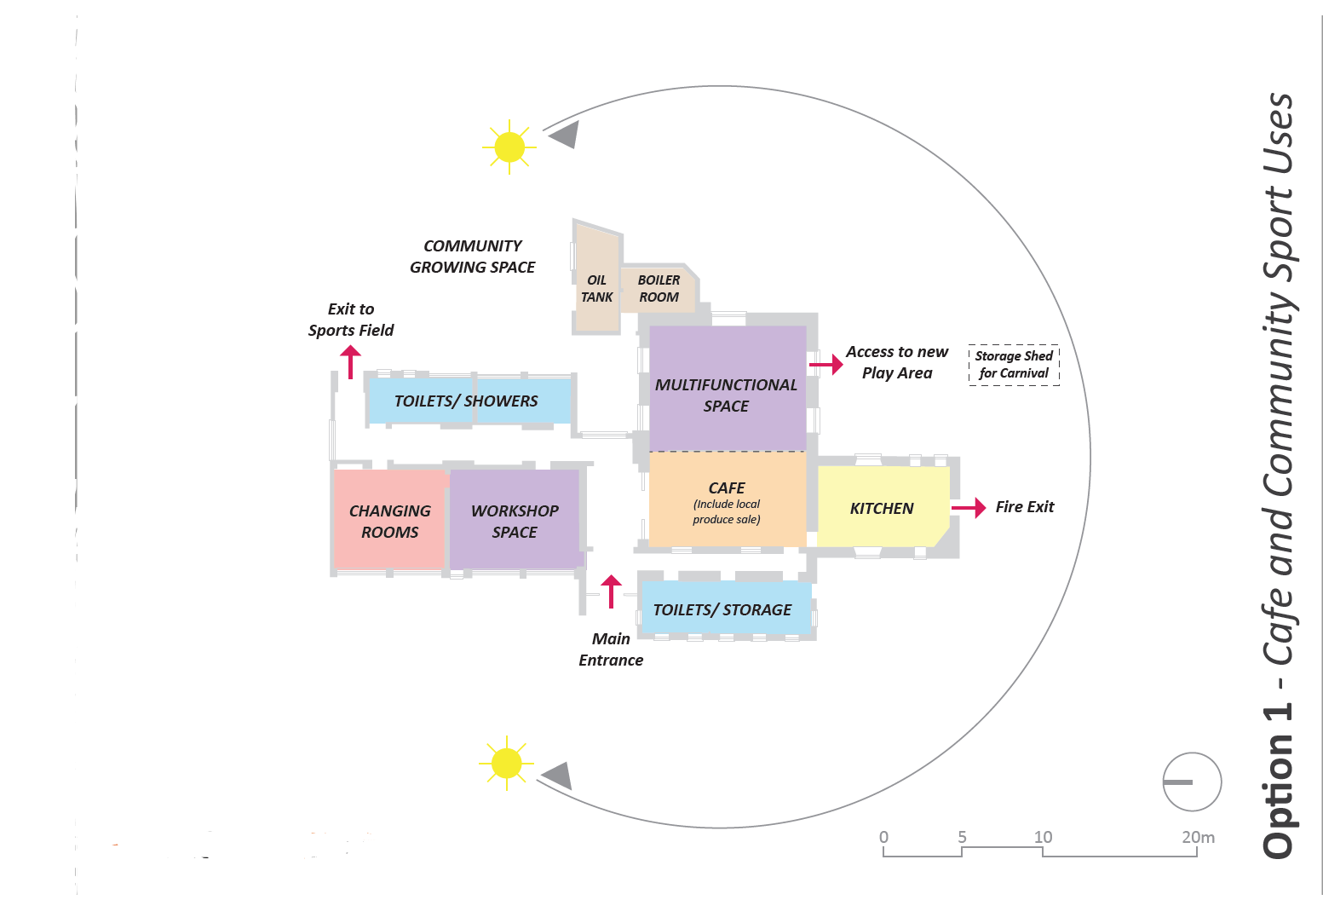

Arcadis Consulting (UK) Limited
Greyfriars House
Greyfriars Road
Cardiff CF10 3AL
United Kingdom
T: +44 (0)2920 729 800

arcadis.com

Option 2 – Bunkhouse and Outdoor Activity
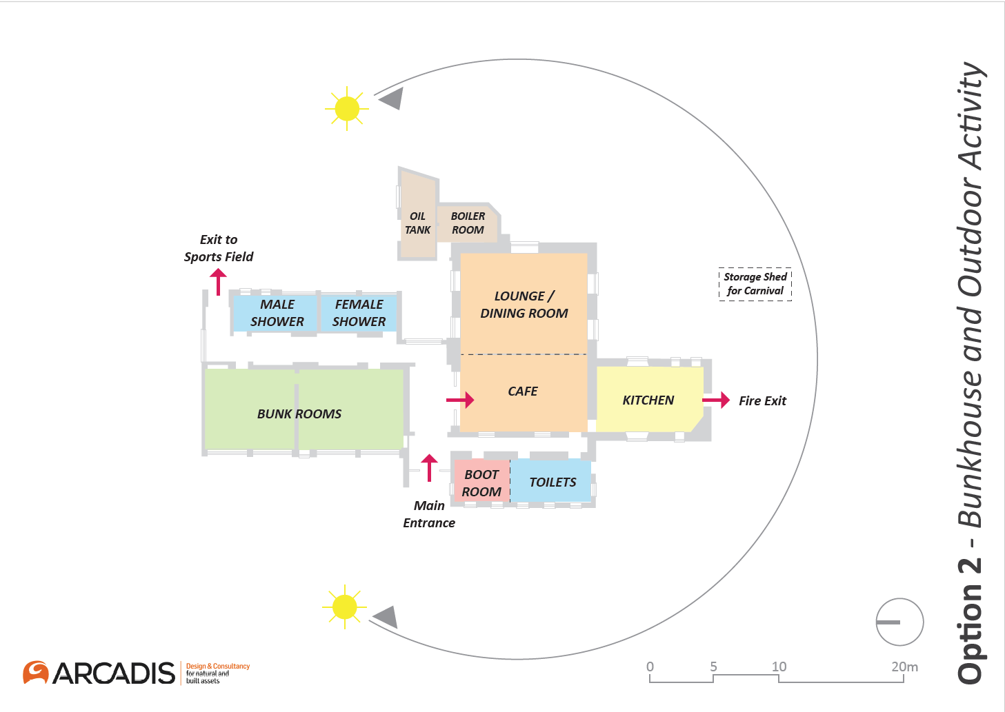

  - Public Consultation on Options
    - On Tuesday 5th March 2019 a public consultation event was held in Y Ganolfan between 18:30 – 20:30. Two notice boards were set up which provided background and context to the scheme and presented both building layout Options 1 and 2 for members of the public to view and comment on. Attendees were able to indicate their preference for either option and provide feedback. All literature and notices were provided in both Welsh and English. A total of 35 people attended the event, representing a range of age groups and backgrounds. All literature for the event was passed to members of the Steering Group who would place it on a notice board in Y Ganolfan, at The Stores and the Dudley Arms.
    - During conversations with members of the public, it became apparent that there was a significant preference for Option 1 – Café and Community Sports Uses. Concerns about Option 2 were connected with potential for anti-social behaviour and lack of facilities for the community. At the end of the consultation event, 100% of respondents had shown a preference for Option 1.
    - From assessing the feedback forms a number of thoughts on potential uses presented were suggested as follows:

Cafe
- There was widespread support for a café at the school, with a number of consultees pointing out that there are a number of residents who would welcome a non-pub environment for social events and have a go-to place during the daytime.
- A café would be good for walkers / cyclists and people passing through the area for somewhere to quickly stop, with ample parking.
- Respondents highlighted the potential mutual benefit for the sports field and the café, with teams, parents and spectators using the café before, during and after games.
- It was highlighted by a few respondents that seasonal variations would need to be considered and that it would require the input of a number of volunteers.

Local Produce Sale
- There was wide support for such an initiative as consultees highlighted that there are a number of farmers in the local area and a number of artists who would like somewhere to sell their goods and crafts.
- A number of respondents felt that this idea would work best if it was linked with the café and was run on a seasonal basis.
- It was also felt that such an initiative could be linked with job training and employment in the local area.

Multi-Functional Space
- There was support for such a function as people felt that the space could be used for larger functions and for when Y Ganolfan is fully booked although there were also concerns raised over the potential for this specific use to negatively impact on Y Ganolfan.
- People highlighted the benefit that this function could have for younger children as there is distinct lack of facilities for younger generations.

Sports Changing Facility
- There was widespread enthusiasm and support for using the school as changing rooms for users of the adjacent sports field.
- It was also suggested that this could be used as a changing / storage space for walkers visiting the café.
- However, it was highlighted that in order for this to be a success and ensure security, this use would require careful management and commitment from the Llandrillo Sports and Leisure Club

Workshop Space / Men’s Sheds
- There was widespread support for such a use in the school for a number of different user groups, including Men’s Sheds, a space for younger generations to use, a space for arts & crafts.

Storage Shed for Carnival
- There was widespread support for such a use as people highlighted the number of locals who have to ‘hand over’ their garage space for storage year on year; and
- In addition, a number of consultees stated that such a facility could be used on a wider scale for the Llandrillo Sports & Leisure Club storing equipment for their events.

Community Growing Space
- There was support for using this space for the local community.
- A number of consultees felt this space could be used by local children.
- Concern that allotments space could have a detrimental visual impact for the village if too near the road.

New Play Area
- A number of people felt that a play area would be a good use for the external areas of the school and should be used to accommodate a wider range of age groups.

  - Preferred Option
    - Taking the above findings of the public consultation event into account, it is considered that Option 1 – Café and Community Sports Use is taken forward as the Preferred Option for the former school site. An outline business plan has been prepared for the Preferred Option and is set out in the next Chapter of this report.
- Outline Business Plan
  - Introduction
    - An outline business plan has been prepared for the preferred option in order to provide Llandrillo Community Council with sufficient information to make a decision about the most appropriate way forward for the former school. This section sets out the likely capital costs that may be involved in converting and refurbishing the building, together with an assessment of potential revenue costs and income.
  - Capital Costs
    - The estimation of capital costs for the preferred option have been informed in part by the most recent building condition survey for Llandrillo Old School, undertaken in January 2011. The building condition survey documents not only the condition of the building, but also identifies issues that need attention or pre-empting, presents maintenance requirements and estimates the costs of works required. The key findings from the building condition survey were as follows:
- windows and doors throughout the school are likely to require full replacement.
- essential mechanical works including to the boiler room, heating system, hot and cold-water storage (including converting systems to mains water supply).
- essential works relating to, for example, ceilings, electrical and external areas.
    - The remedial and emergency costs associated with the work outlined in the building condition survey at the time were estimated to be in the region of £122,000. Because the school has been vacant since 2014, it can be expected that during this time the condition of the building will have deteriorated further. Whilst the school is suffering from damp in places, the roof of the building appears to be in reasonable condition (although a detailed roof survey would be required as part of future stages of work).
    - DCC has produced an Asbestos Management Plan for the building following an inspection undertaken in 2011. The Asbestos Management Plan identified seven locations containing asbestos (risk type ranging from 1 (Low) at six locations and 2 (medium) at one location) and confirmed that the old part of the building and the boiler room contain no asbestos.
    - Capital costs associated with reuse of the building in line with the preferred option are summarised in Table 7. Costs that are excluded from the table include VAT, survey costs, asbestos removal, landscaping costs, abnormal site conditions.

Table 7 Capital Cost Estimates (Preferred Option)
Item | Cost Estimate
Enabling / facilitating / demolition works | £16,516
External windows and doors | £66,690
Internal partitions | £1,800
Internal finishes | £26,334
Fixtures, furniture and equipment | £31,410
Mechanical and electrical services | £96,167
Drainage | £4,500
Renewables (photovoltaic panels) | £7,000
Net Construction Costs | £251,000
Preliminaries (8%) | £20,080
Overheads and profit (6%) | £15,060
Total Construction Costs | £286,140
Design development contingency (12%) | £34,337
Professional fees and surveys (20%) | £57, 228
Inflation (3%) | £8,584
Total Forecast Project Cost | £386,289

  - Revenue Costs and Income
    - This section provides a summary of revenue costs and income in relation to the preferred option for Llandrillo School.

Revenue Costs
    - Table 8 shows estimated revenue costs for the project over the first three years of operation, with explanatory notes for a number of costs provided in the following text.
Table 8 Revenue Costs
 | Year 1 | Year 2 | Year 3
Staff costs | 23,700 | 24,195 | 24,920
Building maintenance | 2,000 | 2,000 | 2,250
Utilities – electricity, water, sewerage | 2,900 | 2,990 | 3,080
Non-Domestic Rates | - | - | -
Insurance | 1,500 | 1,545 | 1,600
Cleaning | 5,000 | 5,150 | 5,300
Marketing and promotion | 2,500 | 2,500 | 2,500
Admin / Miscellaneous | 1,000 | 1,000 | 1,000
TOTAL | £38,600 | £39,380 | £40,650

    - The most significant element of the running costs are likely to be staff related. Costs provided in the table above relate to two posts – a Centre Manager and a catering position – and include staff-related on-costs such as National Insurance. Concerns have been raised with Llandrillo Community Council about the potential management burden that running the building would have; the Council already have responsible for other assets in Llandrillo and are aware of how time intensive asset management can be. For this reason, it is imperative that a Centre Manager post is provided from the outset of the project. Similarly, the running of the café entirely on a volunteer basis could be deemed difficult and again paid support in the form of a catering post is considered necessary. This is assumed to be a part-time role which in Years 1 and 2 would be 22.5 hours per week between March and October, based on opening hours of between 10am to 3pm, for five days a week (including Saturdays and Sundays, but perhaps with scope for some of the weekend supervision to be undertaken by volunteers).
    - An allowance has been made for contributions to ongoing building maintenance, although it is unlikely that significant sums would be required during the first three years of operation given that the building will have been fully refurbished. The maintenance sum relates to both internal and external areas of the building (note that the cost of maintenance for external areas have been minimised as far as possible as it has been assumed there would be a reliance on volunteers in the first instance).
    - The utilities costs provided in the table include electricity, water and sewerage costs. Electricity costs have been based on previous consumption information provided by DCC, moderated slightly according to a less intensive use as presented by the preferred option. The refurbishment of the building has included the provision of a solar panel installation on the south facing sloped roof of the original part of the school building; this has been assumed to be similar to a domestic scale solar panel installation (4kWp system). This would have the advantage of both reducing electricity costs to the building, plus enabling income from electricity generated and exported back to the grid (via the appropriate Feed-in Tariff, which it is noted are subject to change). The utilities cost in the table includes savings on the electricity bill, and payments from both generation and export tariffs, equal to nearly £500 per annum.
    - No cost has been included for the first three years for Non-Domestic Rates (NDR). Small Business Rates Relief applies to eligible small businesses of 100% for properties with a rateable value of up to £6,000. There is also 80% mandatory rates relief for properties occupied by registered charities. Charities may qualify for up to 100% rates relief at the discretion of the local authority if the property is occupied by a non-profit making body and used for purposes which are for example charitable / to do with recreation. There may also be eligibility for hardship relief from NDR of up to 100%.

Revenue Income
    - Table 9 shows estimated potential income for the project over the first three years of operation, again with explanatory notes and assumptions for individual uses provided in the following text. The table shows that break-even can be reached by Year 3 of the project; revenue support to fund the gap between expenditure and income would therefore be required during Years 1 and 2.

Table 9 Potential Income
 | Year 1 | Year 2 | Year 3
Community Café | 7,200 | 10,368 | 17,640
Local produce / goods sale | 1,200 | 2,400 | 3,600
Multi-functional space | 11,410 | 11,410 | 13,810
Community sports use | 420 | 420 | 420
Workshop space | 3,500 | 3,500 | 3,500
Fund-raising activities | 2,000 | 2,000 | 2,000
TOTAL | £25,730 | £30,098 | £40,970

    - There has been much consideration of how the café element of the project is best operated. There are several models that could be used – the café could be entirely run by the community (as described earlier, either entirely by volunteers or a combination of volunteers and paid staff); alternatively the café element of the project could be tendered to an appropriate small business who would be responsible for the running costs of the café and pay an agreed annual rent; a similar model to the latter would be for a profit-share relationship, whereby instead of a fixed annual rent, a prescribed level of profit would be shared with the school management organisation.
    - Discussions with the local community have indicated that a café run purely by volunteers would not be a sustainable approach. There may also be a difficulty in the short-term at least in attracting a small operator to Llandrillo for running the café – there would be an element of risk associated with this as the location may be viewed commercially as being slightly off the beaten track. An intermediate option would therefore be for the café to be run in the first instance by a combination of paid staff and volunteers – this would enable the project to get off the ground and for a market to be established. It would also allow more flexibility in how the kitchen area in the building is used for example for ad hoc cookery courses / for community events / for events linking with sports uses, without having to make arrangements with a commercial operator. The most important aspect of the café however relates to quality, a distinct identity and use of local produce / links with local suppliers.
    - Assumptions for income from the café are based on the following.
- That it could have in the region of 30 to 40 covers (there would be potential for this to increase during the summer when the outdoor area could also be used).
- The income projections assume the café is open for five days per week between March and October initially (note the five days would cover weekends), extending if there appears to be demand.
- A 20% profit margin.
    - A nominal figure has been included for the local produce / crafts sales. The success of this element will again depend on developing links with local suppliers. Should the village shop in Llandrillo close there is the potential for this use to be relocated into the former school; this would provide an additional income generating opportunity coupled with trained and paid staff.
    - The multifunctional space has by its nature a number of income generating opportunities associated with it. It is this area which could, with intensive management, form the financial ‘backbone’ to the running of the Old School. There is plenty of evidence to suggest that people are willing to pay significant amounts of money to attend one-off courses and workshops, whether these be culinary, craft or artisan produce based. Examples and charges from around Wales include courses for photography (£120 per head for a day course), willow weaving (£95 per head), Christmas pickles or truffle making (£50 per head for a three hour course), Christmas wreath making (£45 per head) and artisan breadmaking (£65 per head). There is also a network of artisan producers and craftspeople who could potentially be drawn upon to run specific courses; putting together a annual schedule for the school and developing links with such producers and craftspeople would be critical to the success of the project.
    - The income projection for the multi-functional space has assumed the following:
- Two craft, culinary or produce-based events per month throughout the year. An average of fifteen people has been assumed to attend events; evidence suggests that people attending courses like these are prepared to drive in the region up to 45 minutes for specific courses, giving a reasonably wide catchment area. An average rate of £40 per person has been assumed, although it is noted that for some courses this figure is likely to be higher. By Year 3 attendance rates are assumed to be at 20 people per event.
- An additional programme of events could be planned for the summer holiday season – an event each week during the six week school holiday period for example – to attract visitors to the area as an ‘all-weather’ opportunity. Again, this could be craft based, restricted in places to around twenty people and have an average rate of £5 per head. By Year 3 the number of events could be increased to ten per year (for example including Easter holidays too).
    - Lunch and supper clubs are popular events in the wider catchment area (for example ‘pop-up’ bistro evenings in cafes in Llangollen or Thai evenings). The projections include for one supper club event per month (based on twenty places and at a cost of £20 per head) together with one lunch club per month (again based on twenty places and at a cost of £5 per head).
    - The community events use relates to the use of changing rooms, café and multi-functional space for events held for example as part of the football or bowling club activities or as an alternative venue for use when Y Ganolfan is at capacity. The income projections have assumed twelve such events per annum, which may each generate one-off usage in the region of between £20 and £50 per time according to type and extent of use.
  - Funding Opportunities
    - This section describes potential funding opportunities for the project. These relate primarily to capital funding for the refurbishment of the school building. An overarching comment is that funding is extremely competitive.

The National Lottery Community Fund – People and Places
    - The People and Places large grant scheme offers funding from £100,001 to £500,000 for projects where people and communities are working together and using their strengths to make positive impacts. Eligible organisations include voluntary / community groups, registered charities, social enterprises and statutory organisations.
    - The People and Places programme can fund capital and revenue costs including equipment, staff costs and refurbishments. Revenue funding can also be provided for projects for up to five years. Applications are a two-stage process; the stage one application can be submitted at any time, with the outcome known in thirty days.

The National Lottery Community Fund – Awards for All (Wales)
    - The National Lottery Awards for All programme offers funding from £300 to £10,000 to support ‘what matters’ to people and communities. Eligible organisations include registered charities, constituted groups, not-for-profit companies, social enterprises and statutory bodies. There are three funding priorities and any activity or project must:
- Bring people together and build strong relationships across communities.
- Improve the places and spaces that matter to communities.
- Enable more people to fulfil their potential by working to address issues at the earliest possible stage.
    - One of the key cornerstones of this funding, is the importance of involving the community in the design, development and delivery of activities that are planned.

Welsh Government Community Facilities Programme
    - The Community Facilities Programme is a capital grant scheme administered by Welsh Government. Funding can be used to improve community facilities; small grants of under £25,000 and larger grants of up to £250,000 are available.
    - The Programme is open to community and voluntary sector organisations, including social enterprises. The focus of the programme is on increasing opportunity, creating prosperity for all and developing resilient communities where people are engaged and empowered. All applicants are expected to work with partners which can come from the public, private or third sectors.
    - Applications are sought which are community led, so the lead applicant is usually a community or voluntary sector organisation, for example a community group, registered charity or a social enterprise.

European Union Transition Funding
    - The EU Transition Fund was established by Welsh Government in 2017, to help business, public services and other partner organisations in Wales plan for and prepare for the impacts of Brexit. The details of transitional funding arrangements are still unknown.
    - There is provision for the UK to continue to participate in existing EU funding programmes and activities until their closure in 2023. This includes the Rural Community Development Fund (RCDF) which is primarily focused at LEADER Local Action Groups (LAGs) and other community-based organisations for investment funding across a wide range of interventions. The three main objectives include to:
- Promote social inclusion, poverty reduction, and economic development in rural areas.
- Help those most deprived in rural Wales and those that have limited scope to change their circumstances.
- Develop the resilience and capability of rural communities so that they are better able to cope with and adapt to change.
    - RCDF can support the construction, renovation or adaptation of buildings; other types of building works or habitat improvements actions such as new footpaths, stiles, gates and similar improvements. A minimum limit of grant of £2,400 applies, with the maximum grant contribution per project being £128,000. All claims must be submitted to the Welsh Government no later than 30th June 2023. All project activity must be completed in time for accounts and records to be audited and claims to be prepared and submitted by this date.

The Prince’s Countryside Fund
    - The Prince’s Countryside Fund has grants of up to £50,000 available for projects that will provide a long-term positive impact to individuals and communities. The fund provides funding towards projects affecting areas of greatest need and which clearly contribute towards one or more of The Prince’s Countryside Fund’s objectives:
- To sustain rural communities and drive economic vibrancy;
- To improve the prospects of viability for family farm businesses; and
- To support aid delivery in emergency and building resilience.
    - Organisations can apply for a maximum of £50,000 or £25,000 (for community shops, pubs or village hall projects) for a maximum period of three years. Applications for core costs such as staffing, overheads, training and equipment will be considered.
  - Support Organisations and Opportunities
    - There are other forms of support for the project in addition to simply financial support. The Community Asset Transfer (CAT) process is invariably time consuming and complex, and the end result of a new community project can be daunting for the responsible organisation. Key supporting organisations that may help will in the first instance include Denbighshire County Council and Carwyn Clwyd; external organisations include the Plunkett Foundation.
    - The Plunkett Foundation is a charitable organisation set up with the purpose of ‘the alleviation of poverty and social exclusion in rural communities both nationally and internationally through the promotion and support of co-operatives and social enterprises’. The focus of the organisation’s work includes helping predominantly rural communities to set up and run community-owned shops, co-operative pubs and community food enterprises and supporting rural communities to establish a wide range of other co-operatives and community-owned enterprises. The Foundation can provide a tailored programme of advice and support to individual community groups. Several successful community run organisations in the North-East Wales area have benefited from advice and support from the Foundation, including Cilcain Community Shop and the community run facility at Pwllglas.
    - Other opportunities for support include visiting existing social enterprises and community-run assets in the North Wales region, of which there are a number of successful relevant operations. Hearing about successful projects can help identify lessons learnt, ways to overcome particular problems / issues and the development of innovative ideas.

- Management Arrangements
  - Introduction
    - This chapter provides more information about the Community Asset Transfer process and how the project may be managed by the Llandrillo community. Case studies have been used to illustrate particular examples where relevant.
  - Community Asset Transfer (CAT)
    - Welsh Government guidance states that CAT occurs when a public sector body passes on the management and / or ownership of an asset to a community council or third sector / community group. The opportunities this presents include helping develop ‘thriving and diverse communities sustaining long-term use of assets and services’ with the ultimate aim of CAT being community empowerment ‘ensuring that land, buildings or services are retained or transformed and then operated for public benefit through community asset ownership and management’.
    - In undertaking CAT, there needs to be a proven need in the community for the proposed use, proven support for the proposal and identification of how the community would benefit, all areas which have been addressed in this study. Further work then relates to the ability of the proposed managing organisation to manage the asset and deliver the benefits identified.
  - Management
    - Llandrillo Community Council are the body proposed as the managing organisation for the former school and associated grounds under the CAT. The village community has already had the responsibility for managing Y Ganolfan for over 30 years, Llandrillo Public Toilets for 14 years and more recently the sports field and have an in-depth understanding of asset management. It is worth highlighting here some of the intricacies involved in bringing the public toilets into community management under the umbrella of the Llandrillo Public Convenience Access Group, incorporating energy and water-saving features, requiring legal advice to draw up a 20-year lease agreement with DCC, funded via local precepts, donations and an annual grant from the local authority. The toilets are managed by a 24-strong team of local volunteers responsible for opening, closing and cleaning duties for 365 days a year.
    - A distinction needs to be made between the organisation which is ultimately responsible for the former school and the arm of the organisation which may be responsible for the day to day management and operation.
    - Whilst the Llandrillo Community Council would be liable for the asset, the Llandrillo Old School Regeneration Steering Group has been established as the arm responsible for the progression of the project and ultimately to form the basis of the organisation responsible for the day to day management of the asset. Setting these arrangements out clearly in terms of areas of responsibility and expectation will be an essential first step. Close working practices will also be necessary between the Community Council and the Steering Group – this will need to be achieved through the development of regular reporting mechanisms; there is also overlap between membership of the two bodies which should make for a simpler approach.
    - As the responsible organisation, the Community Council will need to have a good understanding of the proposal in terms of:
- Likely cost and mechanisms to meet this through funding applications
- Ability for the project to be resourced (this to be the responsibility of the Steering Group to develop a resource strategy, based on the identification of paid staff members and a cohort of volunteers identified through the community consultation)
- Understanding of legal and financial liabilities that the Community Council would face. In the advent that the project was financially unsustainable or over time became unviable, what recourse would be taken. This is where it is useful to have an alternative option for the project – in the form of clearance of the site and alternative usage as identified in Chapter 5. In some CAT instances, there is a mechanism by which the asset defaults to the local authority should the project become unviable or if funding to enable the project is not successful. Our understanding from DCC in relation to the former school is that the asset would remain the responsibility of the Community Council in these instances and an alternative approach would need to be taken. As an extreme example, demolition and site clearance could be the ultimate ‘backstop’, for which DCC may be able to provide financial assistance for the works (a preliminary capital estimate for site demolition and clearance is in the order of £115,000 including preliminaries and contingencies).
- Other legal liabilities faced by the Community Council would be associated with, for example health and safety matters. Risk assessments would be required for the asset because it incorporates a playing field; this type of asset has a higher level of risk associated with them.
  - Case Studies
    - Several relevant case studies are included for review, together with some of the lessons that have been learnt as a result of the journey through the CAT process, through how the facilities are managed and run, and from seeking funding opportunities.

Glyn Wylfa, Chirk
    - The Glyn Wylfa project in Chirk (visitor centre, café and business meeting centre) went through the CAT process several years ago and is now established as a successful community facility.
    - Located 15 miles to the east of Llandrillo, Glyn Wylfa incorporates a café, visitor centre, business facilities and local arts and crafts area. Glyn Wylfa Ltd was established as a social enterprise and Development Trust by a team of Chirk residents who have complementary business and social community skills. The café opened over the Easter weekend in 2013, a couple of months before the rest of the site. The Development Trust wanted to get the café opened before other aspects of the site, so as to act as an income generator to pump prime the rest of the project and to demonstrate that the project could be profitable.
    - Volunteers run the café along with a paid café manager. Customers are split, generally 60% visitors and 40% local residents, with visitors coming in particular for day trips to the World Heritage Site and staying visitors from caravan parks. The café (which has sixty covers) is proving increasingly successful and it has been reported to be full at busy weekends. A monthly lunch club for the over 60’s attracts approximately twenty people and space is also rented out to local community groups and organisations on an ad hoc basis and is free of charge.
    - The main building at Glyn Wylfa has been refurbished to provide space for eleven offices. Currently 93% of these are let, featuring a mix of tenants including a ceramics studio, a digital consultant and a supplier of AC current and transformers to name a few.
    - The project is clearly proving to be successful and is currently thriving. One of the biggest challenges to setting up the project has been the level of time and input required from Trust members to drive the project forward. Often three or four meetings have been required a week, making it a serious commitment for those involved; fortunately many of the members of the committee are retired and therefore have been able to dedicate more of their time to the project in a very ‘hands-on’ way. Lessons highlighted including that having planning permission and building control applications in place prior to making an application to the local authority under the Community Asset Transfer process would save a considerable amount of time.
    - The importance of maintaining flexibility within proposals has also been highlighted – situations change and it is important to be able to respond flexibly as necessary.

Canolfan Y Fron
    - Canolfan Y Fron is a community owned and run centre, situated in the former village school building. The school closed in 2015, following which the Community Plan and the Canolfan Y Fron Committee put together a business plan to retain the existing school building as a community centre and sport field for community use. The school building would also provide income generating activity to increase financial reserves for capital expenditure and act as a financial safety net.
    - The community acquired the long-term lease for the building from Gwynedd County Council, were granted planning permission, received funding from the Big Lottery Fund (£946,841) and the Welsh Government’s Community Facilities Programme (£195,000), the committee planned to:
- renovate the closed village school building to become a community hub.
- regenerate the village and local area.
- restore the lost services of a café, shop, community rooms, treatment room, changing rooms and 18 bed bunkhouse.
    - The community centre opened its doors in the autumn of 2018 and is open seven days a week and hosts a variety of community and visitor events throughout the year, providing a range of uses, including:
- a café – which specialises in breakfasts, cakes, teas and coffees;
- community shop – which stocks a wide variety of basic essentials as well as newspapers, takeaway meals, confectionary, soft drinks and some local speciality items;
- accommodation – Llety Y Fron, which offers visitor accommodation suitable for groups of up to 18, or for individuals and families; and
- room hire – Room hire is available for community events, private functions, meetings and conferences.
    - In renovating the building, the community has kept as many original features as possible, including the pitch pine architraves around the doors, the tongue and groove in the Llety, and the slate mullioned window on the east side of the building. The building has also incorporated as many environmentally sustainable elements as possible, including air source heat pumps & underfloor heating; maximum insulation; solar PV panels on the roof and electric car charging points.
    - Particular issues / areas that were identified / lessons learnt as the project progressed included:
- the importance of keeping the community on board – regular feedback sessions / newsletters about what is happening and where the project is heading
- funding stream conflicts in terms of timescales and requirements – useful to have an overarching idea from the start / strategy about the funding process and timescales for applications.
- old buildings consume contingency allocations and can add programme time.
- contractors and lead professionals have their own agendas and tastes and may not always listen to client’s local knowledge and/ or opinions.
    - The community centre is well supported by the wider local community and uses a professional looking website, which is used to promote the community centre throughout the wider area.

Key Points and Lessons Learnt
    - From the review undertaken of comparable projects we consider the following points to be important for consideration:
- Not to underestimate the length of time and effort with submitting formal applications (planning applications, building control applications etc) and to prepare and submit these at as advanced a point in the proceeding as possible.
- Careful consideration needs to be given to how a café might be run – an entirely volunteer-led facility may not give a professional enough image to attract visitors as well as residents, although it may be a good starting point for developing a market and demand. Professional staffing at some level is necessary (either a catering manager or a paid assistant for example).
- Research is needed into organisations able to offer support (not just financial support, but also support in setting up and running a social enterprise). The research highlighted organisations such as the Plunkett Foundation.
- The importance of having an anchor tenant or use is critical – this provides a regular source of reliable income which enables the functioning of less or non-income generating uses.
- Maintaining a flexible approach at the planning stage can help with responding to new ideas and changing situations.
- The number and capacity of members running the project is important – both ensuring the decision-making board is not overly cumbersome in terms of numbers to prevent decisions being made and ensuring that individual members have the capacity and skills to manage the project (encouraging active retired people for example from the local community may be a good idea as may be advertising for people with required skills that may be missing from the current committee (for example legal skills, fundraising etc)).

- Next Steps
    - This section outlines what the next steps for the project are considered to be. There are clearly a number of immediate next steps, as follows:
- discuss the Draft Feasibility Report with the Steering Group and confirm acceptability of contents.
- present the findings from the Report to Llandrillo Community Council with a view to gaining acceptance in theory that the report can form the basis of the beginning of the CAT process with DCC.
- submit the Business Case for the project to DCC Officers as a basis for commencing CAT.
- hold a community event to inform people of the outcomes of the Feasibility Study and next steps regarding CAT.
    - Following this, other areas that would need to be progressed include:

Organisational Development
- Steering Group and Llandrillo Community Council to work together to understand how the two arms will operate in respect of the project, what capacity and skills they have and draw up a list of volunteers from the community (work on this latter aspect has already commenced and a list of some twenty volunteers was obtained at the latest public consultation event). Identification of partner organisations, and possible exploration of early forms of support from e.g. Cadwyn Clwyd and the Plunkett Foundation.
- agreement / formal set-up of a preferred structure.

Community Engagement
- ongoing regular events to inform the local community of progress.

Funding Opportunities
- explore and apply for funding to further develop the project.
- hold fundraising events.
- explore possible sources of revenue funding for Years 1 and 2 of operation.
Consenting
- liaison with local planning authority regarding need for planning permission / obtaining consents.
- liaison with Natural Resources Wales regarding requirement for detailed hydrological modelling to form part of a Flood Consequences Assessment.

Public Consultation Event Summary – March 2018

At a public meeting in March 2018, members of the public were invited to discuss priorities for Llandrillo, identify what is good about Llandrillo and what improvements there could be. A summary of the outputs from these discussions is as follows:

Q1 – If you were in charge of Llandrillo, what would be your priority?

People highlighted the potential for community-based projects which would benefit Llandrillo including those focused around food produce, plants / gardens, baking and the countryside.

People also highlighted priorities for Llandrillo as a whole, including:
- Keeping the school building, as it is found at the centre of the village.
- A café area for local and tourists / walkers.
- Retaining the shop and pubs.
- The need for new uses at the school to not negatively impact on the operation of Y Ganolfan
- Explore potential for sheltered accommodation.
- Explore provision of affordable housing, to keep families in the community.
- Explore potential provision of childcare (nursery).

Q2 – What’s good about living in the community of Llandrillo?

Positives about living in Llandrillo include:
- Good community and community spirit
- Local shop / facilities
- Friendly pub
- Welcoming area and inclusive
- Two good restaurants.

Q2 – What’s not so good / missing about living in the community of Llandrillo?

Things people felt were missing from Llandrillo include
- A café which would provide a meeting place for locals
- Education and training courses in the local area
- Music lessons
- A lack of provision for young children / teenagers / youth club
- The village is lacking the sound of children playing at the school and the vibrancy this brings
- Woodwork workshops
- Cross bow / air rifle shooting
- School / childcare facilities
- OAP facilities
- A library or reading room.

The event was well attended, with 70 residents having registered their attendance, and consisted of residents from a wide range of age groups and backgrounds. Upon leaving the event attendees were encouraged to outline their desire for something to be done at the school, with 100% indicating that they would like to see something done.

List of Consultees
Name | Role / Organisation
Gaenor Richards | Community Council
Maria Williams | Y Ganolfan / Ta Chi / Indoor Bowling
Delwyn Lewis | Y Ganolfan / Indoor Bowling
Cerys Lowe | Youth Club / Indoor Bowling
Paul Sawyer | Indoor Bowling
Eira Lewis | Women’s Institute
Brenda Owen | Clwb Garddio
Lin Norman | Quilters
Chris Linder | Cilan Caravan Park / Llandrillo Sports & Leisure Club
Rev Sandra Roberts | Church of St Trillo
David Robinson | Clwb Bowlio
Lee Mollison-White | Carnival Committee
Sam Brown | Tilhill Forestry
Sally Lloyd Davies | Connected Communities
Simon Poole | Men’s Sheds
Carmen Davenport | Corwen Day Nursery
Stella Shaw | Bala Backpacker’s Hostel
Carolyn Brindle | Economic Development Officer, Denbighshire County Council
Fran Rhodes | Community Development Officer, Denbighshire County Council
Nicola Williams | Denbighshire County Council
Peter McDermott | Team Leader – Marketing, Tourism, Events, Denbighshire County Council
David Shiel | AONB Senior Countryside Officer, Denbighshire County Council
Robyn Lovelock | Llangollen and Dee Valley Good Grub Club

http://www.educationbase.co.uk/Llandrillo-Community-Primary-School-Corwen,BB0024
STEAM Final Trend Report for 2005-2016 Denbighshire County Council (2016) https://www.discoverdenbighshire.wales/wp-content/uploads/2017/02/STEAM-Report-2016-Denbighshire.pdf
Welsh Government, Visits to Tourist Attractions in Wales 2017, Report for Visit Wales, 2017
The Soil Association’s 2018 Organic Market Report, 2018
http://www.canolfanyfron.org/
http://dtawales.org.uk/case-study/y-fron/

