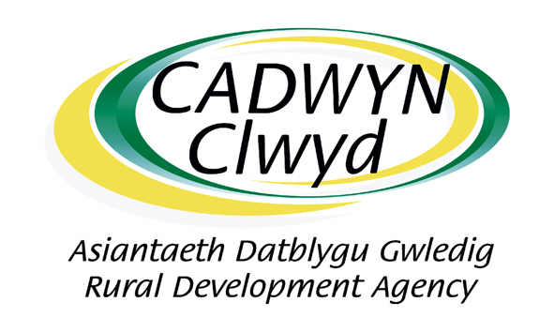
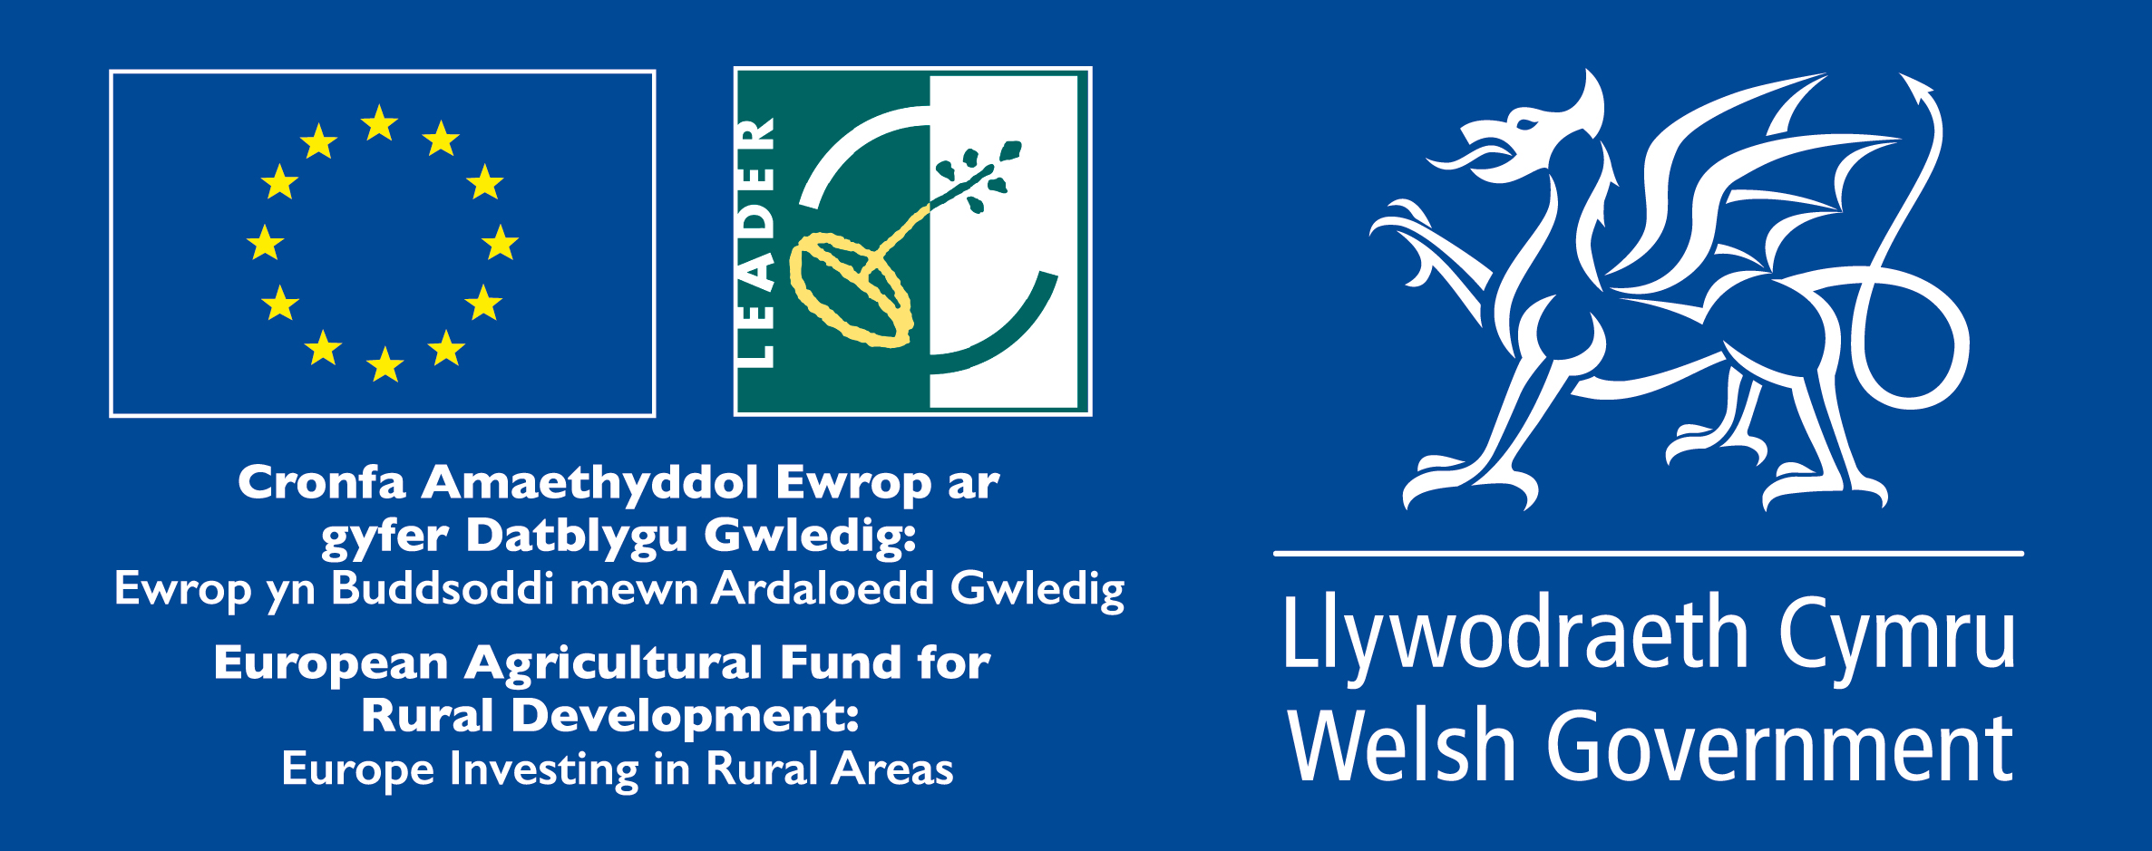

LEADER

Gall grwpiau cymunedol a busnes yng nghefn gwlad Sir Ddinbych, Sir y Fflint neu Wrecsam wneud cais trwy broses ffurflen gais am gymorth ariannol tuag at Astudiaethau Dichonoldeb, Prosiectau Peilot, neu brosiectau Hyfforddiant / Mentora. Mae angen i brosiectau ffitio o fewn un o bum thema LEADER: (1) Treftadaeth, (2) Partneriaethau Busnes, (3) Gwasanaethau Lleol, (4) Ynni Adnewyddadwy, (5) Technoleg Ddigidol. Gall LEADER gefnogi hyd at 70% o gostau prosiect (bydd angen i ymgeiswyr gael y 30% sy’n weddill o arian cyfatebol). Mae costau cymwys yn cynnwys ffioedd a gwasanaethau proffesiynol, a chostau offer ar raddfa fach (dim mwy na £10,000 gan gynnwys TAW). Ni all cronfa LEADER gefnogi prosiectau cyfalaf neu brosiectau y tu allan i'r ardal wledig gymwys. Mae angen cwblhau prosiectau erbyn 31 Mawrth 2023.

Community and business groups in rural Denbighshire, Flintshire or Wrexham can apply through an application form process for financial support towards Feasibility Studies, Pilot Projects, or Training / Mentoring projects. Projects need to fit within one of the five LEADER themes: (1) Heritage, (2) Business Partnerships, (3) Local Services, (4) Renewable Energy, (5) Digital Technology. LEADER can support up to 70% of a project’s costs (applicants will need to have the remaining 30% match funding in place). Eligible costs include professional fees and services, and small-scale equipment costs (no more than £10,000 inc. VAT). LEADER fund cannot support capital projects or projects outside of the eligible rural area. Projects need to be completed by 31 March 2023.

Ffurflen Datganiad o Ddiddordeb /Expression of Interest Form
Enw
Name
Enw’r Grŵp
Group Name
Cyfeiriad Cyswllt gyda chod post
Contact Address with Postcode
Rhif Cyswllt
Contact Tel. Number
Cyfeiriad E-bost Cyswllt
Contact Email Address

Crynodeb o’ch syniad gan gynnwys amcangyfrif o’r gost, amserlen, ffynonellau ariannu a phartneriaid.
Summary of Your Project Idea, including estimated costs, timescales, funding sources and project partners
Lleoliad eich project gan gynnwys cod post neu gyfeirnod grid.
Location of the Project, including postcode or grid reference

Dychwelwch y ffurflen I / Please return this form to: admin@cadwynclwyd.co.uk

Mae Cadwyn Clwyd yn ymdrin a phreifatrwydd mewn modd difrifol iawn ac yn cydymffurfio â phob agwedd ar fframwaith deddfwriaethol diogelu data'r DU sy'n cynnwys Rheoliad Gwarchod Data Cyffredinol Ewrop (GDPR) a deddfwriaeth y DU ei hun. Gallwch weld ein polisi preifatrwydd yma http://cadwynclwyd.co.uk/wp-content/uploads/Cadwyn-Clwyd-Privacy-Policy.pdf sy'n esbonio sut rydym yn diogelu eich hawliau personol.

Cadwyn Clwyd treats data privacy very seriously and complies with all aspects of the UK's data protection legislative framework, which includes the European General Data Protection Regulation (GDPR) and the UK's own legislation. You can view our privacy policy here http://cadwynclwyd.co.uk/wp-content/uploads/Cadwyn-Clwyd-Privacy-Policy.pdf which explains how we safeguard your personal rights.

