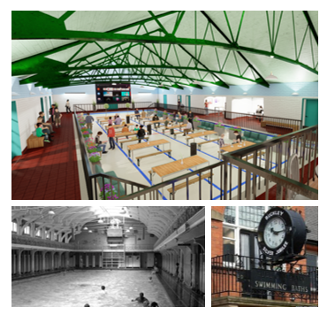

**Buckley Old Buckley Baths Community Hub**

Draft Final Report for: Cadwyn Clwyd and The Old Buckley Baths Community Hall Ltd

June 2021

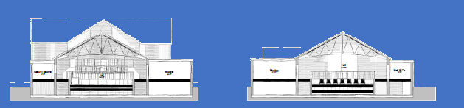

CYNLAS CYF   
and   
DEWIS Architecture

Contents

Executive Summary i

1. Introduction 1

2. Background 1

3. Buckley 1

4. Consultation and Survey 1

5. Strategic Context 1

6. The Proposal 1

7. Governance and Management 1

8. Finance 1

9. Marketing and Communications 1

10. Conclusions and Next Steps 1

Table 1 - Survey Results - What does Buckley Need? 1

Table 2 - Number of Survey Respondents who used the Old Baths 1

Table 3 - Number of survey participants who know where the Old Baths are. 1

Table 4 - Idea Priorities for the redevelopment of the Old Baths 1

Table 5 - Other ideas offered by survey respondents. 1

Table 6 - Priority uses for the Baths - Survey Responses 1

Table 7 - Policy Hierarchy Considerations 1

Table 8 - Initial Management Structure Proposed 12 – 24 months. 1

Table 9 – Long term Governance and Management Structure proposed. 24 months – 48 months. 1

Table 10 - P&L Forecasts 1

Figure 1 – The entrance to the old Buckley Baths 1

Figure 2 - Location of the Old Baths (Town Council to the immediate left). 1

Figure 3 - The First Buckley Water Polo Team - 1937. Photo courtesy of the Buckley Society 1

Figure 4 - The Baths as they look today. 1

Figure 5 - Survey Results Priorities for Buckley 1

Figure 6 – Best things about Living in Buckley. Survey Results. 1

Figure 7 - Other ideas offered. 1

Figure 8 - Flintshire County Council Wellbeing Priorities 1

Figure 9 - The three existing Directors. Cllr Dennis Hutchinson, Cllr Mike Peers, Cllr Carol Ellis. 1

Figure 10 - Melin Daron website 1

Figure 11 - Colwyn Bay Pier Trust website 1

|  |  |
| --- | --- |
| APPENDIX I | DESIGNS AND PLANS |
| APPENDIX II | SURVEY RESULTS |
| APPENDIX III | FINANCIAL FORECASTS |
| APPENDIX IV | FUNDING SOURCES (CAPITAL) |

*  
  
  
  
  
  
This project has received funding through the Welsh Government Rural Communities - Rural Development Programme 2014-2020, which is funded by the European Agricultural Fund for Rural Development and the Welsh Government.*

# Executive Summary

To be completed once the draft has been approved.

# Introduction

* 1. 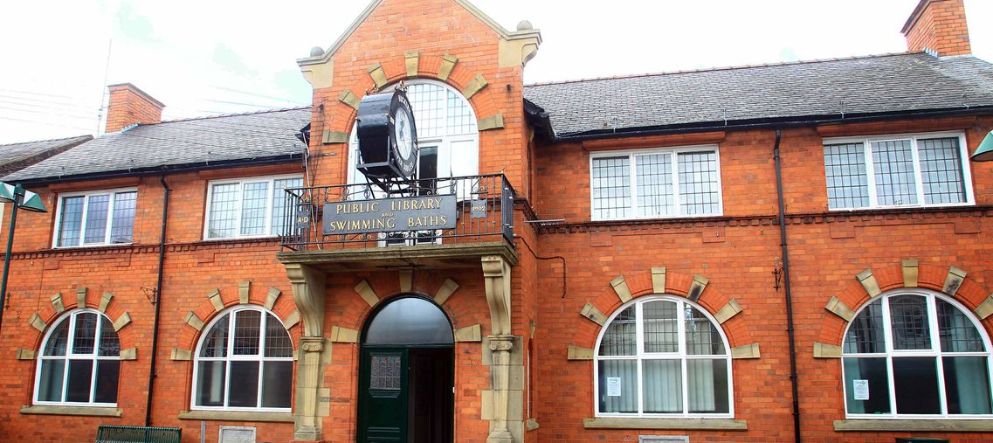This study was commissioned by Cadwyn Clwyd Rural Development Agency, supporting the Directors of the Old Buckley Baths Community Hall Ltd match funding was provided towards the development of a feasibility study and options appraisal for the Old Baths Building in Buckley.  
       
       
       
     This project was commissioned in October 2019, however due to the significant impact of COVID-19, the report is only now drawing to a conclusion.

Figure 1 – The entrance to the old Buckley Baths

* 1. The project is being led by the Board of Directors of the Old Buckley Baths Company, a social enterprise set up to secure the building for the future and to deliver a new vision, based on delivering community benefits and social outcomes.  
       
     The Directors of the Company are now solely responsible for the building and its future preservation. At present there are three Directors, all of whom have been with the project since the formation of the Company in 2012.
  2. This primary purpose of the study has been to examine the most feasible and viable way of bringing back the Old Baths into public use as a community facility, with meeting facilities and exhibition and performance space, and to consider the most viable and sustainable model for the future operation of the company.

Cynlas Cyf and Dewis Architecture were appointed to undertake this work. Cynlas Cyf is a business and economic development consultancy and Dewis, as per the nomenclature, an Architectural practice.

* 1. The brief was to assess local demand and to undertake consultation on a number of levels, and to identify gaps and produce a study with recommendations that could be taken forward by the company in partnership with the community of Buckley.  
       
     The commission required Cynlas and Dewis to:  
     + Engage in Community Consultation
     + Assess the current condition of the building and its suitability for restoration and conversion to meet the project aims and objectives.
     + Draft out a viability assessment of the project.
     + Advise on potential uses for the benefit of the local community relating to the aims and objectives of the project.
     + Provide floor plans of the building showing various proposals relating to the aims and objectives,
     + Provide a business plan, and schedule of works to bring the building back into community use, with estimated costs.
     + Deliver and present a detailed feasibility study with Action plans, and conclusions to the Trustees and Cadwyn Clwyd
     + A proposed governance and management structure for the new venture
     + Community and Stakeholder Engagement. - post project completion
  2. The following report sets out the methodology for delivering the above, and the data and evidence gathered is presented. This evidence has then been used as basis for offering a feasible and viable solution, which the Directors of the Old Buckley Baths Community Hall can then use as a springboard for taking the project forward to the next stage of development.

# Background

* 1. The Buckley Baths have been a landmark in the town’s history since they opened in the latter part of the 1920s. The baths were officially opened on Thursday, June 28, 1928, on what had previously been a bowling green.  
       
     The Baths are located on what is now considered the secondary retail area of the town, on Mold Roa, next to the Town Council.  
       
       
     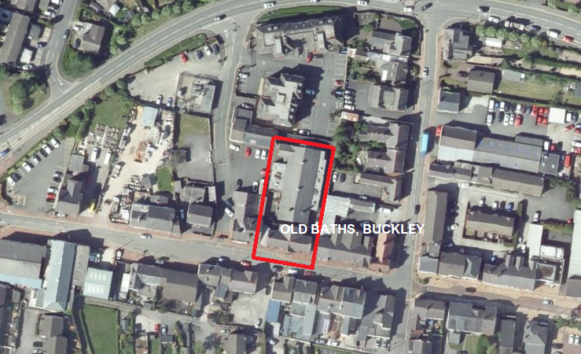

Figure - Location of the Old Baths (Town Council to the immediate left).

* 1. The Baths development wass paid for by the Miner’s Welfare Committee, which donated the £5,000 needed to build the pool.   
       
     As Buckley Town Clerk Martin Wright noted in an interview in the Daily Post in 2010:  
       
     *“The baths represent the labour of 1.2 million tonnes of coal that was extracted to finance the £5,000 it took to fund the building. As well as providing a swimming pool, there were also ‘slipper baths’ for people who had no baths at home.  
       
     “There were six cubicles each with a bath with open taps. The superintendent gave you the top to the tap to turn it on and off. It cost 6d and you had to hire your own towel and bring your own soap. The superintendent cleaned out the baths afterwards.”*
  2. A group of people posing for a photo

     Description automatically generatedIn the same way that the quarrymen of North West Wales came together to help fund the establishment of Bangor University, ensuring that their children were provided with appropriate education facilities, the miners of Buckley responded to the negative perception prevailing at the time that people of mining communities had very low standards of living and hygiene, through the development of the Baths, thereby providing clean modern bathing and washing facilities for their families.  
       
     At that time, the local miners did not have pit-head baths and most lacked proper bathing facilities at home. In addition, there was increasing concern about drowning tragedies due to people swimming in the clay holes created because of brick making. To address these problems, the local Mine Owners, under a Government Scheme, donated monies to a Welfare Fund.   
       
      The fund was managed and distributed by local Miners Welfare Committees, the local Committee then built the swimming pool. This was the only public swimming pool in the area and the name Buckley Baths became synonymous with the town of Buckley.   
       
     As well as providing recreation and washing facilities for the mining families, the use of the baths was offered free of charge to soldiers returning home from the Second World War to help them recuperate.  
       
     A successful swimming club was established right from the start in 1928, and a number of successful Water Polo teams emanated from the town.  
       
       
       
       
       
       
       
       
       
       
       
        
       
       
       
       
       
       
       
       
     The survey undertaken as part of this study further evidences that the Baths were considered a vital part of the community’s resources; nearly 80% of respondents said that they had either swum, or had learn to swim at Buckley Baths.  
       
     The Baths were extensively renovated in 1962. The renovation was paid for by Buckley Urban District Council, and the Baths were officially reopened on April 28, 1962, at a cost of £20,000, a sizeable sum, equivalent to £450,000 in today’s terms.[1]   
       
     The Baths remained a key part of the social fabric of Buckley until they were finally closed in 2005, following the opening of new swimming facilities at Buckley Sports Centre.

Figure 3 - The First Buckley Water Polo Team - 1937. Photo courtesy of the Buckley Society

* 1. 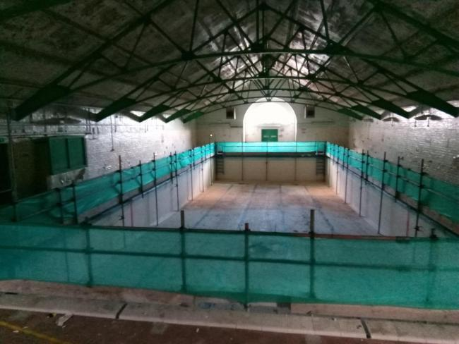Since then the Baths have lain dormant but have not been forgotten. Over the last decade and more there have been continued efforts to ensure that the Baths do not become a forgotten and neglected relic, but rather that the building is reused to support the regeneration and revitalisation of Buckley.  
       
     Since 2010 there have been a number of Buckley strategies, reports and documents commissioned, primarily by Flintshire County Council and Buckley Town Council. Without exception, those strategies and reports identify the redevelopment of the Baths as a key project for the town.   
       
     The 2011 Buckley Town Masterplan noted three core strands of investment and improvement, namely:

Figure 4 - The Baths as they look today.

* A rejuvenated retail centre.
* A new community hub.
* An improved town centre spine.

In relation to the new community hub, it noted that the community hub would be:  
  
*“…. focused around the Buckley Baths building, the Town Council offices and a new one-stop-shop facility on the site of the Police station”.*Since its closure the Old Baths has remained unused. Following its closure, the electricity supply and fuse boards were removed, and water disconnected. No utility services currently serve the building.

* 1. In 2010 the Town Council began to work to identify ways of reusing the baths for the benefit of the community, and in 2012 a company was formed to take ownership of the property with a view to developing it for the community.  
       
     The social enterprise company was formed as a result of the transfer of the Old Buckley baths from Flintshire County Council and established “The Old Buckley Baths Community Hall Limited”.  
       
     The company was registered at Companies House under company number **8331427** on the 14th December 2012.

The three existing trustees are all local Councillors who wish to bring back the old baths into community use. They have laboured hard to bring this project forward, working with partners at both a local and county level to realise the vision for a new Community Facility at the Baths.

* 1. In the next section we set out how the Baths fit in to the wider Buckley picture, both historically and currently.

# Buckley

* 1. Buckley is situated in the east of Flintshire on the range of hills which extends between the valley of the River Alyn and the narrow plain beside the Dee Estuary. The highest point is 518 feet above sea level and the town covers over 4 square miles. Buckley is 9 miles west of Chester and 11 miles north Wrexham and is easily accessible via the A55 which links with the M56 and M53 Motorways.  
       
     As noted in the Buckley discussion document of 2015:  
       
     *“Buckley is an expanding town as evidenced from the volume of development over the last two decades. The 2001 population was 12,753 and in 2011 this had grown to almost 14,000 (10% growth). With growth the town’s boundaries have been pushed to Mynydd Isa in the West, Alltami in the North and Little Mountain, Drury and Burntwood in the East… Buckley Town Centre is well placed to serve all these settlements which represents a total cumulative population of 18,000. Since 2000 Buckley has seen 861 new homes built which represents an increase of 26% to the town.”[2]*  
       
     However, the document also notes:  
       
     “Despite the town growing by a quarter, Buckley has failed to translate residential growth into town centre growth. Indeed, large portions of potentially ‘spoiled mining land’ still exist adjacent to the town centre at Precinct Way”
  2. There has been some form of civilisation in or near present day Buckley for many hundreds of years. The name Buckley first emerges at the time of the Norman Conquest although Bistre (now a part of Buckley but with a wider parish boundary) was the principal settlement. “Meadow Grass Land in a Wood” is one literal translation of the ancient place name Boklee.  
       
     On his marriage to Kathyrn in 1423 Henry V, gave Ewloe and the pastorage of Buckley as an annual gift to his wife, worth £26 per annum.  
       
     The parish church of St Matthew was consecrated in 1822. A new chancel in memory of Prime Minister, W. E Gladstone of nearby Hawarden was completed in 1901 and the porch is a memorial to John Ruskin, the famous author and art critic. Work was later carried out on a new western tower which houses a good peel of eight bells.

At one time there were 14 potteries in the town, one of which was set up by Jonathan Catherall in 1737. Catherall was a staunch non-conformist and received special dispensation from Lord Hawkesbury, after whom he named his house, to hold services at his house. As they became more popular, he built the first non-conformist chapel known as, Chapel in the Meadow. The site of this unique non-conformist bell tower is marked by a mound and plaque near the new Skateboard Park at the Elfed Sports Complex.

In addition to pottery, there were numerous brickworks in the town and Buckley Brick is today world-renowned. There were also many coal mines in the town.

* 1. Modern Buckley is an enigma at present. It is Flintshire’s second largest town, has a relatively prosperous economic profile, and has a strong sense of community. Yet, it is currently underperforming significantly as a retail centre. This is partly due to the pull from other retail destinations, including Broughton, Wrexham, Chester and Cheshire Oaks.  
       
     It is also a town that is ostensibly by-passed, and not interlocked with the main North Wales arterial routes.  
       
     Flintshire’s 2019 Retail Study (Pre-COVID-19) offers a less than positive perspective on the town.   
       
     *“Buckley Town Centre continues to serve a relatively localised day-to-day retail and service function, with a limited convenience and comparison retail offer. Whilst this is not unexpected given Buckley’s role and position in the retail hierarchy, we observed a number of prominent vacant units dispersed across the town centre, and we consider that vacancy levels should be closely monitored as the centre is showing some signs of weakness in this respect. More positively, the Aldi development in Buckley has attracted knock-on investment, through the development of Home Bargains. Similar investment in the comparison goods sector could attract further investment within the town centre.*

*The town centre environment is fairly bland, with some aesthetic enhancement needed in parts of the centre. Our discussions with locally active property market agents indicate that levels of operator demand in the centre are very low, which suggests that the centre is struggling to attract new interest and investment from retailers.”*

* 1. Yet, as will be seen in this report, there is a pride and passion for Buckley inherent within the character of the people. As one respondent to our survey also noted, the town centre is within easy walking distance for most of the outlying parts of Buckley.  
       
     There is a distinct and rich heritage and history, and in modern times the Tivoli has become known as a major destination for bands and artists.  
       
     Buckley should be doing better, but it needs stimulus and vision to make this happen.

Undoubtedly, as most of the strategy and policy documents note, the redevelopment of the Old Baths could send a positive message out and catalyse a renewed sense of positiveness.

* 1. The following sections set out the most appropriate and feasible option for that redevelopment.

# Consultation and Survey

* 1. Since its closure in 2005, great store has been placed on the views and needs of the community of Buckley. The success or otherwise of a reimagined Baths will partly be dependent upon the effectiveness of the project to respond to the needs of the community of Buckley, and the wider environs.  
       
     The purpose of the project, as set out in the brief was to  **“…** undertake a community consultation and options appraisal for the future use of the Old Baths building to develop a community hub/facility for community use and service providers. The study will look at the potential of building and provide a business case that will provide a facility to increase community and business engagement and involvement. “
  2. As one would expect COVID-19 had a significant impact on the Trust’s ability to take this forward. The project was initially scheduled to complete by July 2020; however as set out below, the pandemic had a severe impact on progress.  
       
     A key task within the programme was the need to undertake extensive public consultation.

The main programme of activities was scheduled for May 2020, and it was proposed to work with the Town Centre and Events Manager of the Town Council to utilise an empty shop front to promote the project and use events proposed during late Spring and early Summer to further engage with the community.  
  
It was also proposed to work with the Buckley Society in developing a Memories of the Buckley Baths event; but again due to COVID-19 this was not possible.

* 1. A revised schedule of consultation was then proposed for December through to mid-February 2021, however a further lockdown was put in place in December that again prevailed against undertaking consultation in the form originally envisaged.

However, an online survey promoted through various social media and the local press was delivered. The survey ran between February and early May and generated over 200 responses. Hard copies of the survey was also made available, and a small number were completed and returned to Cynlas via Cllr Dennis Hutchinson (one of the three Directors).

* 1. The survey had 8 key questions, these were:

**Q1.** What facilities does Buckley Town Centre need at present?

**Q2.** What are the best things about living in Buckley?

**Q3.** Do you know where the old Buckley Baths are?  
**Q4.** Did you ever use the Baths to swim or learn to swim?

**Q5.** Which of the following facilities would you think appropriate for the redeveloped Swimming Baths? (Tick each one you think appropriate - see next page).

Respondents were given the following choices:

|  |
| --- |
| Community Facility |
| Cafe or Restaurant |
| Bar |
| Museum & Heritage Centre |
| Concert Venue |
| Wedding Venue |
| Flexible workspace |
| Rentable Offices |
| Sports Activities |
| Children's Parties |
| Mother and Toddler Facilities |
| Artisan and Craft Market |

**Q6.** Any other suggestions?

**Q7.** Please rank in order of importance by ticking the appropriate box, with 1 being the highest and 9 being the lowest(Choices as Q7.)  
**Q8.** Any other comments you'd like to make?

Figure 5 - Survey Results Priorities for Buckley

**Q9.** and **Q10.** asked respondents for their age profile and the first 4 characters from their postcode.

* 1. 210 responses were received, 201 online. The results of the survey are shown below.

Table 1 - Survey Results - What does Buckley Need?

The responses were clear on what the people of Buckley felt was most important for the town centre. First and foremost was the need for a greater range of shops, followed by a greater range of eateries. A need for a community space was third on the list, followed by provisions for the youth of Buckley as well as facilities for children.  
  
Another theme that clearly came through was the need for a bank facility; reflecting the lack of any such provision within the town anymore.  
The main theme that came out of question 2 was the emphasis on community. Despite some concerns about the current performance of the town, a significant number of the respondents talked about the friendliness and community spirit that was prevalent within Buckley. This is shown the word cloud above.  
  
This sentiment was also expressed during the limited one to one consultation undertaken during the period of study. **Q3 & 4** demonstrate the familiarity and connection with the Old Baths. It is clear that of those responding, most had had first-hand experience of using the facilities prior to the closure, and / or knew where the Old Baths were located. Moving forward, this familiarity can be positively exploited and built upon.  
  
**Q5.** Focused on people’s views on what type of activities and facilities would be most appropriate in a refurbished and redeveloped Baths.  
  
61.96% in favour of some form of eatery, either restaurant or café.

Figure 6 – Best things about Living in Buckley. Survey Results.

Table 2 - Number of Survey Respondents who used the Old Baths

Table 3 - Number of survey participants who know where the Old Baths are.

61.41 % of respondents support the use of the Old Baths as a community facility.  
  
56% support the Baths being used for holding markets. Further exploration of this response suggests that markets could include artisan goods and foods.   
  
The chart for **Q5.** is shown below.

Table 4 - Idea Priorities for the redevelopment of the Old Baths

**Q6. o**ffered the opportunity for respondents to suggest any other ideas not previously identified in the survey. A number of the surveys repeated ideas previously outlined; however this question also elicited specific ideas that could be further considered, including a number of leisure facilities, e.g. cinema, bowling, and soft play for younger children.  
  
The responses have been shown in both word-cloud form and as a table (next page).  
  
The tabulated version has brought together ideas proposed into specific categories. General Refurbishment refers to suggestions relating to the physical improvements of the building.  
  
A number of interesting ideas were put forward, including the use of the Baths as an enterprise and creative hub, an alternative venue for specific performances, a focus for the heritage and history of the town, and for health and wellbeing activities.

Table 5 - Other ideas offered by survey respondents.

Figure 7 - Other ideas offered.

**Q7** asked respondents to rank the ideas put forward earlier in the survey, based on their own priorities. Those completing were allowed to rank each idea on a score of 1-9, with 1 being the highest priority. More than one idea could be accorded a score of 1 or 9.   
  
These responses were calculated, and an average score obtained for each idea. The results are shown on the next page.  
The table on the next page clearly shows that the use of the Baths as a community facility came top, with a restaurant or café second.  
  
Note that these ideas are not necessarily mutually exclusive, and a range of ideas and activities could, potentially, be incorporated into the revamped and redeveloped building. **Q.8** was the final question based on the Baths themselves. This question allowed respondents to offer any other comments or suggestions.  
  
The responses received in this specific section offer significant guidance on the community’s wider perspective on the proposed redevelopment, and the town itself. The responses are offered in full as Appendix II.   
  
The responses offer a range of comments, and useful suggestions. These include:  
  
*It needs to be something to keep people in Buckley, something different something interesting and ongoing e.g Mold market food festival  
  
Buckley needs something that will attract people / business to the town indoor shops at affordable prices pop up shops just something other than charity shops and hairdressers*.  
  
*The artisan market would be a lovely addition to the town but would need marketing and the rest of the town would need work to make it more appealing to bring more people in. Buckley sadly is not a destination town, it serves the community so I think whatever we choose to do to the baths should be to serve the community first.*  
  
*Buckley needs huge investment to encourage people into the town, without it I feel anything will struggle.  
  
Make a safe area for young adults or lose them all to other communities like Mold or further afield to Chester.  
  
The project needs to be got on with - it feels like a lot of talking and no doing because nothing is happening  
  
Buckley needs clothing market /shops iv (sic) lived there all my life it been the biggest let down in shops in Buckley I think Buckley people will be celebrating if that ever happened.  
  
Last thing we need is money spent on it for it to not be used. Ensure it is a wanted thing beforehand. Ideal for indoor market as rent for shops too high in Buckley.  
  
There is a lack of a place that visitors can go to find out about Buckley, which does not seem to promote its history as something special. The Buckley Society should be a big part of this space as they take the time to record our history. Buckley doesn’t have a Civic multi-use Hall! It would benefit the community as a whole if run properly and should be able to generate enough revenue to be self-sustaining.*

Table 6 - Priority uses for the Baths - Survey Responses

*For example, the Civic Hall in Neston caters for all sorts of clubs such as dancing; afternoon teas for older citizens; a Cinema for all ages and many other clubs.*

*It would need to be managed so that it is in full time use and not be allowed to be trashed in the process. If it is in good condition, people will use it.  
  
I just hope that Buckley's rich heritage Is absorbed into the iconic building.*

*Exciting to see plans and movement on this project. Please keep this space flexible, don’t designate one facility i.e. market or shops. Utilise the space flexibly for the community. If the community can access it, they will grow to live it and use it. Once a month shopping or market will be plenty, that type of facility only benefits a small part of our community.*

*Somewhere like Alexander's in Chester or Future Yard in Birkenhead. Have local bands, gigs, comedy, cinema with bar and bar snack menu. Somewhere for youth and young to go and get involved in if it has a community link maybe with Theatr Clwyd? Future Yard a great example.*

* 1. In the next section we consider the strategic context against which the redevelopment of the Baths needs to be considered.

# Strategic Context

* 1. This report is set against a backdrop of a number of relevant policies and strategies, operating at four levels of administration:

Table - Policy Hierarchy Considerations

* 1. 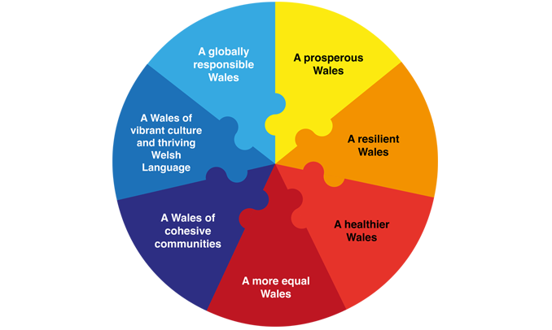National Level Policies are underpinned by a key piece of Welsh Government legislation – the Wellbeing of Future Generations (Wales) Act 2015.  
       
     The aspirations of the Well-being of Future Generations Act 2015 aim to redefine the public sector’s approach to all aspects of its work.  
       
     This core policy of Welsh Government sets out 7 Wellbeing Objectives and governs how public bodies should work in future.  
       
       
     Whilst the Act governs the public sector only, the underpinning ethos extends out to the work that third sector and private bodies undertake in partnership or on behalf of Government. Further, much of the funding now emanating from public bodies requires tangible evidence of alignment and commitment towards the Act by beneficiaries.  
     Timeline

     Description automatically generated  
       
     Prosperity for All, 2017  
       
     The Welsh Government’s Economic Action plan was published in 2017. This sets the tone for its work in developing the prosperity of its communities.  
       
     Of particular relevance to this project are the five ways of working proposed.  
       
     In the foreword, the Plan notes:  
       
     *“We want a strong, resilient and diverse economy that delivers for the people of Wales - enabling individuals to realise their ambitions, businesses to prosper and communities to thrive.”*  
       
     **Covid Reconstruction: Challenges and Priorities, November 2020**  
       
     In November 2020 Welsh Government published COVID-19 Reconstruction: Challenges and Priorities

It set out 8 actions to enable Wales to reconstruct after the Pandemic. These were:

* Employment.
* Education and Economic support for young people
* Council and Social Housing
* Investment in local town centres
* Decarbonisation
* Changing travel requirements
* Support for the foundational economy
* Support for the NHS

Perhaps, of most immediate relevance is the focus on investment in local town centres. It notes:  
  
*“We will step up our investment in our local town centres to help build resilient communities and capitalise on how Coronavirus has re-focused people’s lives on the communities in which they live, including providing better access to open spaces, the creation of remote working hubs, and making sure our public services are more accessible”*  
  
Although it should also be noted that some of the other priorities are also directly relevant, specifically employment, education and economic support for young people, decarbonisation, changing travel requirements and support for the foundational economy.

**Our Economic Resilience and Reconstruction mission, February 2021**  
  
The Welsh Government published this document with a view to taking forward the discussion presented in the Covid reconstruction document which itself built upon the economic development priorities outlined in “Prosperity for All”.

It saw its reconstruction mission building on the early progress it had made in raising the profile and challenges in the Foundational Economy, recognising that there was more to be done to spread and scale the approach.

The document emphasises that the drive for a well-being approach is no longer a fringe report.

Cognisance and appreciation of these priorities will provide a foundation for the project’s strategic aims as it develops as a community facility and amenity for the people of Pen-y-ffordd.

* 1. The Regional Approach.  
       
     The regional perspective is encompassed within the work of the Economic Ambition Board.   
       
     **The North Wales Economic Ambition Board (NWEAB)** is a partnership comprising of the 6 Local Authorities in the region, along with representatives from the private sector, Bangor University, Glyndwr University, Coleg Cambria and Grŵp Llandrillo Menai. The Board was established in 2012 to develop a regional approach to economic growth and to addressing the challenges and barriers facing the North Wales economy.  
       
     The Board has developed a vision for growth, encapsulated in its Growth Deal which was signed with UK Government in December 2020. The Growth Plan has three core principles:
* Connected North Wales
* Smart North Wales
* Resilient North Wales

It is, in reality, a high level, strategic programme of intervention designed to focus efforts on tangible growth opportunities for the region. There are, however, relevant areas of focus. The emphasis on resilience and the aim of ensuring that the region retains its young people, raises employment levels and improves skills, resonates with the aims of this project.

* 1. Diagram

     Description automatically generatedFlintshire level policies perhaps offer the most immediate relevance and resonance for Buckley, and in turn for the future development of the baths.  
       
     As a county it has a number of policies and programmes of specific relevance. Its statutory obligations obviously have a bearing on the Local Authority’s priorities, but those obligations also help define how and in what form Buckley will develop.   
       
       
     As a county, Flintshire’s obligations to the Wellbeing of Future Generations Act are graphically presented within its Wellbeing Statement strategy[3].  
       
     This strategy is a reflection of the Public Service Board’s ambitions – the Board comprises representatives from the public sector, and includes for statutory bodies; the Local Authority, Betsi Cadwaladr University Health Board, Natural Resources Wales and North Wales Fire and Rescue.  
       
     Further exploration of the Flintshire’s Wellbeing priorities demonstrate significant relevance to this project. For example, the focus on Resilient Communities equates to the following:

Figure 8 - Flintshire County Council Wellbeing Priorities

* Enabling and inspiring communities to be confident, cohesive, and forward thinking.
* Developing an approach that ensures that when any public service is working in an area that additional skills and capacity are strengthened within that community.
* Co-ordinating an approach across public service delivery that maximises the impact of community benefits.
* Further developing community ownership models including Community Asset Transfers (CATS), micro social enterprises and community shares  
  1. At a Flintshire / Local level, there are other salient and resonant policy and strategy documents of key importance to this project. Key documents include:
* **Flintshire Local Development Plan (LDP) 2015-30**. This recognises Buckley as one of the key settlements in the county.  
    
  The LDP also has a number of ancillary Topic Papers that have relevance, and need to be considered, including Topic Paper No 9, Health, Community Wellbeing and Cohesion.
* **Flintshire Council Plan 2019-23**. This sets out the Local Authority’s programme of work and there are many themes within it that bear relevance to this project. Of note is the theme of Resilient Communities. This sets out an ambition to work with communities, helping them develop skills and resources to be able to deal with challenging and difficult situations which exist or when they occur. This Plan was prepared pre-COVID-19, but its relevance and significance has become even more profound since 2020.
* **Technical Advice Note 4 Retailing and Town Centres (2016)**
* **Buckley Masterplan (2011)**
* **Buckley Town Centre – Discussion Paper 2015**
* **Buckley Investment Strategy - 2017**
* **Flintshire Retail Study (2019)**
  1. We can see from the above, that there are a number of relevant strategies and policies that need to be considered in developing this feasibility study. Within Welsh Government in particular, there will no doubt be more detailed policy documents and strategies that provide more specific guidance that have a bearing on initiatives emerging from this study,   
       
     One other key factor that needs to be considered is the relationship between relevant stakeholders. In this report we have outlined some of the key strategic relationships, but there is a plethora of other relationships with stakeholders, particularly at community and county level that will also need to be considered.

# The Proposal

* 1. In determining the use of the building, we also must consider the physical attributes and constraints of the Baths, what can be feasibly accommodated, and what level of capacity (in terms of people) can be considered at any one time.

The proposed design is attached as Appendix I. In addition, we have presented some indicative ideas about how the space can be used creatively and flexibly to accommodate a wider variety of community and commercial uses.

* 1. We have worked closely with the Directors and considered all regulatory issues and offer the following thoughts and ideas for the Old Baths.  
     1. To ensure the space is as usable as possible the pool area will be levelled off at 1m below the main hall level as a feature. It was felt raising the level of the pool fully would lose the character of the space and covering the pool with structural glazing would be too expensive. An opening in the floor lit up will highlight the original depth of the pool, and any pool markings will be kept. A balustrade surrounding the pool will be required as a safety measure to prevent visitors falling.
     2. The rooms to the side of the pool, the former changing facilities are to be split into several smaller rooms for multi-purpose activities, including welfare facilities, meeting rooms for renting out, a kitchen and bar for events such as weddings and galas. New window openings are proposed to allow natural light into the spaces. The potential for renting these spaces to businesses is also a possibility.
     3. Capacity of the building - final numbers will be confirmed by Building Control and a Fire Officer. Numbers will also vary depending on what the spaces will be used for.
     4. On average space standards for workspace varies from 5m2 - 3.7m2 per person (HSE guidelines). The more the allocation per person the more spacious the office. If we work on this rule of thumb and take one of the communal offices proposed of 30m2, the maximum number of people we should have in this room is 8 people. There may be additional staff members, in which case it is down to the organisation whether they choose to increase the numbers in that room and the fire management plan.
     5. Using the building as a conference facility implies a different ratio. Because the space is flexible and can have many different layouts, the number of people in the room changes. For example, in a conference room of 70m2 in a theatre style you can fit 83 people, but if the layout is altered to a U shaped the number drops to 22 people.
     6. Another major factor is the agreement with the local fire officer and the fire management plan for the building. How many escape routes does the building have? whether the building has a sprinkler system installed? The final number will be down to the fire officer and building control to ensure the safety of occupants in the building. We must also consider the welfare facilities to ensure there is adequate provision for the increased capacity if the conference room is pushed to its limit.
     7. To conclude one must determine the maximum number of people required in all spaces to ensure the building is sustainable. From this we can calculate the area per person to ensure it is in line with HSE guidelines, this then will allow for further discussion with a fire officer and building control regarding the evacuation strategy and fire management plan (in collaboration with the end users).
     8. The kitchen areas are sufficient for serving food but are not assumed as commercial kitchens on the current plan. We would assume an outside catering company would be used if a wedding were being held at the venue. The café will serve hot beverages, cakes, have the provision to heat food, serve salads and sandwiches, soups etc.
     9. To work out the toilet capacity we are assuming that the building can hold 300 people and therefore 3 female toilets, 1 male toilet and 3 urinals and 1 disabled toilet will be sufficient. It is recommended that a 10% increase is required if alcohol is provided.
     10. Unfortunately renovating the building back into a swimming pool is unfeasible financially hence the proposals to find alternative uses for the property. There are many features within the old building which highlight the previous use of the building which the team felt was essential to retain to remember the history of the building.
     11. One of the key issues with the existing building is access. Bearing in mind this building will be for public use, it is essential that the building is ‘inclusive’ to all. A ramp has been proposed from the car park with new lighting, CCTV, and a welcoming entrance sign. Platform lifts are proposed to help access to the pool and café levels and an accessible toilet has been included.
     12. There will be two access points into the baths, the existing from the street will remain to encourage pedestrians passing, and the other to the rear of the building through the car park. The existing fire escapes will be retained.
     13. The existing entrance level is proposed for use as a café which extends into the main pool pace. Approximately 25 seats can fit in this space, depending on the size and layout of furniture. A kitchenette and servery are proposed at this level.
     14. It is proposed that the project is undertaken partly in collaboration with The Buckley Society, and the look and feel of the baths will, where feasible, incorporate artefacts, including exhibits around the building in glass cabinets, wall hangings etc. This is not about replacing what is already on display elsewhere, but rather to provide an additional outlet for the Society, and to fully reflect the history and heritage of the Baths.  
           
         Photographs of the original swimming baths will be displayed to ensure the history of the building is not forgotten. Minimal work is to be done to the fabric of the building. Enhancing the original features is the priority to restore like new.
     15. The extent of the works will come down to cost, but as a starting point we believe this is the best layout to ensure the building remains in use for years to come. Maintenance and durability are essential to the success of these proposals. Its vital materials chosen are long lasting and as natural as possible.
  2. The ideas.  
       
     We have considered the results of the survey, the optimum layout for the building, and also considered the way in which other buildings within town centres are used creatively and effectively.  
       
     We have also considered the initial requirements of the brief, which stated:  
       
     *“The building will sustain a community asset and potentially provide training and employment opportunities, interpretation on the history of the Old baths and education facility, increase digital take up and inclusion amongst target groups and provide a meeting place for existing and new community groups”.*  
     and  
       
     “… identify gaps and produce a study with recommendations the community can take forward”  
       
     We have also fully taken on board the specific comments made in relation to the proposed project, including preserving the heritage attributes of the building, the need to bolster both the retail and food and drink offer in Buckley, and also issues of potential displacement i.e. taking business from existing traders and operators.  
       
     On that basis we propose a Multi-use centre, encompassing:
* A community hub offering a range of activities and services, complementary to those already offered by other organisations in Buckley. The central space to be used flexibly and creatively.
* A central space that can be used for a multitude of activities, including:  
  + Cinema
  + Artisan Food and Drink Market
  + Artisan Craft Market
  + Conferences
  + Functions
  + Parties
  + Community Events
* A café facility (either operated directly or rented out to an existing operator in the town who is interested in further expansion, or a new trader).
* Office space - prima
* Flexible business space provision – offering aspirant and smaller existing businesses to use the space for their own purposes, and collaboration with others.
* Performance area, complementary to the Tivoli and other venues. This will also include opportunities for history talks, and other lectures.  
    
  1. We would also consider the opportunity to have some form of banking facility within the building, or at the least, an ATM. Such facilities are evidently lacking at present and came through strongly in the survey.
  2. The forecasts set out later in the report offer a positive outlook for the operation of the Baths, post development. The main challenge will be the capital cost of over £1.1m; however this challenge is not unsurmountable.
  3. In the next section we set out the governance and operational model considered appropriate and viable for the Old Baths in the future.

# Governance and Management

* 1. Ownership of the site rests with the Social Enterprise, having been secured as an asset transfer from the Local Authority via the Town Council in 2010.
  2. The company currently has three directors, these being:

**Mike Peers.**  
  
XXXXX  
  
**Carol Elis**XXX  
  
**Dennis Hutchinson**  
  
XXX

Figure - the three existing Directors. From left to right, Cllr Dennis Hutchinson,   
Cllr Mike Peers, Cllr Carol Ellis.

* 1. The objects of the company are:  
       
     *“…. to own and manage the building known as Buckley Town Baths in order to preserve the building itself and to use it for the benefit of the people of the area of benefit and the neighbourhood, without distinction of sex, sexual orientation, race or of political, religious or other opinions by associating together the said residents and the local authorities, voluntary and other organisations in a common effort to advance education and to provide facilities in the interests of social welfare for recreation and leisure time occupation with the objective of improving the conditions of life for the residents”*  
       
     The three current directors of the company have been part of the company since its establishment in 2012. Originally, there were a total of seven directors, but four of the original appointees subsequently resigned their positions.  
       
     The current directors work closely with both Buckley Town Council and the Buckley Society, and this relationship is considered pivotal to the future success of the project.  
       
     There is a recognition that the capacity of the board will need strengthening in the near future, and that capacity will need to be augmented by additional volunteer support, and the moral and strategic backing of stakeholders such as the Town Council and Buckley Society.  
       
     In the longer term there will be a need to recruit salaried staff, but the support of volunteers will continue to be a major feature of the operation of the reimagined baths.  
       
     The number of salaried staff will be limited, but it is vital to the success and further development of the project that such staff are in place.
  2. Stakeholders.  
       
     There are several stakeholders who are either currently working alongside or will play a pivotal role in the future development and successful operation of the Bath.  
      **Flintshire County Council.**The Local Authority for the area has an important role to play in the future prosperity and wellbeing of the community, and both statutory obligations and strategic imperatives to intervene and deliver solutions for Buckley.  
       
     Undoubtedly, as we have seen earlier in the report, the Old Baths are considered a key project in the revitalisation and regeneration of the town. It is important that the next steps of the journey for the Baths closely follow those of the County Council.  
       
     **Welsh Government**Much of the funding that drives community regeneration emanates through various Welsh Government initiatives and schemes, including programmes such as the Community Facilities Programme.  
       
     As elaborated earlier in the report Welsh Government also provides the context and policy steer, including the Wellbeing of Future Generations (Wales) Act 2015, and its key statements on recovery after COVID-19.  
       
       
       
     **Flintshire Voluntary Service Council**The Voluntary Council is one of 19 across Wales and provides invaluable advice and support to community focused organisations in Flintshire. As well as specific programmes of advice and support, it also offers networking opportunities to meet with like-minded organisations, charities, and social enterprises.  
       
     **Local Level Stakeholders**  
       
     Key to the success of the Project will be its relevance to the people of the community and the wider environs. There are a number of organisations working in the area who need to be engaged. It is essential that these relationships are nurtured and embraced, and opportunities for collaboration optimised.   
       
     This includes:  
       
     **Buckley Town Council**  
     The continued support of the Town Council is critical. As one would expect for a town of its size, it has a relatively strong precept, and dedicated staff and resources that can offer both direct and complementary support to the Old Baths project.  
       
     **Buckley Society**As already emphasised, the relationship with the Buckley Society is critically important. The Buckley Society is dedicated to promoting historical interest in the Buckley area.   
       
     In normal times (i.e., outside COVID-19 restrictions) the Society produces an annual magazine and arranges monthly talks at Hawkesbury Community Centre. A team of members and volunteers also compile an archive on computer of photographs, documents and information of interest which is sold on disk, and other materials are produced on DVD and online.

There is usually an annual membership of 75, and they have links across the globe with people who have direct or indirect links with the town.  
  
**Hawkesbury Community Centre.**This key facility for the community has been established since 1982 and provides a range of key services for the residents of Buckley, including a COVID-19 garden developed in 2021.  
  
**Other Local Community Groups**Buckley has a range of organisations, across sports, the arts, music and hobbies, and as the Baths develops there will undoubtedly be opportunities to engage and collaborate with some of these.

**Specialist / Single Issue Stakeholders.**The success of the Old Baths will also rely on developing relationships with key organisations who can deliver specific services or activities at the Baths.  
  
This includes organisations such as Age Cymru, Citizen’s Advice Bureau, North Wales Police, Coleg Cambria, Glyndwr University etc. These all offer potential opportunities for collaboration and joint working.

* 1. Management and Operations.  
       
     The proposed initial structure is set out below:

Table 8 - Initial Management Structure Proposed 12 – 24 months.

It is proposed that the Member of the Board are the guardians of the company, and have overall responsibility for compliance, governance and financial oversight and strategic directions. However, the need to increase the capacity and resilience of the company is one of the most urgent priorities for the next 12 months. This not only relates to the number of board members, but also the development of a formalised membership or volunteer programme.  
  
.  
  
  
  
Once established it is also proposed that key stakeholders are invited to board meetings as observers. It is recommended that this arrangement particularly includes the Buckley Society. Regular meeting with the Town Council (say once a ¼) are also recommended).  
  
It is also imperative that the Directors and Staff forge links with other operators of relevance in the town, including:

Table 9 – Long term Governance and Management Structure proposed. 24 months – 48 months.

* The Tivoli
* Hawkesbury Community Centre
* Groundworks Trust - Repair Café
* The Academy Dance Hall

It is proposed that such arrangements will offer transparency and oversight, as well as providing opportunities for sharing ideas and developing joint initiatives and projects.

* 1. As indicated by the tables above, the operation of the company will also be reliant on salaried staff. However, the number of staff proposed is modest, and appropriate to the level of anticipated business in the first five years.  
       
     Preliminary job descriptions for the staff is set out below:  
       
     **Old Baths Manager.**The Manager will be responsible for the overall management of the facility and its operations day to day. The post holder will also be responsible for:
* Financial Management
* Strategic and management advice to the Board
* Liaison with stakeholders
* Funding and Project development
* Representing the company on both local and strategic fora
* Providing administration support to the Board (Company Secretary)

**Facilities Coordinator**The post holder will be responsible for the management, maintenance, and efficient day to day operation of the building.  
  
The post holder will be expected to be responsible for:

* All aspects of Health and Safety, including compliance.
* Room bookings
* Room preparation and clearing
* Day to day maintenance of the buildings and site.  
  1. Charitable Status.  
       
     it is possible that a charitable arm will, at some point sit side by side with the company.This Charity will be responsible for driving forward purely charitable activities relating to the redevelopment of the site, and specific initiatives that have purely social aims. It would also serve as a receiving body for donations for which Gift Aid can be applied, as well as providing other tax benefits.
  2. In the next section we set out the initial estimated costs and sources of funding for the redevelopment of the Baths. We also provide initial high-level income and overhead assessments of the project from the 1st day of operation once the capital programme is complete.

# Finance

* 1. This section looks at both the capital cost of the project, and the income and overhead costs of the project once operational.
  2. Capital cost. At this stage we can only provide outline costs, based on the preferred plan layout.  
       
     The table below considers comparative developments:

|  |  |  |  |
| --- | --- | --- | --- |
| BUCKLEY BATHS BASIC COST ESTIMATE |  | | |
| Comparable Costs |
| New Build, timber frame, community centre | Area | Total Cost | £ Per M2  £1200 |
| Grade II Listed Building Town Hall, Llangefni | 1300m2 | £2.2 million | £1700 |
| Office Refurbishment, Holyhead | 270m2 | £400,000 | £1500 |
| Glynllifon Grade II Listed Building, Education | 800m2 | £1.1 million | £1400 |

From these figures, a baseline figure can be arrived at.Assume £1,350/m2 Old Buckley Baths  
 700m2 @ £1350 = £945,000

* Allow 10% increase to allow for Inflation/Covid/Brexit impact on materials.
* Allow 10% for Professional Fees

Therefore, potential cost = £945,000 x 10% uplift = £1,039,500

= £1,039,500 X10% fees= **£1,143,450**

Notes:

* VAT has not been included.
* Reports and additional details are required but could fall under the professional fees cost e.g. Structural Report, M&E, Plant room, drainage, Renewable energy provision, Asbestos Report.
* Statutory fees not included – Building Regs, Planning

Note the costs identified above are based on previous work undertaken by DEWIS Architecture. However, a more detailed cost plan is recommended after further details have been prepared. Competitive tenders will be required to determine actual costs.

* 1. Sources of Funding.  
       
     Below is an indicative table of potential funding sources for the redevelopment of the Baths. Further, more detailed work will of course be required at the next stage, however it does give an overview of the possible grants that could be available.   
       
     The funding landscape is ever-changing, and a regular review of the position is essential. Welsh Government’s Programme for Government

|  |  |
| --- | --- |
| **Capital Costs** | **£k** |
| Build | 1039,500 |
| Professional Fees | 103,950 |
| **Total** | **1,143,450** |
| **Source of Funding** | **Estimated Input £k** |
| Welsh Government Community Facilities Programme | 250 |
| Social Investment Cymru (WCVA) | 200 |
| Lottery People and Places | 500 |
| Trusts and Foundations | 125 |
| Own Resources / Fund Raising | 68.45 |
| **Total** | **£1143.45** |

Appendix IV provides more detail on the potential funding sources.

* 1. We have prepared a five-year Profit and Loss forecast which is set out on the next page. More detailed forecasts are provided as Appendix III. The income and overhead costs are premised on a number of factors:
* Estimated running costs of other venues.
* Estimates of income from the following:  
  + Venue Hire & Events
  + Room Hire
  + Café Income
  + Fund Raising
  + Grant Funding (Revenue)

**Fund Raising.** We have assumed that the Directors will continue to seek to raise funds post completion of the development. We would recommend that this be partly in the form of sponsorship and support from private sector companies in the area. We would further recommend that a detailed fund-raising strategy is prepared as part of the next stage of the development of the project.  
  
**Events.** This is also a potential way of generating income directly, as well as generating additional income for the café.  
  
**Grant Funding.** The intention is to ensure that the operation is sustainable and not reliant on grant funding. However, there will be specific opportunities to secure grant funding to deliver specific activities for the community.

Table 10 - P&L Forecasts

  
  
  
  
  
Thus the total net profit forecast is as follows:  
  


* 1. In the next section we offer some initial outline ideas about the marketing and promotion of the Old Baths

# Marketing and Communications

* 1. At present the project lacks a marketing plan, and there is no dedicated collateral, nor is there a presence on social media or on the web.
  2. Work on developing this material can only really be fully developed once the concepts have been agreed; however, it is crucial that a domain name (or names) is secured, and a website is developed.   
       
     Similarly, we would also recommend that social media profiles are created, including Facebook, Twitter, and Instagram.  
       
     The approach to marketing will be developed and enhanced as the project further developed.  
       
     Moving forward deploying a range of traditional and more novel approaches to promote the Baths.
  3. Below are two illustrative examples of websites focused on buildings / structures where there is still much to do but offer a vision and story about what is planned.  
       
     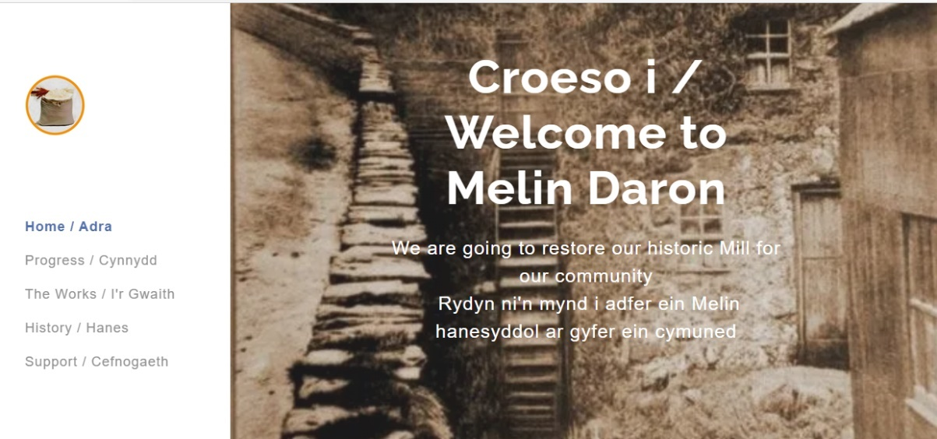

Figure - Melin Daron website

Melin Daron is a former Water Mill in the Llyn Peninsula. The Grade 2 listed building is considered important as an archaeological and architectural feature of rural life on the Llyn. The £1.5m project is in its infancy, but the vision is to reinstate it as a water mill, producing flours from locally grown crops, and offering training and education opportunities for local people.  
  
Colwyn Bay Pier Trust has been established since 2011, with the intention of restoring the Victorian Pier. Again, this is a Grade 2 listed building with a significant heritage legacy.  
  
The Pier was neglected for many years, and in 2017 partly collapsed after a storm. Much of the Pier structure has been saved, and in 2021 a truncated pier was rebuilt, incorporating much of the stanchions and architectural features. However, the long-term ambition of the Trust is to extend the Pier to its former length and revitalise this part of Colwyn Bay.  
  
As with Melin Daron, there is a dedicated website, as well as a significant social media presence:  
  
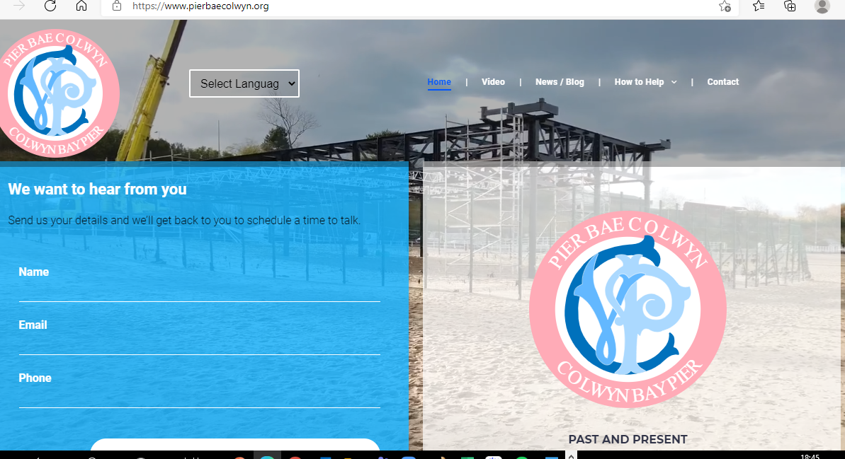

Figure - Colwyn Bay Pier Trust website

These sites and social media platforms offer a range of benefits, including:

* Ensuring that the community is kept engaged and updated.
* Sharing key developments.
* Providing visual updates.
* Opportunities for fund-raising.
* Providing evidence of credibility to stakeholders and funders.
* Recruiting new volunteers and directors

Websites provide an important entry point for services, and many include facilities for online bookings. Social Media. Facebook, Twitter, Instagram, and LinkedIn are useful tools for updating the community and stakeholders and are again used effectively by many community organisations and social enterprises.

* 1. There will also be a need to provide hard-copy collateral. This will be particularly important for the older generation within the community, but also for tourist information points across the region. Many other attractions, hotels and restaurants carry such information on racking, and this could prove beneficial to the promotion of the Old Baths.
  2. PR and Communications. At present there is no formal Communications Plan. A plan of engagement and communications will need to be developed and rolled out which will raise the profile the Old Baths.  
       
     Target markets for the Old Baths include:
* The general community of Buckley.
* Other community groups
* Families
* Youth of Buckley
* Heritage and history societies.  
  1. This is an area which will need further development during 2021/22.
  2. The next section, offers a summary of the key conclusions of the work undertaken, as well as recommendations on next steps.

# Conclusions and Next Steps

* 1. Conclusions.  
     1. The outcome of this study demonstrates that there is a need within the community of Buckley for such a development.
     2. There is strategic alignment with all the key strategies and policy documents prepared by Flintshire County Council, Buckley Town Council and their partners, and the redevelopment of Buckley Baths features prominently in many of those documents.
     3. A multi-use community hub could offer something special for the town, not only serving the sizeable resident population of Buckley, but also the wider population of North-East Wales and Cheshire.
     4. Funding of the project does present a challenge, but not an insurmountable one. There are a number of funding opportunities available, and as the country emerges from the Pandemic the emphasis placed by Welsh Government on the foundational economy, wellbeing, prosperity and the circular economy gives hope that further support and funding may well be in the offing in the near future.
     5. Capacity of the existing team is of some concern at present. And, in correlation with progressing the project further in terms of funding and full design and costings, increasing the strength of the board and the wider company is a key imperative.
     6. The continued under-performance of the town centre is of some concern. The success of the Baths will partly hinge upon Buckley itself reversing the decline of the last decade and more. On the positive side, the town has over 20,000 residents that could be enticed back into the town if a programme of investment in the streetscape and business community is effectively delivered.
     7. A measured and balanced approach to developing the offer within the facility is required. It is important to ensure that existing businesses and other community organisations are seen as potential partners rather than competitors. Buckley is underperforming at present, and the retail and food and drink sector needs bolstering. The role of the Baths should be to help reinvigorate the town centre and offer something additional and complementary.
  2. Next Steps.

The completion of this report merely marks the beginning of the next stage of the journey. There are a number of tasks now required to realise the ambitions of the Pen-y-ffordd Community Group.  
  
The key steps in the journey are set out below:

* + 1. **Business Plan.**The primary purpose of this document was to determine the most appropriate use for the Baths in the future, but this report is not, in essence, a business plan. Mor detailed empirical financial forecasts, market analysis, marketing and communications plan, as well as an agreed pricing structure and operations plan will be required as part of the next phase.
    2. **Full designs and costings.**Again, what has been provided for this report is a high-level assessment of what is feasible architecturally. More detailed designs and a fully costed programme of development will be necessary.   
         
       This should also incorporate a more logistical assessment of how the building can be developed.
    3. **Funding Applications**We have provided a preliminary list of possible funding sources in the report. This clearly demonstrates that there are, in principle, several sources of funding with sufficient levels of grant / repayable finance to realise the ambitions of this project.   
         
       However, work now needs to begin in developing applications further, submitting Expressions of Interest where applicable, and identifying other sources of finance, most especially Trusts and Foundations. Whilst some Trusts and Foundations only fund charitable bodies, this is not true of all, and a significant number will support organisations with social aims.  
         
       This work should be accompanied by a Fund-Raising Strategy. We have also anticipated that this will include an element generated form direct fund raising. This is also something that many funding bodies will expect to see as part of any application.  
         
       We would also recommend further engagement with Flintshire Voluntary Services Council, the Enterprise Team at Flintshire County Council and Social Business Wales to help identify and apply for funding.
    4. **Community Engagement – next phase.**This report’s findings indicate that there is strong support for the project. However, COVID-19 had a significant impact on our ability to engage fully with the people of Buckley. Continued engagement and collaboration with the community is essential if the project is to succeed, not just in securing the buildings and the funding, but also operationally.  
         
       In addition, funders, and in particular the Lottery, will want to see evidence that the community is a tangible part of the project, and helps shape its direction and development.  
         
       Side by side, work to develop a website and social media profiles is recommended as an early action.
    5. **Advice and Guidance**The steps set out above will be more successfully achieved with the ongoing support of relevant agencies. We have already noted the importance of the work of Flintshire County Council’s Enterprise Department, and the support of Flintshire Voluntary Services Council. Their continued support and advice and guidance will be pivotal. Social Business Wales, the third sector arm of Welsh Government’s Business Wales service, can also provide a range of important services. We understand that contact has already been made, and this should be progressed alongside work with the Local Authority and Flintshire Voluntary Services.
    6. **Capacity.**At present the company is three strong, but all the Directors have other competing demands on their time. It is important to seek additional support from within the community and identify individuals with complementary strengths to enable the project to further grow and develop with expediency. This will be essential both during the development, and operationally when the new Community Facility is operational.  
         
       This can be augmented by developing a team of volunteers and ensuring that advice from relevant agencies is sought and fully optimised. Nevertheless, strengthening the group with 2 or 3 other people is recommended as a priority.
    7. **Collaboration and Joint-Working.**There are, undoubtedly, a significant number of community activities and services that could be run from the Old Baths. Work in more fully identifying what services and which organisations can help deliver those services needs to be considered as an early priority.
    8. **Fact Finding and Case Studies.**Other similar operations can offer lessons for the future. The survey results have included recommendations of similar operations, and we would encourage the Directors to undertake further fact- finding missions to better understand how these operate.
  1. This report should provide backing evidence to allow the Directors and their partners to move forward with the project, particularly in relation to begin work on securing the not insignificant amount of funding required to make the redeveloped Baths a reality.

The Directors have shown long term commitment and dedication to the project, and hopefully this report will offer renewed confidence in the viability and sustainability of the project.  
  
COVID-19 has had a profound transformational impact on society, but it has also demonstrated how critically important local services and facilities are to communities. Welsh Government’s continued emphasis on the foundational economy as a cornerstone for reigniting the economy offers further confidence and assurance that the redevelopment of the Buckley Baths will meet with support and backing, as long as the plan itself remains cogent and strategically sound.  
  
___________________________________________________________________________

1. National Archives currency converter - <https://www.nationalarchives.gov.uk/currency-converter>
2. Buckley Town Centre Discussion Paper – July 2015. Planning Policy Environmental Directorate, Flintshire CC
3. A Well-being Plan for Flintshire 2017 - 2023